**Voices of Women with Psychosocial Disabilities   
in Lira, Uganda**

*May 2024*

Lira District Disabled Women’s Association

With the support from Making It Work

**Content**

The women who talked with us 2

A great diversity of women 3

Who do they live with? 3

Level of education 3

Active women in their communities 4

A life of high insecurity 6

Difficult access to health, police and education 6

Living in an unfriendly environment 7

Hopes and dreams for a better life! 8

**Summary**

**Lira District Disabled Women’s Association is a women-led Organizations of Persons with Disabilities operating in Lira district, Northern Uganda.**

**With the support of the Making It Work Gender and Disability Project from Humanity & Inclusion, LIDDWA has been conducting throughout 2024 a project dedicated to increasing human rights and access to justice for women and girls with psychosocial disabilities in Lira district.**

**LIDDWA publishes this report titled 'Voices of Women with Psychosocial Disabilities in Lira, Uganda' with the aim of making their voices heard, their experiences shared and ultimately inform further engagement by all stakeholders for a more dignified, autonomous and healthy life for women and girls with disabilities.**

**We want to thank the women who accepted to talk with us for their time and generosity; as well we thank the MIW Coordinator for her support.**

**For more information please contact Lira District Disabled Women Association** [**liddwa9@gmail.com**](mailto:liddwa9@gmail.com) **Mobile +256392177086**

**\*All pictures**: credit Atlantic Media

|  |
| --- |
| **Recommendations**  Interviewed women with psychosocial disabilities shared their recommendations for further action either by LIDDWA or by other stakeholders such as the local government.  **Women with psychosocial disabilities in Lira are requesting stakeholders to act on the discrimination and violence they are facing within their homes and communities; and to be given the means to live a more healthy and autonomous life.**  Most women express the need for more sensitization on their needs and rights towards community members, husbands and relatives; through awareness sessions and home visits.  Many recommendations focus on women’s economic empowerment: women are requesting provision of start-up capital for being able to start small scale business.  They ask for lasting projects allowing them to successfully engage into farming, poultry and piggery, and other income generating activities such as shop business, tailoring and knitting.  Last, some women mentioned explicitly that they should be better included in Government program, in particular to ensure better access to health. This includes:   * Benefiting from mobility devices. * Ensuring the health centres located in remote areas are provided with adequate drugs without shortage, * and employing qualified mental health personnel to ensure a decentralized access to mental health services. |

# The women who talked with us

**Interviews have been conducted between 29th February and 5th March 2024, by Apio Mercy and Atala Cissy who are women volunteers of LIDDWA.**

The interviews were guided by a questionnaire developed by LIDDWA with the support of the MIW coordinator. Confidentiality was guaranteed throughout by a special code system that did not allow the women to be identified from their completed questionnaires.

Each woman has been explained what the interview was about; their consent has been sought and obtained.

## A great diversity of women

A total of 16 women have been interviewed; half of them live in Lira city and the other half in Ogur sub-county.

All of them have a psychosocial disability; in addition, two women had also a physical disability, one woman has a severe visual impairment and one woman is deaf

They have a diversity of age, as shown in the graphics.

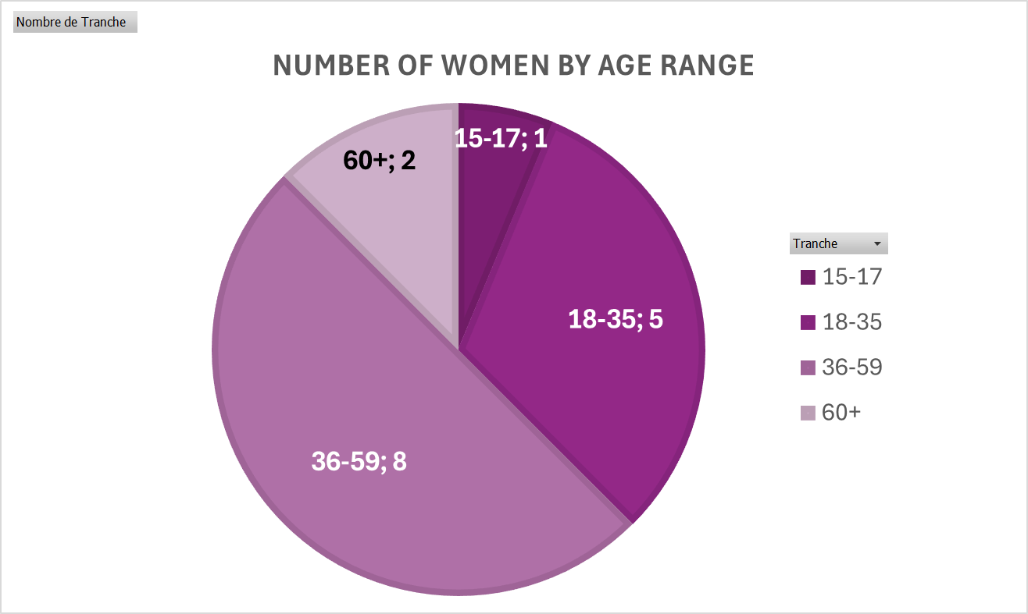

## Who do they live with?

Among the 16, 4 live with their husbands, 7 live with relatives and 5 live alone.

**As well:**

* 4 are married with kids (and are living with their husbands)
* 2 are not yet married and have no kids
* 10 are single mothers.
* 2 of them had their children taken away to live with other relatives

## Level of education

The level of education is diverse:

* 5 of them stopped in lower primary school.
* 1 attain “O” Level certificate
* 1 attained first degree.
* The 9 others never went to school.

They were questioned about the reasons for not being enrolled or dropping-out. The lack of money is the reason for 8 of them; for 2 of them it is linked with their disability status.

## Active women in their communities

**All but one woman with severe physical impairment has an activity**: farming is the most common occupation, are selling goods comes second. The others have diverse occupations such as working as a cleaner, tailoring, running a restaurant or having housework activities. Last, one is organizing outreach for person with psychosocial disabilities. At least 11 of the women have an activity that earns them a living.

Monthly average income is not more than 190,000 Uganda Shillings (50 USD); it serves for medicine and food, and also for clothes and caring for their children

For their activities, most of them consider being skilled. Still **their monthly income** for the month before the interview went from 20,00 Uganda Shillings to 600,000 Uganda Shillings; average monthly income at 190,000 Shillings among the interviewees, which is clearly not sufficient to cater for food and other needs of a family. 10 out of the 16 women report not having sufficient clothes.

Despite having an occupation for 15 of the women we interviewed, only 4 reports feeling independent.

Among the women, 7 express they are dependent on relatives or their husbands, 5 are not sure and 4 feel independent.

**We asked the women if they were holding a position within their community**: majority of them answered no, as the community members would not allow them to do so, because of their mental health condition. Still, 7 women have a position in the community: 1 is LC1 secretary, 2 have responsibilities within their VSLA (Village Savings and Loan Association), 1 is in the office of the clan leader, 1 has a position within an Association. As well, most women join community events on Sundays in particular: Church service and Group savings are the most common activities for the women we interviewed.

Six of the women interviewed hold positions of responsibility in the community, despite the reluctance of community members due to their mental health condition.

Similarly, when asked about the confidence in their capabilities, 9 women said they have not been feeling confident lately. For the women feeling confident, 3 of them made a causal link with the fact that they were under their medication.

“I feel confident as am good in writing skills and reading”

“I am doing agricultural practices and I have a feeling of success”

# A life of high insecurity

## Difficult access to health, police and education

Access to services is a challenge for women with psychosocial disabilities; the women interviewed shared their mixed experiences of access to services.

### Access to education

Most of them were not enrolled at school or dropped out in low levels, as shown before. In school, 3 of them were feeling happy, the rest told us about they were neglected by peers and even experiencing bullying.

“No teacher knew my problems and how to encourage me to remain in school.”

### Access to police and health services

Among the 16 women interviewed, 8 of them declare that the police station is not accessible to them, due to long distance.

Most women access regularly health centres or hospitals, either when they are sick or to get treatment for their mental health condition. 8 women reported having a positive experience with the health centre: medical personnel have been friendly and treating them well. **For the other half, they reported having been neglected, not receiving treatment or support.**

|  |  |
| --- | --- |
| Shortage of medicine is a paramount challenge for interviewed women, as 13 of them are under treatment for their mental health condition and/or another disease: when drugs are not available at the hospital, they are supposed to buy them, although their resources are not sufficient. |  |

Because of poverty, women suffer interruptions in treatment that are very damaging to their mental health and well-being.

Combining the issue of unavailability of medicine and the attitudes of health personnel, all 16 women reported problems with accessing health in their context. In addition, 8 of them have never heard of family planning, 7 have never been vaccinated against any affection.

8 out of 16 women have never heard of family planning.

## Living in an unfriendly environment

“Sometimes I feel like I want to die because I am useless when people annoy me.”

Women with psychosocial disabilities that were interviewed face severe and multifaceted difficulties in the community that significantly impact their sense of security and well-being.

### From negative attitudes to insecurity in the daily life

The community often perceives these women negatively, seeing them as incapable of basic tasks such as cooking; community members are frequently mocking or making fun of them. Derogatory terms such as "mad women" and "useless" were reported repeatedly, highlighting a severe lack of respect and acceptance, leading to widespread segregation and isolation.

“They call me mad lady.”

We asked women if they feel free and secure when moving in the community. Only 3 have been saying they feel free and secure; the others do not feel free when moving in the community because other people fear associating when them, and others are reporting negative attitudes towards them.

Only 3 of 16 women said they feel free and secure when moving in the community

The women were asked how, in their opinion, the community perceives them.

All of them mentioned segregation and discrimination. 5 of them mentioned being laughed at, 14 of them used words such as “valueless” or said they are looked down upon. Half the women reported being called “Mad woman”.

The challenges these women face in their daily lives extends beyond social perceptions to include **physical violence, neglect, and others forms of gender-based violence (GBV) such as economic violence, within their homes and within the community**. They experience segregation and discrimination not only in the community but also within their families. Financial struggles are prominent, with difficulties in securing transportation, paying for children's school fees, and affording medicine.

Some women also reported having been subjected to violence; from intimate partner violence to denial of parental rights, to being denied property rights. For instance, a couple of women reported that their land was taken from them, either by a relative or after a divorce. LIDDWA has been following on each case of violence disclosed during the interviews, with appropriate actions.

### Emotional insecurity and psychological struggles

We asked women about how they felt at the time of the interview: 12 of them said they were feeling bad, for various reasons.

When we asked about their happiness in life in general, results were more mixed but certainly articulating love as a key factor influencing their happiness: 8 women said they have been sad because people do not love them, when the other half said they have been happy if provided with care and love. One woman expressed the pain of missing her children that have been taken from her by relatives[1].

Some women talked about the strain of combining domestic responsibilities with leadership roles, experiencing the mental load that can be overwhelming for mothers with disabilities.

We asked the women who they were going to when feeling sad or lonely: 12 out of the 16 said they have no one to turn to in such a case.

# Hopes and dreams for a better life!

15 women shared that their future becomes bad when they lack basic needs like shelter, clothing, medications and food

We asked each woman what was her dreams and hopes for the future. Most of interviewed women’s hopes revolve very strongly around their main daily difficulties.

All of them expressed their will to be healthy again in the future. Others shared hopes such as:

* Being able to start a business for 5 of them
* Wanting to build a safe, peaceful and good home for her children to stay
* Be able to cater for their children for 8 of them

When it comes to longer terms dreams, only one woman expressed that her disability prevented her from having hopes for the future. One-woman dreams of being a doctor to help her peers with psychosocial disabilities. Another one wants to do an agricultural course to support her father.

“I want to be a doctor so that I can help women and girls with psychosocial disabilities”

“I want to build a good home where my children can stay safely and peacefully”

**Report edited by LIDDWA with the support of Making It Work – final version 30 May 2024**

1. LIDDWA has been following on that particular case.