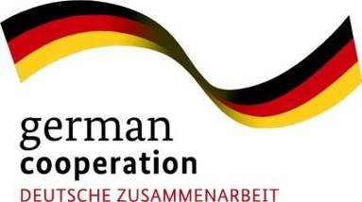
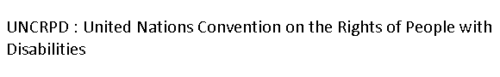

FOREWORD
Realizing the fulfillment of the rights of persons with disabilities in every aspect of life is a central goal of the UNCRPD (United Nations Conventions on the Rights of Persons with Disability). In Indonesia, people with disabilities have been active in advocacy movements in support of the implementation of the CRPD. These efforts resulted in the Indonesian government ratification of the International Convention on the Rights of Persons with Disabilities (Law no. 19 of 2011 and Law no. 8 of 2016 on Persons with Disabilities). The issuance of both of these laws is the first step towards fulfilling the rights of people with disabilities in Indonesia.
Currently, advocacy efforts in Indonesia are focused on the implementation of these laws, and how it will affect the fulfillment of rights for people with disabilities in the country. This requires the efforts of various parties, including local and national governments, observers of disability issues, organizations of people with disabilities, people with disabilities, and the general public.
As a contribution to the fulfillment of these rights, Handicap International is working together with people with disabilities through the Advocacy for Change project, This project aims to support the fulfillment of rights of persons with disabilities on a practical level. In addition to contributing to people with disabilities’ capacity building, the promotion of accessibility, and better avenues for more participation in government services, the Advocacy for Change project seeks to document good practices undertaken by individuals and organizations for people with disabilities in the implementation of CRPD principles.
Handicap International uses the "Making it Work" methodology which is commonly abbreviated as MiW. MiW is a tool developed by Handicap International for documenting and promoting the practices used to support the fulfillment of the rights of persons with disabilities in accordance with the CRPD. The MiW is also used as an advocacy tool, as various parties can refer to these practices to review and replicate the various methods of supporting the fulfillment of the rights of people with disabilities in accordance with the principles of CRPD.
The MiW methodology requires a participatory approach during the documentation process and the application of collaborative and multi-stakeholder approaches. This indicates that the determination and selection of good practices must be undertaken by a committee made up of several parties to ensure not only that these good practices are in compliance with the CRPD principles, but also that they are reproducible and sustainable.
It is our hope that the documentation of these good practices will inspire and would be replicated in an effort to encourage the implementation of the CRPD on a wider scale both nationally and internationally, so that the fulfillment of the rights of persons with disabilities as a major objective of the CRPD is truly able to be realized.
Handicap International
Team Advocating for Change

Table of Contents
FOREWORD 2
Table of Contents 5
INTRODUCTION 7
Summary of AfC Project 7
What is making it work 7
MIW Concept 7
What is a Good Practice 9
Making it Work in Process 11
Committee MembersYogyakarta 16
Committee members East Nusa Tenggara 18
Convention on the Rights of Persons with Disabilities (CRPD) Journey in Indonesia 19
What is the CRPD? 19
GOOD PRACTICES 26
Case Study 1 26
Case Study 2 31
Case study 3 40
Case Study 4 46
Case Study 5 53
Case Study 6 60
Good Practices with Gender Perspective 67
Conclusion and General Recommendations 68
Conclusion 68
Recommendations 69

ABBREVIATIONS
AfC : Advokasi for Change
Bengkel APPek : Bengkel Advokasi Pemberdayaan dan Pengembangan Kampung (Advocacy of Kampong Empowerment and Development Organisation) BMZ : Bundesministerium Für Wirtschaftliche Zusammenarbeit CIQAL : Center for Improving Qualified Activities in Life of People with Disabilities
CRPD : Convention on the Rights of Persons with Disabilities Diffcom : Diffable Community
HI : Handicap International
IDEA : Institute for Development and Economic Analysis
ILAI : Independent Legal Aid Institute
KPI : Komisi Penyiaran Indonesia (Broadcast Commission of Indonesia)
MiW : Making it Work
NTT : Nusa Tenggara Timur (East Nusa Tenggara)
OPD : Organisasi Pemerintah Daerah (Local Government Organization)
OPDis : Organisasi Penyandang Disabilitas (Disabled People Organization)
PERSANI : Persatuan Tuna Daksa Kristiani (Christian Physical Disability Association)
RRI : Radio Republik Indonesia (Republik of Indonesia Radio) SIGAB : Sasana Integrasi dan Advokasi Difabel (Difabel Integration and Advocacy Association)
WKCP : Wahana Keluarga Cerebral Palsy (Cerebral Palsy Family Association)

INTRODUCTION

Summary of AfC Project
Advocacy for Change - BMZ (2015-2017)
The Advocacy for Change Project is a project funded by German BMZ for 24 months covering three countries: India, Indonesia and Timor-Leste.
In Indonesia, the Advocacy for Change project aims to increase the effective participation of people with disabilities in inclusive development efforts at the local level, and promote their participation in development at the national level. Specifically, the Advocacy for Change project seeks to improve and monitor the people with disabilities' access to local government processes and existing social services.
The expected results are:
- In the Gunungkidul District and Kupang Municipality, local governance processes and social services will include persons with disabilities.
- In the 2 villages at the Gunungkidul District and 2 villages at Kupang Municipality, persons with disabilities will have access to public infrastructure and social services.
- In Yogyakarta and NTT Provinces, accountability mechanisms of local governance processes and social services delivery involving DPOs and other civil society organizations were developed.

What is making it work

MIW Concept
"Making it Work" (MiW) is a methodology developed by Handicap International in 2009 after the adoption of the Convention on the Rights of Persons with Disabilities (CRPD). This methodology documents Good Practice on the involvement of people with disabilities in development, and analyzes how it is possible to replicate and sustain positive changes in Good Practice in line with UNCRPD principles. MiW provides tools to guide organizations or groups to work collectively in identifying, documenting, and analyzing good practices that contribute to the promotion of rights within CRPD. These good practices are then used as means to encourage changes to systems, policies, and services in order to conform to UNCRPD principles.
People with disabilities and their representative organizations play an important role in utilizing and implementing MiW methodology through collaboration between multi- stakeholders and sectors. All actors involved can play a role in determining the changes they want to make. MiW implementation emphasizes a learning-by-doing process that encourages the multi-stakeholder groups to work collectively in gathering existing practices and encouraging change. This approach aims for successful, possible to replicate and enhanced learning, as well as to provide recommendations for policy makers, service providers, and other development stakeholders.
In general, the MiW methodology consists of three main steps:
- Building multi-stakeholder cooperation
This approach is the core element of MiW. This is a method for creating "learning alliances," as well as commitments where various stakeholders are linked by a common interest in promoting inclusion.
- Collecting, documenting and analyzing good practice
In this step, the multi stakeholders (MiW committees) will discuss a number of topics: the criteria for the good practices to be collected; mapping Good Practice; how to collect good practice; identification of participants; analyzing, validating and determining how to publish documentation of good practices. This is an important process for determining those good practices that will serve as an advocacy tool.
- Change Action
This step is an important element of MiW. Good practice documents that undergone the validation and analysis process are then used to drive change. In this step, the use of good practice documents, strategies, steps, and advocacy targets are identified to drive the desired changes.

Monitoring and evaluation is also an important part of the MiW process. In this context, monitoring and evaluation aims to see whether changes to policies, systems, and advocacy services are conducted using good practice.

What is a Good Practice
Good practice is the key element in the MiW methodology. In this context, the good practices referred to are practices that facilitate "full and effective participation in society based on equality", and those practices agreed upon by people with disabilities as "good" which have had a positive impact on their lives. MiW provides more weight on documenting and analyzing practices that are adapted locally and culturally. Good practices, in this case, support what is successfully done locally with local resources. More information on Making it Work (MiW) can be found at http://www.makingitwork-crpd.org/.

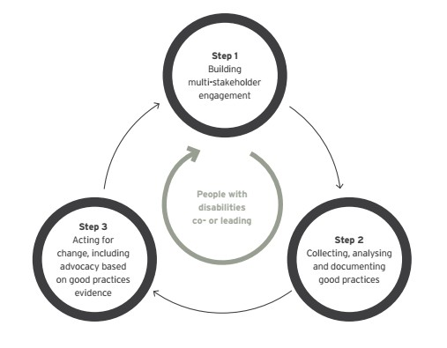

Making it Work in Process

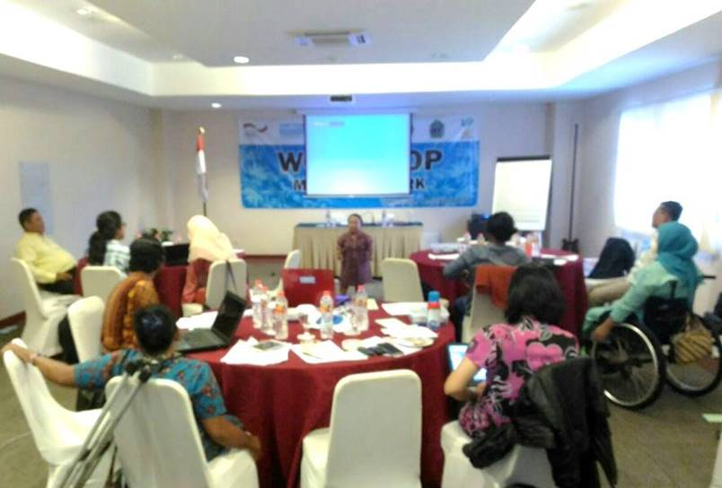1. Making it Work Workshop and Building Commitment with the establishment of the MiW committee
Workshops on MiW methodology were conducted in Yogyakarta and East Nusa Tenggara. These workshops were the first step in introducing the concept of Making It Work. Workshop participants were drawn from the difference elements of DPOs, women's organizations, educational observers and practitioners, community leaders, journalists, and social organizations concerned with issues of disability. The involvement of participants from these communities aimed at gaining diverse perspectives on disability issues, as well as the implementation of CRPD in Indonesia.
In addition to strengthening knowledge about MiW methodology, the workshop participants also built a joint commitment to engaging in the practice of MiW. This commitment was established within the MiW committee. Through this workshop, the committee created action plans, objectives, and advocacy targets, good practice targets and and technical themes for data retrieval. These later became the committee's work guidelines in the implementation of the MiW methodology.

Collecting best practices
The composition of the committees in Yogyakarta and NTT are as follows:

Yogyakarta
    - Hartaning Widjaya : SOLIDER Journalist
    - Winarta : ILAI Member
    - Bambang : IDEA Member
    - Purwanto : CIQAL Member
    - Suryatiningsih Budi L. : CIQAL Executive Director
    - Presti : SIGAB Member
    - Dra. Ernie Februaria, M.Si : Community Leader
    - Sukiratnasari : KPI Member
    - Taufik : Chairman of Care for Disability Bantul Forum
    - E. Dewi K. : Handicap International

B. East Nusa Tenggara
●  ● | Nopriana Hida Bunga  Aser Paskah Rihi Tugu,SH | : Forum  : RRI Kupang
● | Ema Marina Taneo | : Noelbaki Village Staff
● | Dinna Novista Noach | : Persani member
● | Matius Indarto | : Handicap International
● | Agustina Selvidayani | : Persani Member

Collection, Analysis and Validation of Good Practices
In MiW methodology, good practice is a key element. The MiW Committee compiled a number of good practices then used them as an advocacy tool to encourage the implementation of CRPD. The MiW Committee generally took four steps to ensure that the stories they collected reflected good practice.

2.1. Defining good practice criteria
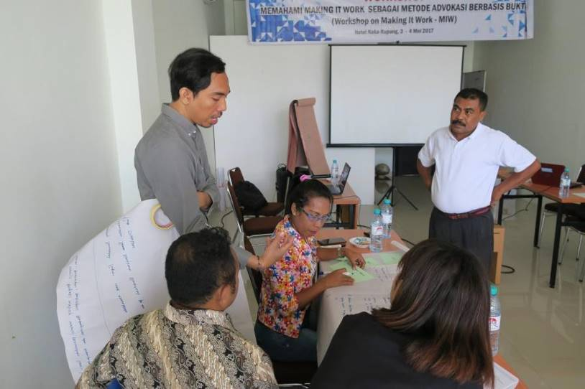During the initial workshop on MiW, the process of defining the criteria for good practice was initiated. There are five good practice criteria provided by the MiW methodology. This process gives space to the committee to add criteria deemed relevant to the situation and
the territorial context of each region. The result of the discussions of the MiW committess in Yogyakarta and Nusa Tenggara led to the creation of two additional criteria for good practice that were added to the original five. The criteria that the committees agreed upon are as follows:
    - The stories presented should be able to show positive changes in relation to the fulfillment of the rights of persons with disabilities. The changes in question can be policy changes, changes in systems, or changes in attitudes relevant to the CRPD.
    - Defining the stories to be identified and replicated. In this context, the committee agreed that terminology can be reproduced so that stories can be developed in other regions through other actors. This stories should function to provide inspiration and an overview of the steps taken.
    - The stories promoted can also display sustainability, meaning that the approach and strategy of the stories has the potential to be continued by local stakeholders.
    - The stories should focus on the role of persons with disabilities in promoting policies and services that match their needs in accordance with the principles of the CRPD.
    - The stories should be in accordance with the general principles of the CRPD (Convention on the Rights of Persons with Disabilities):
      - Respect for inherent dignity, individual autonomy; including freedom to make choices, and individual freedom;
      - Non-discrimination;
      - Full and effective participation and participation in society;
      - Respect for the difference and acceptance of persons with disabilities as part of human life and human diversity;
      - Equality of opportunity;
      - Accessibility;
      - Equality between men and women;
      - Respect for the growing capacity of children with disabilities and respect for the right of children with disabilities to maintain their identities.
    - The good practices should come from NTT and the Yogyakarta Special District regions.

Identifying and collecting good practice
In the process of identifying and collecting stories that could potentially serve as examples of good practice, the NTT and Yogyakarta MiW committees collected twelve stories. The stories were recorded in format that emphasized main points. After meeting to discuss whether the stories represented good examples of good practice, the committee agreed to go forward with verification process for the twelve stories before the final process of writing them fully.

Verification and good practice writing
Through a discussion process, the committees agreed that the stories must be tailored to meet the six criteria. If the stories chosen do not fulfill the six criteria the committee will seek other options. Verification is achieved by referring to the the storytellers, service providers and the government agencies that are the targets for advocacy in the stories. Interviews and FGD are also used as part of the verification process. This session also aimed at collecting as much information as possible for use in the writing process.
Results of the verification process results were discussed among the committee members, resulting in six stories chosen to advance to development of full-story format. The committee agreed on the following format for development of the stories:
- Background: explains the organization's short profile and the situational aspects of the advocacy
- What it does: describes the advocacy efforts undertaken by the organization
in relation to the context
- What works: details the results of the advocacy activities undertaken
- What can be learned: describe what can be learned from the success of the activity
- Testimonials
- Articles in the CRPD and the laws relating to the story.
Stories can be written either by the actor or the committee members of the MiW. In Yogyakarta, the writing process was completed by the committee members, since not all actors were able to document their experiences in story form. In NTT, some of the stories were written by the stakeholders themselves.

Validation and Finalization of Good Practice
During the validation and finalization process, the MiW committee sits together to read and examine the full texts of the stories produced. This process is needed to ensure that the existing good practices meet the predetermined criteria. In addition, this process aims to ensure that the committee comprehensively understands the

good practices that are collected in order to make conclusions and recommendations.

Action for Change
The MiW methodology uses the documentation of good practices for analysis in order to develop constructive recommendations in an effort to encourage the implementation of CRPD within social organizations, organizations of persons with disabilities, governments, and service providers.
Efforts to encourage the implementation of the CRPD require Action for Change. In order to achieve these goals, the committee disseminated good practices to stakeholders, in this case the government and social organizations, including people
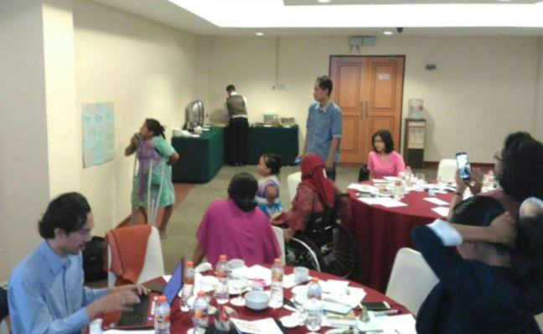with disabilities. They held a workshop that both presented and discussed good practices as well as introduced the MiW methodology to a wider audience. For the MiW Committee, the workshop also functioned to collect input from various parties to contribute to better strategies for future advocacy activities.

4.
This is an important part of the MiW process in encouraging the
implementation of CRPD using proven practices that can have significant impacts and produce significant change.

Committee MembersYogyakarta
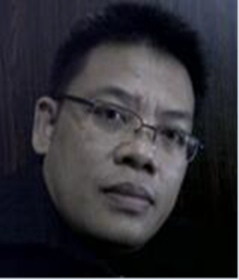  Winarta  Is the Director of the Independent Legal Aid Institute (ILAI) and also a member of the Committee on the Protection and Compliance of the Rights of Persons with Disabilities of the Special Province of Yogyakarta (Division of Monitoring and Complaint Service). He first came into contact with Persons with Disabilities since 1995 when volunteering at the Legal Aid Institute (LBH) in Yogyakarta. His experience of dealing with cases of discrimination experienced by people with disabilities fostered his interest in the issue of the rights of people with disabilities. From 1996-1997 he participated in writing an objection to the draft law on "People with Disabilities" being discussed in the People's Legislative Assembly. His future plans incluse a focus on pro-local disability regulations, as well as the DPO Window - The World Bank in mapping the problems faced by Persons with Disabilities in Eastern Indonesia. A number of his articles on the topic of the rights of people with disabilities have been published in Kompas, Kedaulatan Rakyat, Bernas, and Tribun Jogja. | 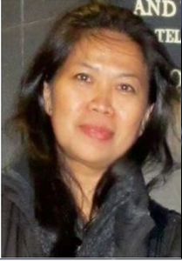  Harta Nining Wijaya  1. Solider journalist  2. Chairwoman of Perspektif Yogyakarta | 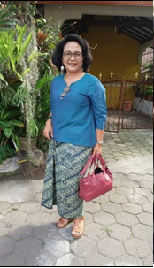  Dra.Ernie Februaria.M.Si  Holds a position in Education at the Town's Disability Committee Working Group  Recent activities are:  Working on the research network team of the City of Yogyakarta  Working on the Coordination Team for  poverty alleviation for the City of Yogyakarta  Working on the Ethical Education Team in the City  of Yogyakarta  Member of the Yogyakarta Disability  Committee
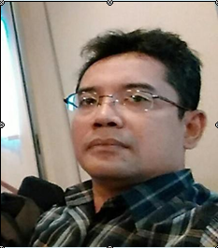  Bambang Hery Purwanto  Institute for Development and Economic Analysis (IDEA) Association Staff | 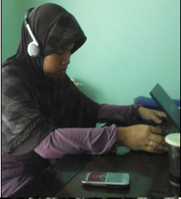  Presti Murni Setiati  Research Assistant at Sasana Integrasi dan Advokasi Difabel (SIGAB) | 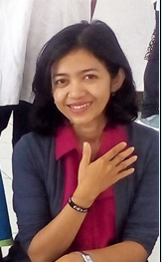  E.Dewi Kurniawati  Deputy Project Manager Handicap International
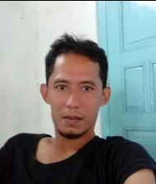  Purwanto  Project Manager at the Center for Improving Qualified Activity in Life of People with Disabilities abbreviated to CIQAL | 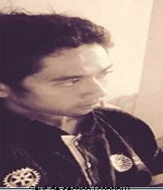  Taufik Hajat  Member of the Board of Bantul Care for Disability Forum (Forum Peduli Disabilitas Bantul FPDB)  Taufik has assisted persons with disabilities since the 2006 earthquake, and has been active in disability activism work since 2008. He has worked with several organizations for people with disabilities. Along with the Disability Care Forum Bantul, he endeavors to work in the field of disaster management tools and advocacy. | 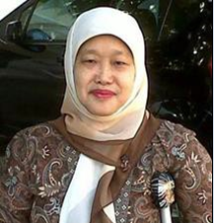  Suryatiningsih Budi Lestari  Chairwoman of the Center for Improving Qualified Activity in Life of People with Disabilities (CIQAL)
Sukiratnasari
Yogyakarta Women Network

Committee members East Nusa Tenggara
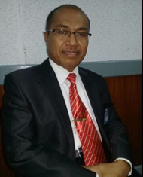  Aser Paskah Rihi Tugu, SH, MSi (RRI Kupang) | 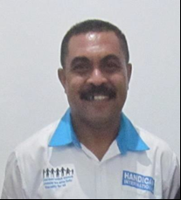  Yohanes M.Z. Bela (Handicap International) | 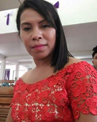  Nopriana Hida Bunga (Nunbaun Sabu Disabilities Forum)
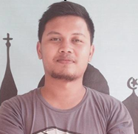  Matius Indarto (Handicap International) | 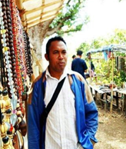  Kris Poto Bisilisin (Kilas Timor | 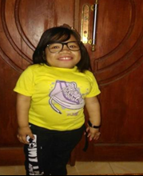  Dinna Novista Noach (Association of Christian Physical Disabilities / Persani
Agustina Selvidayani (Association of Christian Physical Disabilities / Persani | 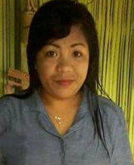  Erna Marina Taneo (Head of Noelbaki Village Government Affairs)

Convention on the Rights of Persons with Disabilities (CRPD) Journey in Indonesia

What is the CRPD?
The Convention on the Rights of Persons with Disabilities is an international human rights treaty adopted by the General Assembly of the United Nations on 13 December 2006. The Convention was opened for signatures on 30 March 2007 and entered into force on May 3, 2008, after ratification by Ecaudor, the 20th State Party.
In February 2011, the Convention had 98 States Parties and was the first Human Rights Treaty to be ratified by a regional integration organization, the European Union. As of December 2016, 160 States have signed this Convention and 174 countries have ratified the International Convention on the Rights of Persons with Disabilities, with 92 States ratifying the Optional Protocol.
The Convention adopts a broad categorization of persons with disabilities, and reaffirms that all persons with any type of disability should enjoy all human rights and fundamental freedoms. The Convention also explains how all rights categories apply to persons with disabilities, and identifies areas where adaptations should be made for persons with disabilities so that they can effectively exercise their rights. It also identifies areas where their rights have been violated, and where the protection of rights must be strengthened.
How does CRPD work?

All States Parties are required to submit regular reports to the Committee on the Rights of Persons with Disabilities about the implementation of the rights contained in the Convention in their individual territories. The committees usually meet in Geneva and hold two sessions per year to review States reports. States should report initially within two years of ratifying the Convention and, subsequently, every four years. The Committee reviews each report and makes general recommendations. These recommendations are continued in the form of close observation of the State Party concerned.

What is the Optional Protocol to the Convention?
The Optional Protocol that came into force in convergence with the Convention established two additional mandates for the Committee:
  - Receipt of and checks of individual complaints
  - Investigates evidences of grave and systematic violations of the Convention
The UN General Assembly adopted the Convention on 13 December 2006. The Convention consists of 50 articles and the Optional Protocol. The Convention contains comprehensive social, economic, cultural, political and civil rights. It marks a major change in viewing the problems of people with physical or mental or intellectual impairment, and also those with sensory impairments in daily life who interact with the surrounding community and its environment.

Convention on the Rights of Persons with Disabilities Ratification Efforts in Indonesia
The definition of Persons with Disabilities used in the Convention is a broader and more comprehensive term than the previous definition of defective people in Law No. 4 of 1997 concerning Impaired (cacat in Bahasa), as well as related laws and regulations put into practice in Indonesia. Indonesia participated in the signing of the Convention on 30 March 2007. At that time, the State of Indonesia was represented by the Minister of Social Affairs Bachtiar Chamsyah accompanied by the Director General of Social Services and Rehabilitation Makmur Sunusi, and the Chairman of the Indonesia Disability Association (Persatuan Penyandang Disabilitas Indonesia), Siswadi.
In accordance with Article 43 of the Convention on the Rights of Persons with Disabilities (CRPD), Indonesia as a signatory to the Convention shall ratify (bind itself) to the Convention. Philosophical, sociological and juridical reasons motivate Indonesia's desire to ratify the CRPD. The objective of ratifying the Convention is to strengthen respect for, protection of, and the fulfillment and promotion of the rights of persons with disabilities in all fields.

According to Law no. 24/2000 on International Agreements, Ratification of an international agreement that affects social issues, budgeting, and politics needs the approval of the House of Representatives in the form of Law. The Convention on the Rights of Persons with Disabilities belongs to this category.
Moreover, the application of the Convention in Indonesia must be in accordance with the provisions of the drafting of laws and regulations, academic manuscripts and official translations. Translations of the Convention into Indonesian were created to accompany the Draft Law on the Ratification of the Convention. The translation effort began with a review of the term "defect" which was the prevailing term used in government documents. The language of the proposed law for the application of the Convention was discussed In a meeting in Bogor, Indonesia in January of 2009. The meeting was attended by various agencies, including disabled people organizations and the National Commission on Human Rights. The Ministry of Social Affairs in cooperation with the National Commission of Human rights initiated the meeting, yet at its close the parties were not able to fully agree on one term in Indonesian for the translation of the concept of 'persons with disabilities'. They proposed six possible terms further discussion.
Meanwhile, the Ministry of Social Affairs urged immediate ratification of the proposal for various agencies / institutions / ministries and social organizations with disabilities. The Minister proposed the ratification process to the Minister of Foreign Affairs and proposed the initiative for the permission of the President. The License Agreement Initiative for the process of ratification of this Convention was introduced through the Letter of the Secretary of State Secretary no. B-72 / M.Sesneg / D- 4/02/2009 dated 17 February 2009.
The translation process continued with the drafting of the Academic Paper and the Draft Law on the Ratification on the Rights of Persons with Disabilities. Inter- ministerial consultations along with the participation of disabled people organizations was part of the process. The socialization of the contents of the Convention at the central and regional levels are to be undertaken by the Ministry of Social Affairs, the
Ministry of Foreign Affairs, the Ministry of Justice and Human Rights, and different

types of disabilities and the National Human Rights Commission along with other agencies and institutions.
The National Commission on Human Rights and the Ministry of Social Affairs continued the facilitation efforts to finalize the official translation of the CRPD manuscript in Bahasa Indonesia. The National Commission on Human Rights invited experts in the fields of philosophy, communication, psychology, human rights law, linguistics, disability, and disability practitioners to submit official translations with disability terminology in Indonesian. The term "penyandang cacat (crippled people)" used so far was determined to no longer be appropriate for the following reasons:
- The language aspect: the word defect denotatively has a negative meaning, such as sufferer, a deficiency which indicates the value or quality is not good, a blemish, a disgrace, or something damaged. The word cacat also has a connotative meaning that conveys a sense of humiliation or negativity.
- The word cacat arises because a powerful party (group or state) uses the word to identify to a group of people who deemed handicap. The perceived flaw is a social construction, not the reality of one's existence.
- Philosophically, no one is crippled. God created humankind in the most perfect state.
- The psychosocial effects of the term "penyandang cacat" include: creating
social distance, making subjects and people feel guilty, positioning the so- called "penyandang cacat" as somehow incomplete, inadequate, unexpected, and portraying them as victims.
- Empirically, the term " penyandang cacat " used so far has caused
unfavorable attitudes and treatment to persons who are labeled using that term. The term " penyandang cacat " has led to a lack of understanding about the existence of the so-called "crippled people".
- Being crippled is regarded as the identity of a person, which is lower than the person who is considered to be free of impairment. Yet ' penyandang cacat ' is not a state that determines the quality of 'bukan- penyandang cacat '. The 'being crippled' is not a measure of the limitations of human existence. 'Being crippled' are only certain conditions of the human being that leads them to 'way difference' at the level of reality when facing life itself, rather than in comparison with other human beings.
Given the negative connotations of the previous terminology, it was decided that a new set of criteria was needed to guide the development of new terms. The descriptive maxim for the subject was outlined in the following fifteen points:
- Describes the facts
- Does not reproduce or institutionalize negative elements (non-harrasing)
- Encourages a spirit of empowerment
- Highlights positive aspects and inspires positive action
- The term has not been previously used
- Considers the diversity of users and the diversity of usage
- Can be absorbed and understood by wide range of groups
- Fulfills a representative-standard-accommodating character for the purposes of Convention ratification
- Is a term that does not contain violent language or elements
- Is in alignment with other internationally used terms
- Takes into account linguistic variability
- Contains respect for human dignity and prestige
- Describes similarity or equality of the subject
- Easy to pronounce
- Takes into account the dynamics of the development of society
The term "persons with disabilities" was approved to replace the term "cacat (handicap)" in a meeting of experts initiated by the National Human Rights Commission in March of 2010 in Jakarta. The term was then discussed at second meeting in April of 2010. The Ministry of Social Affairs facilitated the discussion of the Academic Paper and the draft law on CRPD, managing the process of approval across state institutions, disabled people organizations, academics and the National Human Rights Commission in Bandung. At the meeting, all parties agreed on the term "penyandang disabilitas" as the translation from the phrase "person with disability".
After the official translation of the Convention’s text and the associated Academic Paper was agreed upon, the process for the ratification of the bill began in December 2010 with the introduced of the bill to representatives from various ministries under the coordination of the Ministry of Justice and Human Rights. The coordinating ministries agreed that all aspects of the CRPD would be ratified with the exemption of the Optional Protocol. The Optional Protocol was not ratified because Indonesian parties did not agree to the individual complaint system protocol at the International Commission on Human Rights.
On May 4, 2011, the Minister of Foreign Affairs filed an application with the President (No. 211 /HI/ 05/2011/60/60) requesting a Presidential Mandate on the adoption of the United Nations Convention on the Rights of Persons with Disabilities draft to be presented to the House of Representatives.
On June 6, 2011, the President of the Republic of Indonesia through the Letter of the Minister of State Secretary no. B-743 / M.Sesneg / D-4 / PU.03 / 06/2011 requested the relevant ministries to undertake the United Nations Convention on the Ratification of Persons with Disabilities draft.
On June 23, 2011,the President, through the Minister of State Secretary no. B-858 / M.Sesneg / d-4 / PU.03 / 06/2011 appointed the Minister of Social Affairs, the Minister of Foreign Affairs and the Minister of Law and Human Rights to represent the President in the Discussion of the Draft Law on for Ratification on the Rights of
Persons with Disabilities in the House of Representatives of the Republic of Indonesia.
On July 7, 2011, the House of Representatives through Badan Musyawarah DPR (Council Body of the House of Representatives) discussed the draft of the Ratification of the Convention on the Rights of Persons with Disabilities and appointed the House of Representatives Commission VIII to discuss it with the Government.
On September 26, 2011, the Ministry of Social Affairs and the Ministry of Foreign Affairs representing the Government, gave testimony in a working meeting with House of Representatives Commission VIII on the urgency of the ratification of the Law on the Ratification of the Convention on the Rights of Persons with Disabilities.
On October 12, 2011, in a government working meeting represented by the Minister of Social Affairs, the Minister of Foreign Affairs and the Minister of Law and Human Rights with the House of Representatives Commission VIII, the factions gave an opinion on the Law on Ratification of the Convention on the Rights of Persons with Disabilities. At that time, all factions approved the ratification of the Ratification Law of the International Convention on the Rights of Persons with Disabilities and passed it to be brought in the House Plenary Session.
On October 18, 2011, the House of Representatives (DPR) on the Plenary Session approved the Law on Ratification of the Convention on the Rights of Persons with Disabilities. This means that Indonesia becomes the 107th country ratifying the Convention on the Rights of Persons with Disabilities.

GOOD PRACTICES

Case Study 1

Good practice : Community Based Forum as Community Public Space
Title | The Key is Culture
Location | Panggungharjo Village, Sewon Sub-district, Bantul District, Daerah Istimewa Yogyakarta
Scope | Art and Culture Participation
Writer | Hartaning Widjaya
Organization | Volunteer/ MiW Committee
Dear friends,
If you wish the society to accept you You should have accepted yourself and all of His blessings given to you..
for my disabled friends (Butong Idar/Diffcom)

Background
Stigma towards people with disabilities as individuals who have unequal capacity in comparison with non-disabled people is still commonly found throughout society. That wrong perspective is one of the obstacles faced by people with disabilities to be accepted as equals in society. Acceptance in society is an open door for the rights and chances of people with disabilities to engage in social relations. Acceptance will facilitate the interaction process for individuals with disabilities as citizens who the state has certain rights and obligations to.
Sukri Budi Darma or Butong (the founder of Diffcom) felt the bitter effect of stigma when faced with difficulties in finding a lodging house in Panggungharjo. Due to his disability, the landlord thought he was not able to remain independent. The same thing happened to Riza (a blind person) who had a bad experience while buying food that was very heartbreaking. In reality, due to the low level of understanding amongst the general society, it is common for some village governments to regard people with disabilities as "objects" of development, regarded as the recipient of charity. The stigma to regard people with disabilities as an object of development causes is frustrating and often leads to these individuals choosing to discontinue social interactions. This surely cannot be allowed, because the village is the primary structure in the process of citizenship services and the most basic structure in the process of citizen participation.
These kinds of conditions cause people with disabilities to become frustrated and to withdraw from social interaction. This choice keeps people with disabilities isolated from community interaction which can make stigma towards people with disabilities worse (terpuruk) and also reproduces negative attitudes.

What to Do:
In 2009, Butong, Taufik Hajat, Yulianto and Imam Subaweh organized a number of discussions to examine the stigma towards people with disabilities in Pangungharjo Village, Sewon Sub-district, Bantul District. The Difable and Friend Community (Diffcom) was established to address this issue. Diffcom set out to work with the beliefs and values of local culture referred to as local wisdom which is rich in philosophical teachings. Local wisdom sees the value of humanity in expressions of equality, as well as in the important values of sympathy, tolerance, and mutual help (gotong royong). Diffcom chose to implement its program through art as a means of self-expression and education for the community, describing their organization as a flexible and independent inclusive community.
As part of the wider community, Diffcom opens the door for anyone who wants to join them without exception, as a manifestation of their inclusive spirit. Diffcom opened a common space in community life, through the management of cultural arts activities they call pawiyatan in Panggungharjo Sewon Village. This activity is open to all citizens to be involved in the process, with many choices of activities that can be done together for the community, for example, performing arts, theater, music and art.
Pawiyatan is a medium of expression, communication, interaction and education for people with disabilities and other members of society.
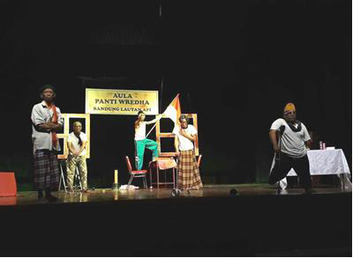Competition of National Inclusion Theater in Bandung won by Diffcom

Indicators of Success:
- The interaction, communication and education about people with disabilities and their interaction with the wider community resulted the existing stigma in the community has slowly begun to lessen.
- Butong and other people with disabilities in the area are no longer have difficulties in finding places to live. In addition, some independent small businesses in Panggungharjo Village have begun to open themselves to providing people with disabilities job opportunities.
- At full initiative, Panggungharjo Village Government has built accessibility facilities in village offices with the installation of a ramp, a guiding block, the provision of accessible toilet, and more importantly village programs that are integrated with other activities to fulfill the rights of people with disabilities.
- Through art activities (music and theater) outside of the Diffcom area, they have also introduced more understanding of disability issues to the wider community providing information about the abilities of people with disabilities, which has helped to lessen stigma.

What can be learned :
- Opening information and education through cultural activities about people with disabilities and members as part of the wider community is key to Diffcom success, as they are convinced that the stigma towards people with disabilities is attributable to lack of understanding about disability issues in the community.
- Building relationships in the community starting from sharing capacities was
also important to the success of the efforts. Diffcom used pawiyatan as a means to express information and communicate with the wider community, and through these activities the community became more familiar with the capacity or abilities possessed by persons with disabilities.

Testimony:
Village Head of PangungHarjo:
"People with disabilities are one of the components that exist in society who have the same rights to state services as others, but in many cases, they tend to close themselves off from social interaction with wider society. Diffcom, with its disabled and non-disabled community, initiates a concept of inclusion by opening a socialization space in the community, and through this displays their own capabilities. Diffcom has succeeded in changing the perspective of members of the community who previously considered the people with disabilities as objects, helping them to become the citizens who are equal to other citizens according to their capacity. "

Contact information good practice:
Butong Idar (Diffcom) Phone: 087739803432
Email: sbudid75@gmail.com

IMPLEMENTATION OF UNCRPD AND THE NATIONAL REGULATIONS PRIMARILY ASSOCIATED WITH THE FOLLOWING ARTICLES:

Good Practices and Articles in the Convention on the Rights of Persons with Disabilities (UNCRPD)
- Article 5, Equality and Non-discrimination
- Article 8, Awareness raising
- Article 9, Accessibility
- Article 19, Living Independently and Engaging in Society
- Article 21, Freedom of Expression and Argumentation, and Access to Information
- Article 27, Employment and Employment Opportunity
- Article 30, Participation in cultural life, recreation, leisure, and sports
In addition to the articles above, the story is also sufficiently related to the following UNCRPD articles:
- Article 3, General Principles
- Article 4, General Duties

Good Practices and Articles in Law. 8 year 2016
- Article 2, Principles of Implementation and the fulfillment of the rights of Persons with Disabilities
- Article 5, on the Rights of Persons with Disabilities (1)
- Article 23, Right to Live Independently and Engaged in Society
- Article 24, the Right to Express, Communicate, and Obtain Information
- Article 45, Employment, Entrepreneurship, and Cooperation
- Article 16, Rights of Culture and Tourism
- Article 87 of Culture and Tourism (1 & 2)
Good Practices and Articles in Regional Regulation of DIY Province Number 4 Year 2012 on the Protection and Fulfillment of the Rights of Persons with Disabilities
- CHAPTER I Article 2
About the basic principles of Province Regulation (PERDA) implementation
- CHAPTER II Protection and the Fulfillment of the Rights of Persons with Disabilities Part One
Article 4, Regarding the operation of each type and form of the fulfillment and protection of the rights of persons with disabilities
Article 29, (1 & 2) Equal opportunity in obtaining capital access to financial institutions and / or government-owned and private financial institutions for business development.
Article 68 Art, Culture and Sports
- CHAPTER III, Article 89 Accessibility

- CHAPTER IV, Article 94 Community Participation

Case Study 2

Good Practice: Building Inclusion Starts in the Village
Title | Building the Foundation of Inclusion with Sendangadi  Village Government
Location | Village Sendangadi District Mlati District Sleman District Special  Region of Yogyakarta
Scope | Participation in Development Planning
Writer | Dody Kurniawan Kaliri
Organization | Mlati Disability Organization (Organisasi Difabel Mlati (ODM)

Background:
Mlati is the name of one of the seventeen subdistricts in the Sleman District, Yogyakarta Special Region. Mlati sub-district is a densely populated area with many campuses and schools. Monetary Data Government Mlati Semester II 2014 recorded 85,507 people living in the region Mlati. In addition to campuses and school, many companies are based in the region.
There are five villages within the scope of Mlati sub-district: Sinduadi Village, Sendangadi, Tlogoadi, Sumberadi and Tirtoadi. There are a number of persons with disabilities included in the population of the Mlati sub-district. The village is the smallest geographic unit of governance in the Republic of Indonesia, and it is estimated that a large number of people with disabilities live in rural areas. The Mlati Difabel Organization (ODM) serves as a forum for people with disabilities in the Mlati sub-district, and they have recorded 668 individuals with disabilities living in the sub- district. The organization has been engaged in advocacy work to build equality, non- discrimination and inclusion for people with disabilities in Mlati.
In the period from 2010 to 2014, in addition to strengthening the organization and visiting the families of people with disabilities, the organization's board also
communicated with both the sub-district and village governments. ODM has made several achievements that are evident at the yearly Sub-district Development Planning Meeting (Musrenbangcam). In the 2016-2017 fiscal year, when the sub- district office was rebuilt a ramp was included on the east side of the building.
ODM managers have been working on planning and development strategies since 2013. They have observed that many citizens with disabilities in Mlati stay in the village.
In addition, people with disabilities in many villages are still marginalized. There is still stigma at the village level, including a prevalent beleif that disability occurs because the parents of the disabled individual have committed a sin.

Finally, the village government has not been involved disability development strategy in the village, so that the needs of the villagers' rights are often neglected. For example: The construction of buildings that will serve as village government offices do not provide facilities and infrastructure that facilitates the accessibility needs of disabled citizens. These are some of the main reasons that future ODM strategy should work to establish, build, and strengthen disability organizations at the village level

What is being done:
Starting in early 2014, some disabled villagers from Sendangadi Village in the Mlati sub-district accompanied the ODM board in a meeting to discuss what the future of the organization should look like. They participants agreed to create a Disabled Village Forum (FDDS) as well the FDDS management. Those members of ODM at the sub-district level who live in Sendangadi Village became part of the FDDS board. This was hoped to strengthen the presence of the disability organization in the area. Since these members already had experience in advocating for the interests of people with disabilities at the sub-district level, it made sense to shift them to the area of advocacy work at the village level. At the beginning of the formation of the FDDS, the priority targets were set out as follows:
- Sendangadi Village Disability Organization will obtain a Decree (SK) from the village government in Sendangadi.
- FDDS will be involved in the Sendangadi Village Musrenbangdes
- FDDS will obtain a budget for operational activities from the village government
Previously, the village government was not concerned with the needs of citizens with disabilities. This is based on a statement from one of the now retired village staff. He said that "the village has not yet been involved in disability issues in the village, because they feel kasian (pitied) if they have to come to the village office." People with disabilities have not been invited to attend the village development planning meetings at all. Given this situation, ODM considered a communication strategy where the village government should be at the fore of their efforts. To open the door to collaboration with the village government, ODM uses its experience in communicating through activities such as lobbying, discussion with sub-district / village equipment, building networks with other institutions to map village apparatus that is influential in disability policy making. In addition to the Village Chief, the Kasi Welfare Society (Kesra) of Sendangadi Village administration headed by Mr. Harjuno served as important partners in building communication. In Indonesian government at all levels, disability rights is still not a main task or function of the public welfare field. These three FDDS priorities are often discussed with the Head of the Village and Head of the Section for Community Welfare.

Indicators of success:
The decree for the Disabled Village Sendangadi Forum was published / legalized
in April of 2015, marking the recognition by the village government of what ODM had worked to communicate. This was good news for the 156 people with disabilities in Sendangadi Village (FDDS Data). The decree outlined two issues of importance fr the Sendangadi village government in relation to the presence of disability organizations.
First, the village government recognized that the disability organization in Sendangadi village is equal to other organizations or institutions in the village such as PKK, Karang Taruna, LPMD and others.
Second, there organization has a legal institutional status that is recognized by the village, so village government is required to allocate budget money to village disability organizations.
Decision Letter of Disabled Village Forum Sendangadi
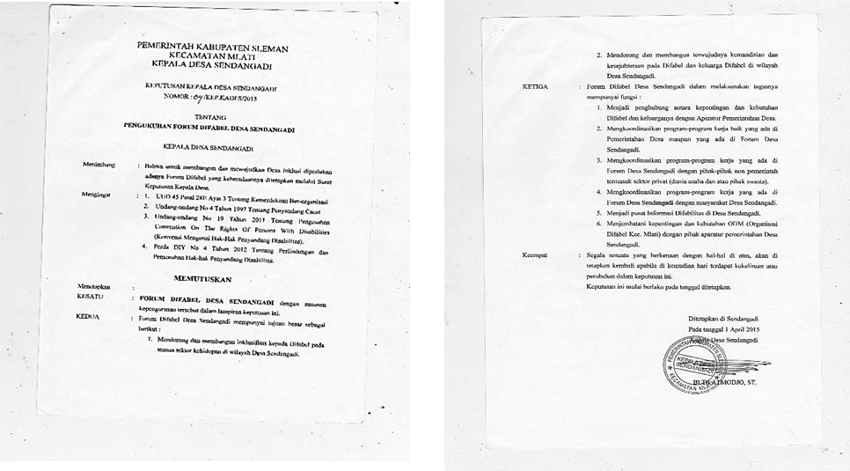

FDDS is invited to the Musrenbangdes in 2015
In December of 2015, people with disabilities of Sendangadi Village were invited to to attend the Sendangadi Village Development PLanning Meeting through their FDDS representatives. Development planning is a compulsory activity for all villages in Indonesia. This yearly meeting is attended by many stakeholders in the village, as well as by community groups such as Gapoktan (Gabungan Kelompok Tani), Village Consultative Bodies (BPD), Karang Taruna Desa, PKK Desa, Representatives of the District Government of Mlati also attend.
This experience was important in providing information about trainings held by the the village and by the sub-district governments, including information about their budgets. The meeting also provided information about the size of the budget 2016 budget and the locations slated for development. Each sub-government unit of the village (dukuh) also presented the proposed priority programs and activities to be implemented over the course of the next year.
(FDDS) took this opportunity to ask for time to speak and to propose two activities. The two activities proposed were sign language training for disabled individuals and their families, and physiotherapy training for families with children with cerebral palsy (CP).

FDDS gets budget allocation from Village Government in 2016
In 2016, the Sendangadi Village government was included in the budgeting for the Village Government Work Plan for 2016 (RKP). Meetings are held four times a month, and the monthly routine is a a priority of FDDS activities. This monthly forum serves as an avenue for communication between people with disabilities and the village government. In addition to people with disabilities from Sendangadi Village, these meetings are also attended by invited representatives from the village government, members of Babinsa (representatives of the TNI / Koramil in the village), Bhabinkamtibmas (Police / Police representatives in the village) and members of other institutions. Members of these groups are invtied in order to strengthen the Disabled Desa Sendangadi network.
The Bhaginkamtibmas Desa Sendangadi meeting frequently addresses environmental security issues, potential areas of crime and social problems, as well as legal protections for persons with disabilties. This is a positive change since , residents with disabilties previously rarely received this kind of information. Now the meeting is held at the Sendangadi village hall and has allowed more communication between the police and disabled members of the community.
Importantly, persons with disabilities who had never visited the village are now accustomed to coming to the village. They feel confident to express their needs

directly to the village government. Those persons with disabilities who are unable to attend the meetings in person can be represented by their parents or siblings.
In 2016, FDDS began to work with the SIGAB Institute for the Village Initiation Pilot Program in Sendangadi. The Sasana Integration and Advocacy for the Disabled (SIGAB) is one of the institutions in the Special Region of Yogyakarta that concentrates on the struggle for the fulfillment of disability rights. In collaboration with the Indonesian Ministry of Community Empowerment (PMK) and The Asian Foundation (TAF) in 2016, FDDS was chosen to run the Village Inclusion Program Pioneer (RINDI in Bahasa Rintisan Desa Inklusi). This program is included in one of the pillars of the FMD ministry's major program called PEDULI. There are eight villages in Sleman and Kulonprogo which are currently implementing the RINDI program, including Sendangadi village. To ensure the program runs well in this location, both people with disabilities and those without were chosen as Village Facilitators and Village Cadres.
The achievements of the Village Inclusion Program Pioneer (RINDI) are:
  - District and Village Governments understand and support the Inclusive Village program.
  - People with disabilities are able to speak up and be directly involved in policy making in the village and the wider community (the inclusion of people with disabilities in the Musrenbangdes is one example of this).
  - Village government and village communities have a positive understanding of people with disabilities and can blend together, get together, work together and help each other without any discrimination.
  - The village government is able to carry out village development that recognizes and considers the needs of people with disabilities.
  - The successful example of the Village Rintisan Inclusion program is a model for other villages, at least for the neighboring villages around Sendangadi.
Many of the organizational activities have made significant achievements related to these five points. Some of the strategic successes of the RINDI program activities are as follows:
- Strengthening the organization through organizational management training.
- Strengthening skills for people with disabilities through training on planting by the Polybags Method.
- Community learning that includes people with disabilities, village authorities and
other citizens regarding reproductive education, learning together about accessibility, and learning pro-disability budgeting.
- Discussions on establishing Inclusive Villages.
- Learning to manage the Village Information System.

The Village Initiation Pilot Program in Sendangadi Village ended in 2016. Of course there were many challenges that were faced for sake of building and strengthening the breadth of the Sendangadi Village Inclusion program over the course of sixteen months.There are a number of good practices from past RINDI program implementation that contributed to strengthening inclusion in the village. The successful practices that should be highlighted are:
- Sendangadi Village has now built a ramp (facilities for physical accessibility) to the Village's Public Service Room. In the future, it is hoped that this will be followed by accessible toilet facilities and information services.
- The Forum for Inclusive Education Sendangadi Village. The forum was originally intended to establish communication between education implementers (SD, SMP, SLB) in Sendangadi Village, the Disabled Village Sendangadi Organization, and the Sendangadi Village Government. Departing from the concern that the concept of "educational inclusion" was not fully realized, the assumption was that if people with disabilities want attend an inclusion school (a school that already has an SK from the Board of Education to implement Inclusive Education). In Sendangadi there are seven elementary schools, one junior high school, and and some kindergarten and early childhood educational institutions that possess an SK for implementing inclusive education. In theory, however, all schools should be obliged to implement inclusive education and accept students with disabilities. To address this issue, the Forum holds meetings once every two months to learn about disability issues, discuss interaction with people with disabilities, and to review and learn about how to build inclusive educational systems in our respective schools.
- Implementation of the Village Information System (a shortened from Sistem Informasi Desa or SID). The Village Law No. 6 of 2014 has become a force in encouraging the transparent transmission of information. SID is a kind of Interactive online service that not only presents news but also population data. SID can be accessed by all citizens with access to the internet. Some of the benefits of the SID service is access to information about news and activities in the village or community. The correspondence system in the village is made easier by access to SID, including the availability of population data, including data on people with disabiltiies in the village. The remaining challenge is that there are still many people who do not about the existence of SID, so that the contribution of the community to providing news and data is minimal, however, SID can be one method of strengthening village inclusion through social media movements. Inclusion Movement in the Village can greatly benefit from the use of the media Village Information System (SID). The large number of news stories about inclusion in the village, for example, can help to spread knowledge and encourage participation in inclusion efforts.

What can be learned:
What we have learned from the good practices outlined above:
- Mapping the situation, including potential and existing problems is essential to success. Mapping has helped ODM to focus on which level of advocacy is provides the most strategic advantage (in this case, the village level). In addition, ODM is able to formulate a clear strategy and steps for advocacy steps using existing potential. Most people with disabilities live in villages, and the the stigma and outlook of village communities is a majo factor that must be addressed in improving the implentation of rights of people with disabilities.
- Mapping of ODM internal potential strongly supports advocacy. Identifying and applying successful advocacy practices that were used at the sub-district level the potential of networks already established can be applied to work at the village level.
- Implementing successful advocacy practices through lobbying and related stakeholder approaches strongly supports village-level changes.
- Mapping of key village figures becomes a means of connection and communication with other relevant stakeholders.
- Working within the current governance culture and encouraging relevant stakeholders to accept new issues cooperatively. Keeping Kesra involved as one of the partners in project implementation makes the village government more amenable to accepting ODM concepts and targets cooperatively and maturely.

Good Practice Information contact:
Dodi Kaliri (ODM) Telp: 0856 – 2888- 593
Email: kalirisleman@gmail.com

TESTIMONY:
Kaur Kesra Desa Sendangadi (Mr. Harjuno) stated that the involvement of people with disabilities in the development planning process at the village level will be beneficial for the village because the village will know more about people with disabilities real issues.

IMPLEMENTATION OF UNCRPD AND THE NATIONAL REGULATIONS PRIMARILY ASSOCIATED WITH THE FOLLOWING ARTICLES:

Good Practices and Articles in the Convention on the Rights of Persons with Disabilities (UNCRPD)
Article 5, Equality and Non-discrimination Article 8, Awareness-raising
Article 9, Accessibility
Article 19, Live Independently and Engaged in Society
Article 21, Freedom of Expression and Opinion, and Access to Information Article 24, Education
Article 25, Health
Article 26, Habilitation and Rehabilitation
Article 27, Employment and Employment Opportunity Article 31, Statistics and Data Collection
In addition to the above articles, the story is also sufficiently related to the following UNCRPD articles:
Article 3, General Principles Article 4, General Duties

Good Practices and Articles in Law No. 8 of 2016
Article 2, Principles of Implementation and the fulfillment of the rights of Persons with Disabilities
Article 5, on the rights of Persons with Disabilities (1)
Article 23, the Right to Live Independently and Engaged in Society Article 24, the Right to Express, Communicate, and Obtain Information Article 40, Education
Article 45, Employment, Entrepreneurship, and Cooperation Article 90, Social welfare
Article 110, Habilitation and Rehabilitation Article 117, Data Collection

Good Practices and Article in Regional Regulation of DIY Province Number 4 Year 2012 on the Protection and Fulfillment of the Rights of Persons with Disabilities
CHAPTER I Article 2
Concerning the basic principles of Province Regulation (PERDA) implementation CHAPTER II (Protection and Fulfillment of the Rights of Persons with Disabilities) Part One
Article 4, Regarding the operation of each type and form of the fulfillment and protection of the rights of persons with disabilities
Article 5, on education

Employment Article 16, Every Persons with Disabilities have equal rights and opportunities to find employment and / or do decent work
Article 43, Quality Service Efforts in accordance with the conditions and needs of persons with disabilities that require
Article 46 a, b, c
- dissemination of information about disability;
- dissemination of information on disability prevention; and
- counseling about early detection of disability.
Article 48 (2) Health and medical services referred to in paragraph (1) can be done through home care, and mobile health centers conducted by designated health personnel in their working area.
Article 51, Health Service Facilities Article 55, Health Insurance CHAPTER III Article 89, Accessibility
CHAPTER IV Article 94, Community Participation
CHAPTER V Mainstreaming of Persons with Disabilities Article 95,
On socialization and data collection of Persons with Disabilities and mainstreaming in development.

Case study 3

Good Practice: WKCP Health Initiative for Health Budgeting Advocacy
Title | Screening TORCH
Location | Yogyakarta Municipality, Yogyakarta Special Province
Scope | Participation in Development Planning
Writer | Purwanto  E. Dewi Kurniawati
Organization | Volunteer/ MiW Committee

Background
WKCP (Cerebral Palsy Family Association) is an organization that serves as a forum for parents with children cerebral palsy and cerebral palsy (CP) researcher. WKCP aims to provide education and assistance to parents of children with CP, as well as perform various activities to promote the independence of children with cerebral palsy to obtain their rights, focusing in advocacy and preventive sector. One of the routine activities the organization holds is a discussion of the relationship between disability and health issues. In 2012, WKCP discussed the relationship between TORCH and disability. From various routine discussions held by WKCP, the forum provided information about the hypothesis that TORCH viral infections (Toksoplasma, Rubela, Cytomegalovirus / CMV and Herpes) during pregnancy can cause infants to be born at high risk for disability, especially cerebral palsy. This hypothesis was reinforced by the results of discussions with WKCP advisor Prof. Nartini and with information from some parents of children with cerebral palsy about the TORCH viral infections during their pregnancies.
In 2013, with the support of small grants from Handicapped International, WKCP conducted a survey of 120 respondents who are parents of children with disabilities, specifically parents of children with cerebral palsy. This survey aims to reinforce the initial hypothesis of the correlation of TORCH viral infections with children born with disabilities. The results of this survey were used as a media tool for advocacy to encourage policy for educational funding to study the effect of TORCH viral infections in pregnancy. The result was surprising: of the 116 surveys completed, 48 respondents stated that during their pregnancy they had asked the doctor to do the lab test for TORCH, and 40 of them tested positive for TORCH viral infections.
Looking at the findings of the simple survey, WKCP is increasingly convinced of the relevance of TORCH viral infections during pregnancy to the number of children born with disabilities. WKCP feels TORCH is a time bomb that will soon explode if not immediately anticipated by all parties, becuase it represents one cause of the high birth rate of children with disabilities.

What is being done:
Post-survey, WKCP conducted a series of workshops and held audiences with the Yogyakarta Special District Health Office to present their survey results and the need to educate the public about TORCH and disability. The WKCP presented this as a cross-cutting issue, and the Health Office noted that the presentation of the results of this survey was also important for other agencies related to this issue. Facilitated by the Yogyakarta Special Secretary, WKCP was given the opportunity to make presentations in front of the Department of Education, the Department of Social Services, Bapedda, and Gadjah Mada University Academic Hospital. WKCP also utilizes advocacy channels through legislation by attending hearings at one of the factions of DPRD I Yogyakarta. On that occasion, WKCP presented the results of their survey.
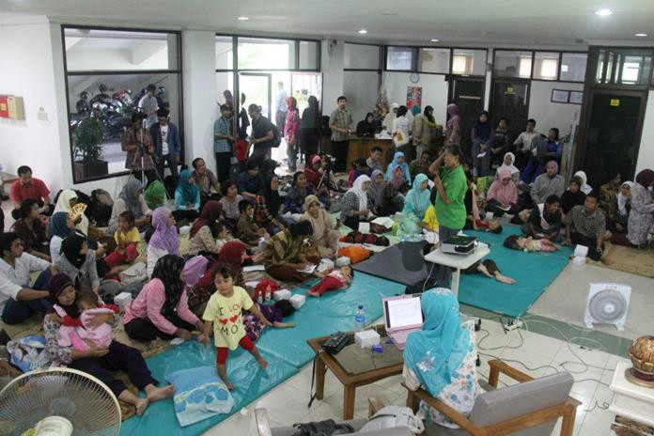In addition to formal activities with related institutions, WKCP also built informal mechanisms with key personalities of individual agencies. WKCP actively approaches informal discussions with key figures and competent experts in health. These relationships have facilitated the process of sharing information and discussion. As a result of these efforts, WKCP requested Prof. Nartini to become a WKCP advisor, which has also been very influential in the advocacy work being done by WKCP.
One of the WKCP activities involving expert physiotherapists

Indicator of success:
- Open communication was the foundation for sharing perspectives between WKCP and the Health Office about the link between TORCH and disability. TORCH and disability have become a familiar issues in medical circles. However,

the Health Office does not have enough information from the field to reinforce their hypothesis about TORCH and disability. Through an audience with the Health Office, the DHO met with experts like Prof. Nartini, related SKPD, as well as an organization capable of providing an overview of the situation in the field. The results of this audience were used by the DHO as the basis to request a budget be allocated for academic studies of TORCH viral infections and disability.
- A party closely related to funding in this case is Bapeljamkesos (social welfare services agency specifically in Yogyakarta). Therefore, an examination of TORCH was implemented through Bapeljamkesos. This academic study was conducted through a preliminary survey with 140 samples. The results of the survey demonstrated that the prevalence of babies born with disability from parents infected with TORCH viruses was high enough that the Bapeljamkesos decided to reassess the data with a study using 500 samples of individuals screened for TORCH. Screening for TORCH is done with respondents who are evenly distributed in special areas of Yogyakarta as an action to anticipate pregnancies with a higher risk for producing infants with disabilities. In 2017, Bapeljamkesos increased the number of TORCH screening tests to 1000 respondents across the Special Region of Yogyakarta. This process shows the succes of WKCP has successfully advocated advocacy efforts for the improvement of policies aimed at addressing disability risks in early pregnancy.

Changes accomplished:
- The issue of disability prevention was included in the government work plan through programs at the Health Department and Bapeljamkesos.
- The budget allocation for TORCH auditing increased.
- The Health Office started providing education to TORCH examiners.

What can be learned:
  - Building networks with experts in the field in question, in this case Prof.
Election Nartini had a remarkable effect research or academic activities in accordance that supported WKCP advocacy goals.
  - Using surveys to support advocacy goals is likely to be more interesting and more understandable to policy making bodies and government institutions compared with other methods.
  - Persistence in the advocacy process is essential. WKCP implemented many activities ranging from workshops, presentations and hearings, as these are avenues to formal relations that are useful in policy advocacy work.

Good Practice Information Contact:
Anis Sri Lestari Telp: 08175459689
Email: anis_pks@yahoo.com

TESTIMONY:
Dr. Etty Kumolowati (Head of the Health Service Division of DHO DIY 2011-2016, who in 2013 was involved in initial initiation of TORCH screening) stated that "WKCP encourages the Health Office to do TORCH screenings, which will be very important for reducing the risk of pregnancy with children with disabilities."
Setyarini Hestu Lestari (Section Head of Disease Control): when WKCP encouraged TORCH examination, she was the acting Head of Health and Referral Health Section (2011- 2015) stated that "Without information and collaboration with WKCP, Dinkes did not know what was happening on the ground. The public was aware of TORCH infection and its impact on the birth of babies with disabilities, and the need for TORCH examination of those planning for pregnancy. Dinkes was already aware of thes relation of TORCH infections to risk of disability in early pregnancy. It was through the interaction of WKCP and Dinkes, including meeting with experts like Prof. Nartini that helped with the development of the related SKPD. From this basis, the health office has a reasong for requesting a budget to know what is happening on the ground.
At that time, data from members of WKCP was too narrow, so we tried to find data from a broader sector of society. It was not an easy process as we have to guide our research with simple questions, such as whether respondents have relatives neighbors with similar characteristics. Socialization of this issue should be more vigorous.
WKCP should actively collaborate with the government because the government can access Bapeljamkes financing. It would be better if WKCP and Bapeljamkes partnered up to follow up on the examination with education for those infected with TORCH, and more extensively for those who are planning to get pregnant. Thus the birth of babies with disabilities can be prevented and of course this will reduce the number of vulnerable groups.

IMPLEMENTATION OF UNCRPD AND THE NATIONAL REGULATIONS PRIMARILY ASSOCIATED WITH THE FOLLOWING ARTICLES:

Good Practices and Articles in the International Convention on the Rights of Persons with Disabilities (UNCRPD)
Article 5, Equality and Non-discrimination Article 7, Children with disabilities
Article 8, Awareness raising
Article 25, Health

Article 29, Participation in political and public life Article 31, Statistics and data collection
In addition to the above articles, the story is also sufficiently related to the following UNCRPD articles:
Article 3, General Principles Article 4, General Duties
Good Practices and Articles in Law No. 8 of 2016
Article 2, Principles of Implementation and the fulfillment of the rights of Persons with Disabilities
Article 5, on the rights of Persons with Disabilities (1) Article 12, Right to Health
Article 19, Right of Public Service
Article 22, Rights of Data for Persons with Disabilities Article 117, Data Collection
Good Practices and Articles in Regional Regulation of DIY Province Number 4 Year 2012 on the Protection and Fulfillment of the Rights of Persons with Disabilities
CHAPTER I Article 2
Concerning the basic principles of PERDA implementation
CHAPTER II Protection and the Fulfillment of the Rights of Persons with Disabilities Part One
Article 3, Regarding the operation of each type and form of the fulfillment and protection of the rights of persons with disabilities
Article 41, Every Person with Disabilities is entitled to receive quality health services
in accordance with the conditions and needs of individuals with disabilities.
Article 43, Quality Service Efforts in accordance with the conditions and needs of persons with disabilities that require
Article 45, Health Service Efforts as referred to in Article 43 include:
- promotive;
- preventive;
- curative; and
- rehabilitative.
Article 46 a, b, c
dissemination of information about disability; dissemination of information on disability prevention; and counseling about early detection of disability.
Article 51, Health Service Facilities Article 55, Health Insurance
CHAPTER IV, Article 94 Community Participation

CHAPTER V Mainstreaming of Persons with Disabilities Article 95 On socialization and data collection of persons with disabilities and mainstreaming in the development

Case Study 4
Title | MATA AIR LEARNING GROUP EFFORTS IN PROMOTING  VILLAGE STAFF IN FULFILLMENT OF DISABILITY RIGHTS
Location | Mata Air, Sub District. Kupang Tengah- Kupang District – NTT
Scope | Participation
Writer | Matius Indarto
Organization | Volunteer / MIW Committee

Good practice : Citizen Based Forum as a Common Space to Encourage the Government to Build a Disability-Friendly Village in Mata Air Village, Kupang Tengah Sub- district, Kupang District

Background
Mata Air Village (Desa Mata Air) is one of the villages in Kecamatan Kupang Tengah, Kabupaten Kupang, East Nusa Tenggara. This village has a population of 5345 people including 2,662 women and 2,683 men. Mata Air Village does not have any officially recorded data on people with disabilities. However, we do know that most people with disabilities in Desa Mata Air are from families with lower economic status. This makes people with disabilities more vulnerable, both in terms of fulfillment of the right to economy, as well as the rights to education, politics, and health.
Mata Air Village has only recently begun to address public participation in development planning, especially related to the issue of people with disabilities. The needs of people with disabilities have not been considered or been seen as a priority in development planning. Attention to people with disabilities emerged around 2015 through the encouragement of several forums of that were created by the initiative of the villagers, village government, and non-governmental organizations that were working on other issues in Mata Air Village.

What is being done
The emergence of policies on disability at the village level cannot be separated from the involvement of citizen-based forums. One of the forums that encouraged changes in Mata Air Village is the Water Learning Group (KBMA) initiated by Mama Desi, assisted by Dian Anakaka (psychologist). KBMA was established in November 2015 as part of the follow-up activities that Handicap International introduced at the conclusion of their program of inclusive education 2014. At that time, the new inclusive education program was limited to performing parenting skills. From this activity, it seemed from the participants' awareness and expectations that it was important to think about the sustainability of these activities. Participants felt it was unfortunate that the already-growing forum would halted along with the end of the project from Handicap International (HI) in 2017.
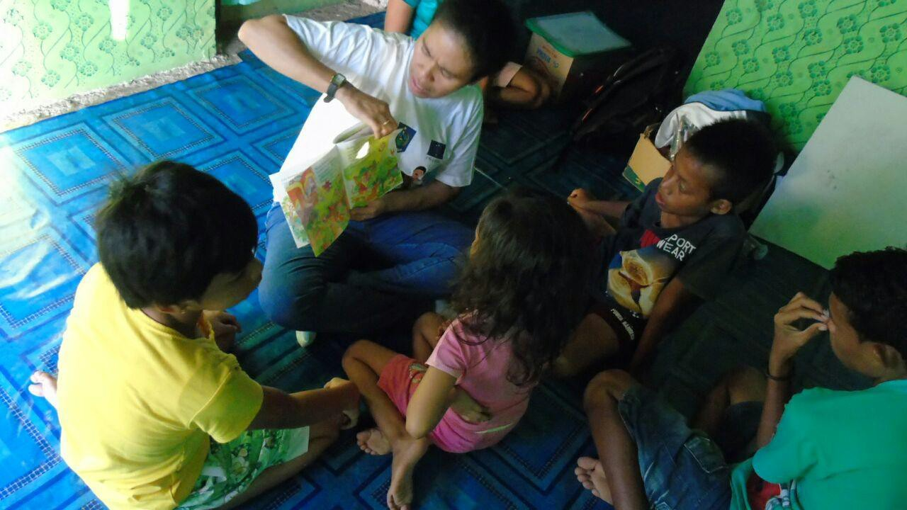This concern is quite reasonable given that there weren't yet any providers in Kabupaten Kupang who covered training for parents of children with disabilities. At first, KBMA activities were still very fluid. New activities were limited to meetings to identify needs. One of the member's strategies involves Persani and his volunteers and the Kupang Family Communication Forum (FKKADK) to help strengthen the capacities of the forum members, especially on issues of disability and organization. At that time, some students from Cendana University also participated in the process of developing and strengthening members of KBMA. Financing was still undertaken by the forum who shared responsibility by dividing roles. Persani became a resource, and learning forums provided space. Students at UNDANA helped in terms of logistics such as stationery
Photos of a learning Group Mata Air's Activities.
Learning forum activities didn't only focus on capacity building, but also began to collect data on people with disabilities in Mata Air Village. People with disabilities were divided into two categories, namely those of productive age and children. From the data gathered, there were 12 people with disabilities of productive age and 14 children with disabilities. The data were also disaggregated by sex (14 women and 12 males) and their types of disabilities.
The data was then verified to be re-mapped. One interesting thing discovered in Mata Air Village is the vulnerability of people with disabilities is not considered from the perspective of the economic status of their families. This means that although persons with disabilities are from middle-and upper-income families - who it assumed benefit from access to information - it does not necessarily guarantee the fulfillment of the rights of persons with disabilities. In fact, there are some people with disabilities who come from families that are capable, but they are still not able to accept the conditions experienced by their children and automatically close off the possibility of their children getting access to education.
Another challenge that also arose during the data collection was the high level of the resistance of families with disabilities. This resistance arises because they are often visited by both social and government institutions, who come to register and promise assistance. As time went by, help did not come. This is where Mama Desi and the members of the forum needed to work hard to convince these families with a personal approach. The approach used was to go from house to house to talk privately with parents of children with disabilities.
As time went by, the activities undertaken by KBMA gained appreciation with local families and also with the village government. Initially, the village government still closed their eyes to the needs of persons with disability, but slowly they became more open. This is attributable to the work that was built by Mama Desi and the group study she built together with local citizens.

What works
Since the Village Development Planning meeting in 2016, the needs of people with disabilities gradually began to be considered. Previously, the needs of persons with disabilities were not included in the development priorities at all. Even the involvement of persons with disabilities was not accommodated in any part of the planning process. Furthermore, persons with disabilities were not recorded and were forgotten. This was highlighted by a speech in some communities attending the
meeting who says that it is not right to fight for the interest of only one or two persons.
In the 2016 planning meeting, for the first time, persons with disabilities participated from the first time through a joint learning forum. At that time, Mama Desi was there to represent people with disabilities from Mata Air Village. The issue of disability is of course still new to most of the meeting participants. If not supported by the majority, then the needs of people with disabilities will not be included in development priorities. At that time, Mama Desi built relationships with some of the representatives from the hamlets in Mata Air Village who wanted to voice the needs of people with disabilities. This garnered a positive response from the residents' representatives. As the meeting progressed, they actively promoted the needs of persons with disabilities to be included in village development plans.
The struggle paid off as their proposal was accepted for inclusion in one of the village development plans. This meant that when the proposal was accepted, there would be consequences for the budget allocated to people with disabilities. In 2016, the village government allocated a budget of five million rupiah to support joint forum learning activities. Initially, the funding support was to be taken from the PKK (Women organization) post fund, but eventually it was taken from the allocation of the budget from over budget calculation (SiLPA). This funding support is then maximized to support the strengthening and sustainability of forum activities.
Ahead of the 2017 planning meeting, Mama Desi prepared some people with disabilities to be involved in the development planning process. The capacity of people with disabilities is also supported by Persani as an organization of people with disabilities. There is one village forum which contains not only disability groups, but also other vulnerable groups facilitated by Bengkel APPeK that urged the village government to pay attention to the needs of vulnerable groups.
At the 2017 meeting, there were four people representing people with disabilities involved, including two persons with disabilities (one female and one male) and two parents with disabilities. Persons with disabilities then used the disability forums as a space for advocacy. The results of advocacy at the village level then paid off. The village allocated 15 million rupiah for the sustainability of the learning forum. The funds will be allocated to help support facilities and infrastructure for the learning activities.
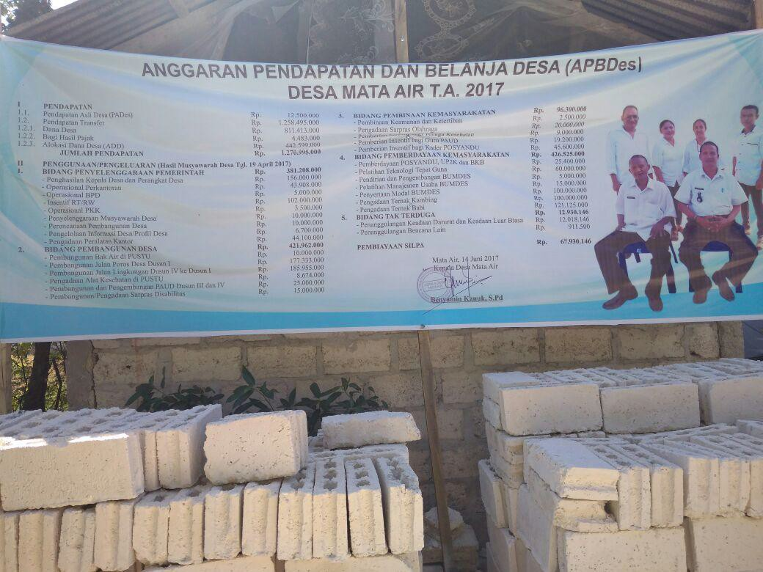Photo Banner Information APDes Mata Air installed in front of village office

What can be learned
The changes that have occurred in Mata Air Village began with a long process. Although initially these community-based forums were started through non- governmental organizations that happened to work in Mata Air Village, or were part of the impact of the implementation of a project, the issue of project sustainability meant that the movement did not necessarily stop at the project level. The spirit and initiative of people with disabilities, families of persons with disabilities, and support forums of persons with disabilities continued to work collectively and are still very strongly available and despite no funding from the project.
This becomes a lesson of encouragement to continue movements that have been formed through short-term projects. It is also necessary to think of the synergy of movements built with efforts that are being carried out by the local government.
The commitment of the village government to pay attention to and to fulfill the rights of people with disabilities is also one of the key factors. Strong commitment must also be accompanied by a strong capacity and the awareness of policy makers, especially in regards to inclusive development issues. Village budget allocation certainly cannot be separated from the process of communicating at the district level. So far, the capacity of the Mata Air Village apparatus has increased, especially in fulfilling the rights of people with disabilities and vulnerable groups. A good example is the detailed disaggregation of persons with disabilities. Data collection has been initiated by KBMA and disaggregated by age, gender, different disabilities, needs and potential. This data is very useful for both people with disabilities and government organizations in helping to empower disability groups.

Contact Information Good Practices
Matius Indarto 081291557233

Testimonials
"My mission and vision is clear ... in my five core programs, I have included attention towards disabled people and other marginalized groups ... as a manifestation of that mission and vision in 2016, I allocated funds for the establishment of a disability forum. In the following year, I allocated more budget money for the development of the group's activities."
"I agree and I accept very well the existence of these forums (on disability). First, the presence of these forums can gather (people with disabilities) together in a forum where they can tell stories, can vent, can convey their aspirations. The second important thing is that through this forum their aspirations can be delivered ... from the deliberation of the village we always present representatives of these forums .. "
Benyamin Kanuk, Village Head of Mata Air

IMPLEMENTATION OF UNCRPD AND THE NATIONAL REGULATIONS PRIMARILY ASSOCIATED WITH THE FOLLOWING ARTICLES:

Good Practices and Articles in the International Convention on the Rights of Persons with Disabilities (UNCRPD)
Article 5, Equality and Non-discrimination Article 8, Awareness raising
Article 9, Accessibility
Article 19, Live Independently and Engaged in Society
Article 21, Freedom of Expression and Opinion, and Access to Information Article 24, Education
Article 26, Habilitation (Habilitation) and Rehabilitation Article 29, Participation in Political and Public Life Article 31, Statistics and data collection
In addition to the above few chapters the story is also sufficiently related to the following UNCRPD articles:
Article 3, General Principles Article 4, General Duties

Good Practices and Articles in Law No. 8 of 2016
Article 2, Principles of Implementation and the fulfillment of the rights of Persons with Disabilities
Article 5, on the rights of Persons with Disabilities (1)
Article 23, the Right to Live Independently and Engaged in Society

Article 24, the Right to Express, Communicate, and Obtain Information Article 40, Education
Article 90, Social welfare
Article 110, Habilitation and Rehabilitation Article 117, Data Collection

Case Study 5

Good Practice: Inclusion of Disabled Persons in Noelbaki Village Women's Forum
Title | Women's Participation in Policy Making in Noelbaki Village
Location | Noelbaki, Sub District. Kupang Tengah- Kupang District– NTT
Scope | Policy
Writer | NOPRIANA HIDA BUNGA
Organization | Volunteer / MiW Committee

Background
In some places, women are still regarded as objects that function everyday as a housekeepers. Women are bound by the ties of customs, traditions, and mindsets that always assume women are just housewives who take care of households, take care of cattle, and even have to go down to the fields to help their husbands.
While women are burdened with many duties and responsibilities related to "taking care of the house," the role of decision-making is not enjoyed by many women. Similarly, in the village of Noelbaki, women have long been involved in several kinds of deliberations fron the hamlet level to the village level. However, their involvement is just at the level of deliberation, leaving them unable to fully apply their rights.
The village of Noelbaki is located in the Central Kupang sub-district, Kupang Regency of East Nusa Tenggara Province, east of Tanah Merah and Oelpuah Village, West of Mata Air village, in the northern part of Kupang bay, and the southern part of Oelnasi Village and the Village of Oelpuah. Noelbaki has a very large population density in Kabupaten Kupang with a total of 2,995 families consisting of 4476 men & 4209 women. Most of the people in Noelbacki have jobs as agricultural laborers, stone harvesters, motorcycle taxi drivers and the like.

What is being done :
In 2011, Mrs. Martha Keuwuan pioneered a women's group in Noelbaki village. She began the process by forming a women's group at the sub-village level in an effort to raise awareness of women's rights. Departing from the idea that there was an increased need for women's participation, "Mama" Martha began to form women's groups. As the process progressed, these women's groups were well received by the village PKK team, the women group is recognized and invited to meeting with PKK.
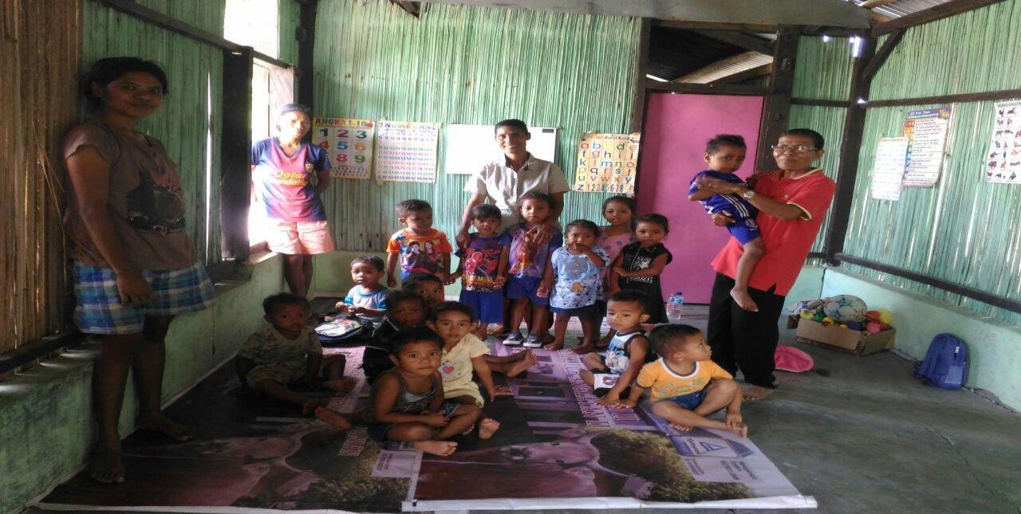
Photo of Mama Marta (red shirt) doing activities with a PAUD group in Noelba
One of the women's groups in Noelbaki is the "DAMAI" Farmers Women Group. This group became a forerunner of the emergence of a Village Policy (Peraturan Desa)
in Noelbaki village. There was also a women's charity group, the LAISMANEKAT Women's Group, the Women's Forum for Village Development, and a study group called Citra Kasih.
These groups worked to strenghten women's participation in all kinds of development processes. Capacity building for these women focused on increasing women's participation rights in the development process. Motivating women to implement their rights development processes and declaring that women have equal rights at all levels of village development helped to encourage local participation . One of the major obstacles for these efforts is the assumption that women are only needed to complement the process and do not need to be actively involved.
The women's struggle in Noelbaki village received a positive response from village government officials and the BPD in 2016 by issuing a Village Rule that governs the involvement of 30% of women's participation in the planning, implementation, monitoring and evaluation of village development.
Village government officials also feel that women are very reliable partners in all development processes in the village. Melchizedek Keubana, Village Head of Noelbaki, says women are a good driving force. These ideas were the basis of the village government's establishment of a team consisting of village government officials, BPD, and women's representatives. Then the team began to work and accommodate the aspirations of the community from hamlet level to village level.

A local NGO called Alfa Omega, an NGO that has been in the village of Noelbaki for twenty years was joined in 2015 by NGO Benggkel Appek that provided mentoring activities as well as providing capacity building and awareness of the importance of women's role in development planning so as to strengthen the women's struggle in Noelbaki village.
After the Appek Workshop provided training and capacity building for women, a forum called NEKAF Forum was composed of women from vulnerable groups and persons with disabilities. The NEKAF Forum later became the representative of women's groups and persons with disabilities in the village of Noelbaki in all development processes.
Law no. 6 2014 was central to the women's groups in Noelbaki fighting for their aspirations. Women's groups struggled for place in village development planning and to get support from the village head, the head of BPD, and the community. On the basis of a notion of "ENTIRELY INDEPENDENTLY OWNED", a "Team 11" was created consisting of elements of village government, the BPD chairman, and women's representatives. Through their hard work and with government support, the PERDES No.09 / DNK / VIII / 2016, PERFORMANCE OF WOMEN'S PARTICIPATION 30% IN PLANNING, IMPLEMENTATION, MONITORING AND
EVALUATION OF VILLAGE DEVELOPMENT was published on on 31 August 2016. This policy helped urge women to participate in all aspects of the development planning process because they feel that women also have the same rights as everyone else. This Perdes only applied in Kupang and NTT.

What works :
Following the Perdes, the women's forum became the representative of women's groups in all aspects of the development planning process in Noelbaki Village. Their aspirations and needs are welcome in the 2016 village consultation process (Musrenbang), and this has encouraged governments to allocate budgets for women and persons with disabilities. Implementation of the published Perdes means that if the presence of women has not reached 30% for planning meetings then the deliberation is CANCELED. Women's groups that previously existed joined the NEKAF Forum, including those with disabilities.
From the economic sector, women in Noelbaki Village began to empower themselves in helping the family economy. If previously a woman was just helping her husband work in the fields, now she may have started to grow her own crops. In the household industry sector there is already a group of women who make sticks based from sorghum, and this is impactful to their economic status.
The NEKAF Forum also encourages village governments to assist with the economic needs of of disability groups. For the year 2017, the budget has been set in the

APBDES through the Village Fund of Rp 100,000,000 (one hundred million rupiahs) earmarked for vulnerable groups including disabled persons, for use in livestock business development activities.
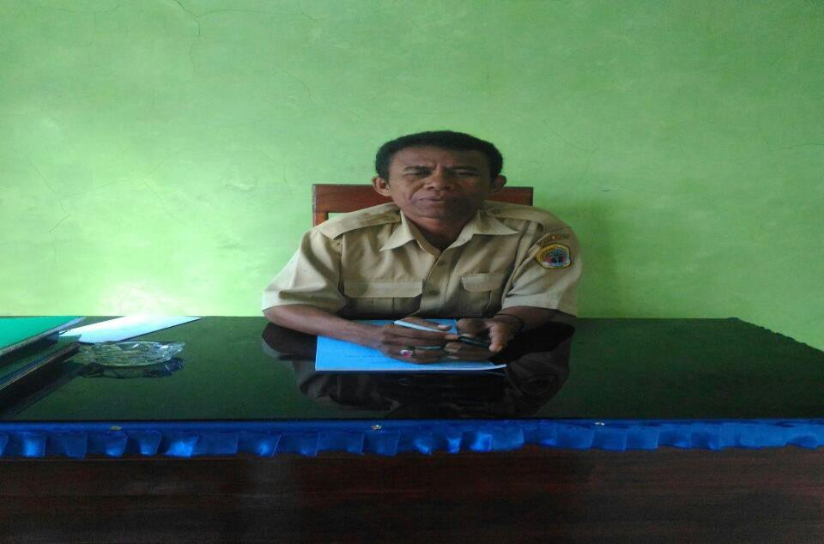The Noelbaki Village Head Mr. Melchizedek Keubana asserts that for 2017, this allocation of village funds is set out in the Noelbaki APBDES, not only for women's groups but also for persons with disabilities.
Photo of Mr Melchizedek Keubana, Village Chief Noelbaki
The existence of the Village Rule on Women, as well as the village budget for women's groups, not only for the benefits women's groups but also has an impact on other vulnerable groups. The women's group in the village of Noelbaki feel much change, and their growing ability to be more economically independent has already made an impact.

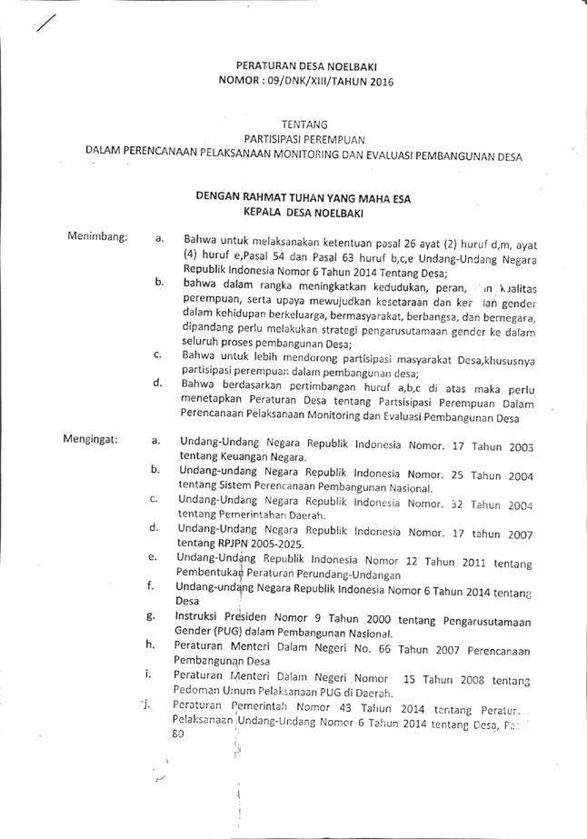Photo of Noelbaki Village Regulation on Women's Participation
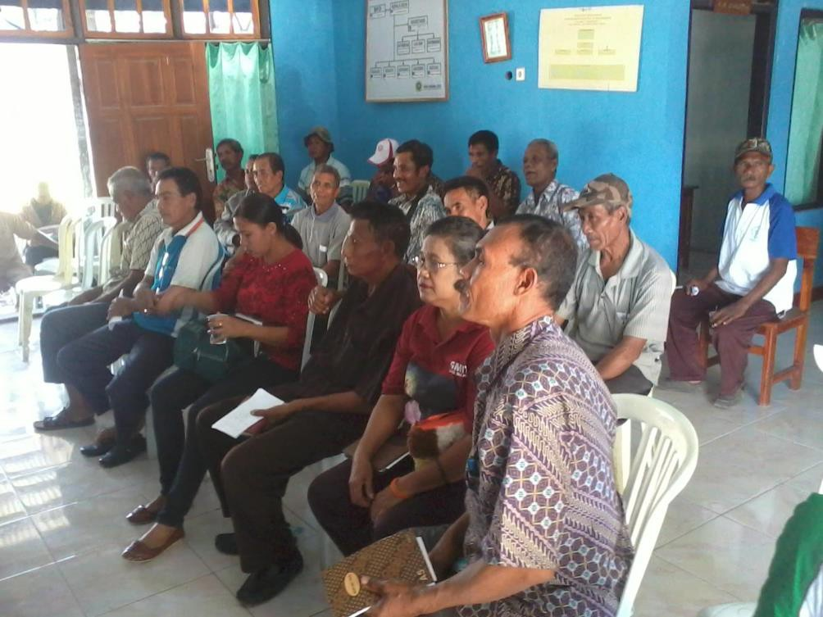
Photograph of the meeting for the Act of Noelbaki Village Regulation on Participation of Women

After the issuance of village regulations, various positive impacts on women's lives were seen through the development of women's forums. These forums are active in all village planning and development processes. This is an important record and a beautiful moment in history for women in the village of Noelbaki - where they have championed their rights as women who have also enjoyed the meaning of true INDEPENDENCE.

What can be learned
Changing ways of thinking, and changing access to economic independence in the family is an important lesson for from the Noelbaki community case. Starting from the struggle of women, a simple mindset that appreciates their existence and rasies awareness of their abilities is part of the process. The many processes that provide valuable learning opportunities to demonstrate that women are actually part of an independent nation, and that women are able to be responsible. Women are able to do things that are useful for the surrounding community. To start a goodwill for the masses, budget is not an issue. Good initiative and participation can strengthen togetherness.
A very helpful and supportive government apparatus becomes a force in continuing to run a uniform policy. This policy will become stronger when applied in tandem with the budget allocated to vulnerable groups of people from the village level to the district level.
Collecting data on the number of vulnerable groups, the number of people with various vulnerabilities and various disabilities is essential. Documenting the variety of vulnerabilities becomes a necessity in an advocacy process for the fulfillment of the rights of these vulnerable groups.

Contact Information Good Practices
Nopriana Hida Bunga
+62 821-4456-0894

Testimonials
"I am proud of and strongly support the existence of the women's forum in Noelbaki village, which is very helpful to the government in the development sector and economy."

Melchizedek Keubana, Village Chief Noelbaki

"Women's initiative is very good because they took the initiative in proposing musyawara from the village level .... Women in Noelbaki experienced a change where initially they were only positioned as assistants to their husbands. After their forum came into existence they became independent in many ways, including in the sectors of agriculture and economy. In the agricultural sector, they can already grow their own crops. In the economic sector they have their own income from the garden and home industry. "

Mrs. Martha Kewuan, Chairman of the Nekaf Forum

IMPLEMENTATION OF UNCRPD AND THE NATIONAL REGULATIONS PRIMARILY ASSOCIATED WITH THE FOLLOWING ARTICLES:

Good Practices and Articles in the International Convention on the Rights of Persons with Disabilities (UNCRPD)
- Article 3, General Principles
- Article 4, General Liability
- Article 5, Equality and Non-Discrimination
- Article 6, on Persons with Disabilities of Women
- Article 8, Awareness-raising.
- Article 10, Right to Life
- Article 12, On Recognition of Equal Rights Equality
- Article 19, About Living Individually and Engaging in Society.
- Article 29, About Participation in Political and Public Life.

Related to Law no. 8 2016
Policy issues
Article 12, Social Welfare Article 14, Public Service Article 18, Data Collection
Article 19, Live Independently and Engaged in Society

Case Study 6

Good Practice: The role of disabled people organization in participation of development with Bappeda Kupang Municipality
Title | Persani voicing the Rights and Needs of People with Disabilities  at Kupang Municipality
Location | Kupang Municipality – East Nusa Tenggara
Scope | Advocacy
Writer | Dinna and Matius
Organization | PERSANI and Handicap International

Background
Inclusive development is one of the mandates and recommendations of the Goal of Sustainable Development (TPB) or the Sustainable Development Goals, and Indonesia has ratified these goals with Presidential Regulation no. 59 of 2017. This policy provides the basis for the Indonesian government from both local and national levels to continue to promote inclusive development. Inclusive development itself is expected to eliminate the existing poverty gap. Through an inclusive development approach the representation of the most vulnerable groups in society, including the poor and disability, begins to be given equal citizenship.
Speaking of inclusive development, Indonesia has actually had a participatory development planning mechanism that serves as a development planning consultation (Musrenbang). Musrenbang is done from the hamlet level, to the village, to the district up to the national level. But sometimes the implementation of Musrenbang still not enough to affect the most vulnerable groups in the community one of them is disabled people. People with disabilities are a group that is seldom involved in development planning.
The impact is that their needs are not accommodated, it further impacts the fulfillment of their basic rights. When these basic rights have not been met, it will extends the vulnerability related to their disability.
Kupang City is one of the administrative areas in East Nusa Tenggara Province, with a population of 402,286 people, consisting of 206,189 men and 196,157 women4., The Kupang City Social Service has recorded 798 persons with disabilities. While NTT Provincial Social Service in 2013 noted that there are 194 children with disabilities and 512 adults with disabilities. This means that the data collection on disability in Kupang City is still not integrated amongst various departments and agencies.
4 Kupang City Statistics Agency.Kota Kupang in Figures 2017.Kupang.BPS Kota Kupang.2017. P. 45

There are still many families who hide the existence of their family members with disabilities. However, from the figures presented above, only a few of them are subsequently involved in the development planning process in their areas. The new issue of disability for some governments at the sub-sub district level is the lack of representation of people with disabilities, in addition to the lack of capacity of persons with disabilities, especially in conveying opinions and strategies for advocation.

What is being done?
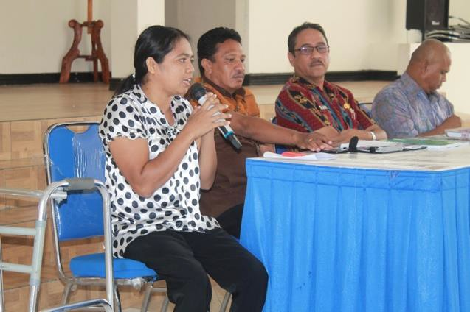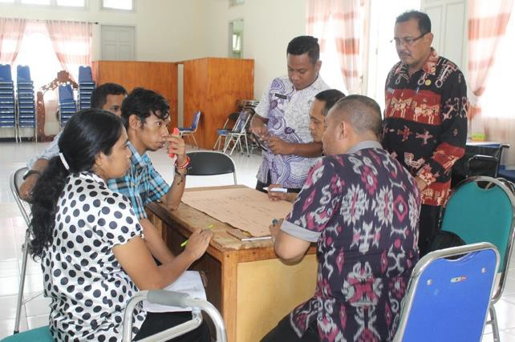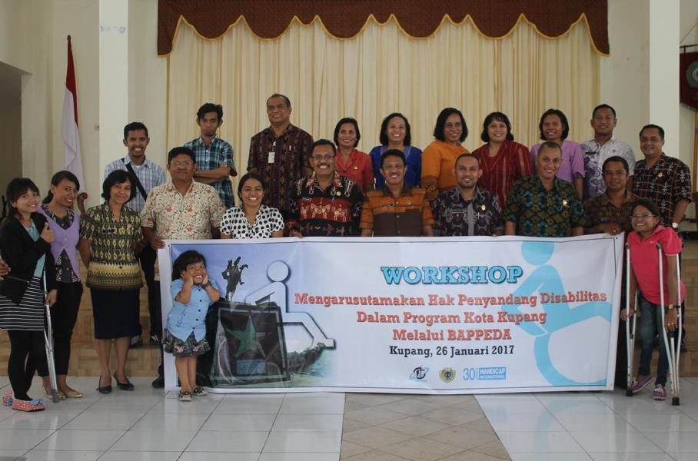The low level of participation of people with disabilities in development is one of the reasons for Persani NTT to start building a network with the Kupang City government. But before that, Persani also held an internal discussion to discuss what things should be done, what plans needed to be made in undertaking advocacy activities with the government, especially BAPPEDA Kota Kupang. Persani also prepares for every regular meeting at the office to become a good facilitator for various exercises.

Photo of Workshop on Mainstreaming the Rights of Persons with Disabilities in the Kupang City Program Through BAPPEDA
From some of these meetings, Persani then agreed on the appropriate steps and network mapping that could support the work to be done. This step serves as a reference for Persani to approach the government. Persani agreed to start this activity at the beginning of the year, with consideration of the deliberation of development planning held in March.
Persani then coordinated with BAPPEDA Kupang Municipality to build good communication and work together in a workshop made by friends of Persani. Approaching with BAPPEDA Kota Kupang is not so difficult for Persani, because BAPPEDA Kupang Municipality is very receptive to the issue brought by Persani regarding Disability Issues, and feel that this issue is very important to be followed up together.
After arranging a joint schedule, Persani NTT created a workshop with the theme "Advocacy For Change". Workshop activities were conducted on January 26, 2017 from 09:00 to 16:00 pm, housed in the Hall of Mayor Position House Kupang with the number of participants who attended as many as 30 people consisting of BAPPEDA Kupang Municipality 14 people, Kupang City Health Office 2 people, Kupang City Social Office 2 people, Kupang City Education Office 2 Persons and 10 people Persani NTT.
In the workshop Persani gave an understanding to the participants who attended the concept of disability and changed the word "disability" to disability, and understanding about the rights of people with disabilities to be fulfilled by the government and to build cooperation between the Kupang Municipality government and the people with disabilities fulfillment of the rights of people with disabilities in Kupang Municipality.
In the workshop, BAPPEDA Kupang Municipaility also presented material, where the emphasizing that persons with disabilities need to understand the stages of planning and budgeting so that they can be actively involved in the development planning process, as well as persons with disabilities are part of the community so they are expected to participate in every stage of planning, especially in the Musrenbang. The government is obliged to involve persons with disabilities in Musrenbang from the urban village level to city level. In carrying out the development process, the government must be inclusive, using three principles: Participatory (expected involvement of persons with disabilities in every phase or cycle of planning), Non- discriminatory (regardless of difference, because everyone has equal rights), and Accessibility (space to persons with disabilities in meeting the needs through the plan program undertaken).
The process of delivering material by Persani and BAPPEDA Kupang Municipality was followed by a discussion together. In the discussion the participants identified what opportunities can be accessed by people with disabilities in the fields of

education, health, work, involvement in the planning and development process, and how to facilitate people with disabilities to access it.
In addition to workshops with Bappeda Kota Kupang, Persani NTT also lobbied the Kupang City Social Service, Kupang City Health Office, and Kupang City Education Office. This approach is used so that problems faced by PwDs related to education, health, as well as other issues can be described together.

What worked?
The outcomes of Persani's approaches can be easily seen, such as in the perspective of participants who are beginning to change, who initially thought that people with disabilities can do nothing, and ignored their rights. Initially people with disabilities experience no ease and face difficulty in receiving service from the government. But the government is beginning to change its perspective, people with disabilities are given the same opportunities as other non-disabled people in fulfilling their rights and obligations. The use of the word disability also begins to change by using the term persons with disabilities or other terms (disabled).
Other results seen include the emergence of a commitment from BAPPEDA Kupang Municipality to maximize the active participation of persons with disabilities in the Musrenbang process. The form of the commitment is the issuance of the Notice Letter with No.BAP.045.2 / 13/2017 on the involvement of persons with disabilities. This letter is then distributed to kelurahan and kecamatan in Kupang City with the aim of becoming a reference to those who organize activities to involve PwDs in the planning and budgeting process. Disabled persons with disabilities are no longer merely objects but valued and given the opportunity to convey what their needs are.

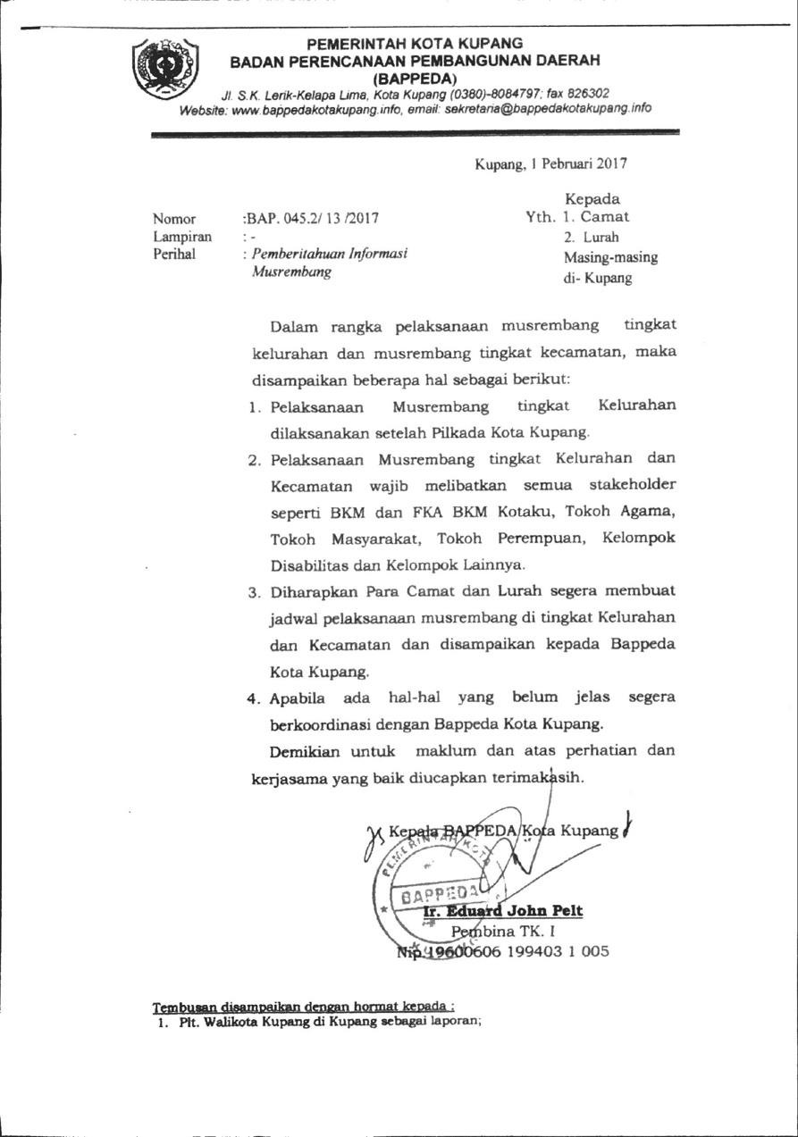Photo of the Musrenbang Information Notice issued by BAPPEDA Kupang Municipailty for Musrenbang process at Kelurahan and Kecamatan level.
From the Circular Letter, Persani noted that there are 6 sub-districts and 2 sub- districts in Kupang City that have started to involve PwDs in the Musrenbang process. At the city level, Persani was also involved in the Musrenbang and it was attended by two representatives. This is quite encouraging because so far both persons with disabilities and organizations with disabilities have not been so involved in the development process. The release of these circular letters can be at least a reference and basis for a more inclusive development process, especially in the city of Kupang.

What can be learned?
Encouraging policy changes within in the government requires persistence and a long process. Several things can be noted from the story above:
- Capacity building for persons with disabilities and organizations of persons with disabilities is an important precondition in building the movement. The weak capacity of people with disabilities to voice opinions, and have knowledge about regulations and knowledge of the systems and mechanisms of development can be a weakness of the movement. The role of strengthening the capacity of people with disabilities can be undertaken by organizations of people with disabilities and other civil society organizations. That is why in building an advocacy movement, it is also important to network with other agencies or organizations.
- Building understanding and coordination with the government is also a necessary condition for successful advocacy. One of them is networking with Local Government Work Units (SKPD) in mainstreaming disability issues to be taken as important issues. On the contrary, it is also open to the government that the issue of disability is not a sectoral issue of only two agencies but cross-cutting issues. When disability issues are seen as cross-cutting issues by the government, the themes that contribute to the disparities in access to development that have been experienced by people with disabilities are diminishing to the full extent that they become equal to the non-disability community.

Contact information
Dinna Noach
+62 822-6623-4841

IMPLEMENTATION OF UNCRPD AND THE NATIONAL REGULATIONS PRIMARILY ASSOCIATED WITH THE FOLLOWING ARTICLES:

Good Practices and Articles in the International Convention on the Rights of Persons with Disabilities (UNCRPD)
Article 5, Equality and Non-Discrimination Article 8, Awareness-raising.
Article 10, Right to Life
Article 17, On Protecting the Integrity of Persons with Disabilities Article 19, About Living Independently and Engaging in Society.
Article 21, On Freedom of Expression and Argumentation and Access to Information.
Article 28, on the Eligible Living Standard and Social Protection Article 29, About Participation in Political and Public Life
In addition to the above few chapters the story is also sufficiently related to the following UNCRPD articles:
Article 3, General Principles Article 4, General Duties

Linkage with Law no. 8 years 2016
Article 5, Rights of Persons with Disabilities Article 7, Free Right of Stigma
Article 13, Political Rights Article 17, Social Welfare Rights Article 18, Accessibility Rights
Article 23, the Right to Live Independent and Engaged in Society Article 24, the Right to Express, Communicate, and Obtain Information
Article 27, Conduct of Respect, Protection and Fulfillment of the Rights of Persons with Disabilities

Good Practices with Gender Perspective
- In case study 5 and 3, the high number of women with disabilities involved contributes to policy-making access at the organizational level, helping in the management of decision-making and acquiring a gender perspective to accommodate women's rights to be met through policy at the village level.
- In some good practice stories, case study 2, 4 and 6; the issuance of a Decree reinforces the advocacy undertaken for people with disabilities incorporated in forums or organizations at the village, sub-district level and so on.
- The high number of women as recipients so as to encourage the acceptance of benefits up to 60% (good practice in Sendangadi), represents a significant amount of attention and fulfillment of the government's needs.
- Increased preventive efforts such as those undertaken by the WKCP through screening for TORCH proves the involvement of women with disabilities are not the only beneficiaries receiving full support from policy makers.
- WKCP which has full support from Prof. Nartini, and the inlcusion of competent academics helped them achieve policy change. Therefore, efforts were made to obtain accurate data for beneficiaries on target.
- Equal attention must be paid to women's and men's roles in order to raise awareness of the importance of reproductive health (e.g, awareness of the TORCH viral infections) as a preventive effort to reduce the risk of children born with disabilities.
- If advocacy has been successfully completed up to the budgeting stage at the provincial level, it is certain that gender mainstreaming becomes the basis of the policy.
- Making sure that all stakeholders related to increased community access, at the village level at least 30% of women with disabilities, as well as women who have access to new policies needs to be improved.
- Both community forums and organizations increased the participation of women with disabilities by up to 50%. This provides significant benefits so that their to suport the participation of women in activities and in policy making. The number of beneficiaries significantly increased, as men with disability are not the beneficiaries of influential policy.

Conclusion and General Recommendations
The following recommendations may be considered to replicate as well as to increase and sharpen the breadth of achievements.

Conclusion
  - The implementation of the fulfillment of the Rights of Persons with Disability is still far from expectations. Nevertheless, people with disabilities, along with stakeholders, have already undertaken good practices at the local level (case study 6), both at the village (case study 1, 2, 4 and 5) and provincial levels (case study 3). This shows that the fulfillment of the rights of persons with disabilities is truly possible. CRPD Implementation is reflected through these collected practices, showing that these good practices can be effective because there is good cooperation between people with disabilities and the government.
  - The active role of people with disabilities is still needed to support and encourage the implementation of Law no. 19 of 2011, and Law no.8 of 2016. In reality, not all stakeholders understand the issues of inclusion and disability. This requires the cooperation of various parties with different approaches to address this gap in understanding and in raising awareness.
  - The level of understanding held by government officials and staff on disability and inclusion issues has a major impact on the acceleration of CRPD implementation and implementation of Law No. 8 of 2016. This has an effect on the perspective of more inclusive planning, programming and activities. Policy holders' disability and inclusion concepts can have a real impact on the fulfillment of the rights of persons with disabilities. If more local and national policy holders are aware of the concept, it will have a significant impact in realizing inclusive development.
  - The effort to fulfill the rights of persons with disabilities should not always be done with a formal process, as documented in case study 1. The cultural approach that uses local wisdom can better introduce the concepts of inclusion and disability to local communities so that they are more easily accepted by the general public.
  - The rights fulfillment effort cannot go through an instant process; the good practices accumulated indicate that consistent, systematic, step-by-step efforts are required to achieve the fulfillment of rights
  - In the Indonesian context, the fulfillment of the rights of persons with disabilities can not be dependent on the government's efforts alone, but needs to be achieved and encouraged by inviting other stakeholders to speed up the process and create real impact as demonstrated in case study 3.

Recommendations

Government
  - The good practices of this CRPD implementation need to be used as a reference for how to collaborate with DPOs for the implementation of CRPD.
  - Concrete efforts are required (training, workshops, discussions) to ensure that all staff in government institutions ― across sectors ― have an understanding and awareness of inclusion and disability; increasing their capacity to enable people with disabilities to become the subject of development.
  - The government needs to involve people with disabilities, including women with disabilities, as subjects in every stage of development, from planning to monitoring and evaluation.
  - The government needs to mainstream disability issues in planning budgeting across all sectors of development (education, economy, infrastructure, health, etc.)
  - The government needs to have accurate data on persons with disabilities, which is segregated by age, gender, and disability, so that the planning of programs better targeted.
  - The government should involve persons with disabilities in the data collection process to obtain more comprehensive data.
  - The government needs to provide specific and customized affirmative programs for people with disabilities, as well as focus on reducing barriers for people with disabilities.

Legislative
  - Enhanced understanding and awareness of the concept of disability and inclusion that people with disabilities are the subject of development to be used as reference in termination of policies and regulations.
  - Involvement of people with disabilities in decision-making (e.g. public hearings)

Organizations working on Disability issues and with DPOs

  - The DPO plays an active role in raising awareness with the public and government about disability and rights issues and disseminating that information.
  - DPOs can use existing good practices and encourage the use of the MiW methodology in advocacy work.
  - The DPO ensures the representation of people with disabilities, including women with disabilities in every stage of development.
  - Understanding the context of the situation and local wisdom can encourage the fulfillment of the rights of persons with disabilities, for example through arts and cultural activities or sports.
  - DPOs need to build networks with organizations and other stakeholders in advocacy efforts to fulfill the rights of people with disabilities.

CBOs, NGOs, INGOs, and Service Providers
  - People with disabilities, including women with disabilities, are beginning to be included in existing programs and services, both as beneficiaries and participating in program implementation.
  - The inclusive concept forms the basis of project design, therefore aspects such as budgeting, infrastructure, information and approaches are tailored to ensure that people with disabilities can be involved in and benefit from the project.
  - Providing space includes the creation of opportunities and capacity building activities, as well as employment opportunities for people with disabilities, including women with disabilities.
  - Ensuring advocacy of disability issues at the most basic level to the national level.

MiW gudeline page 32
Sources http://www.ohchr.org/EN/HRBodies/CRPD/Pages/QuestionsAnswers.aspx and https://ppdi.or.id/kronologis-upaya-ratifikasi-the-cconvention-on-the-rights-of-persons-with- disabilities.html
According to BPS (Statistic Office Centre) productive age is 15 to 64 years)

