

Good Practice case study

How is it possible to improve access to educational services for people with disabilities?

Relevant articles of the CRPD: 9, 19, 24, 26
Country: Yemen
Region: Middle East
Languages available: English

Access to Educational Services in Yemen

Name of Organisation:

Yemen Association for Landmine and UXO Survivors
Sana’a, Jarraf neighborhood, next to the Al Thawra Stadium, P.O. Box 25143
Telefax: + 967-1-336862
Email: saleh0096@hotmail.com

General services provided

The association is a DPO and a service provider with all of its members, survivors of landmine and associated injuries. Services provided are:
- Vocational training;
- Rehabilitation;
- Income-generating projects;
- Inclusive education.

Good practice area submitted

Inclusion of landmine victims and survivors, young males and females alike, in public schools and universities.

Good practices

Availability
Good database on relevant factors on the issues (i.e., locations of landmines and survivors) with a well defined target group.

Affordability
Free services due to good financial support of the government.

Accessibility
A facility of one main centre in Sana with six other satellite centres in different districts, all with physical accessibility features.

Accountability
Policy and procedures are documented and demonstrated.

Quality
There is a committee for inspection and follow-up, composed of three members who are not in the board of the organisation.

General – Overall comments

It is an innovative and inspirational organisation that addresses a critical problem in Yemen. The organization has effective networking with the concerned local authority and the international bodies and efficiently utilises its financial resources.

Background and context
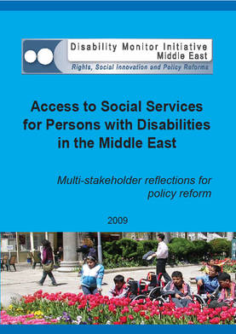
Full project report: Access to services for Persons with Disabilities in the Middle East (DMI ME, 2009)

Criteria for the good practices: See pages 99 -118 of the full report.

Recommendations from the good practices: See pages 122 -125 of the full report.

Links to further resources:
Full text on article 9 - Accessibility
Full text on article 19 – Living independently and being included in the community
Full text on article 24 – Education
Full text on article 26 – Habilitation and rehabilitation

