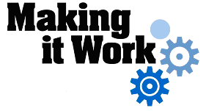

Good Practice case study

How can people with disabilities participate in city councils and ensure disability issues are included in decision-making processes?

Relevant articles of the CRPD: 29
Country: Sierra Leone
Region: West Africa
Languages available: English, French

The Election of a Disabled Councillor to the Makeni City Council

Description of the practice and the process involved

Local Government in Sierra Leone revolves around a system of 19 councils as follows: 5 City Councils, namely Freetown City Council, Bo City Council, Makeni City Council, Koidu – New Sembehun City Council, Kenema City Council, 1 Municipal Council in Bonthe and 13 District Councils, one in each of the 12 provincial districts and one in the Western Area Rural District. While the City Councils and the Bonthe Municipal Council have Mayors, District Councils have Chairpersons as heads.
Voters in Sierra Leone went to the polls on Saturday 5th July 2008 for the Local Council elections. These were held on party lines, using the “first past the post” system. Independent candidates were free not to use a political party symbol but instead select a symbol from the range presented by National Electoral Commission (NEC). Councillors, chairpersons and mayors of councils are elected directly by universal adult suffrage and majority vote.
Two elections were conducted simultaneously, one to elect the Mayor/Chairperson and the other to elect Councillors. Each registered elector was given two ballot papers. All votes cast in each election (i.e. mayor/chairpersons and councillors) were aggregated across all the wards in the locality. The elections, monitored by observers, were peaceful and free.

Makeni City Council is one of the 19 Local Councils established as result of the 2004 Local Council Act. Makeni City being the provincial headquarters of the Northern Province of Sierra Leone has a population of about 40,000 and is located about 145 Km north-east of Freetown, the capital of Sierra Leone.
This case study describes how disabled people have successfully engaged in local politics in Makeni.
A disabled person, a 33-year-old man with post-polio syndrome, is now an elected Councillor for Makeni City Council. He is a member of the Disability Awareness Action Group (DAAG) and the Public Relations Officer for the Polio Persons’ Development Association (PoPDA). He was the Youth Chairman for the Makeni Union of Youth Groups for 2 years (January 2006-December 2007).
The election campaign of the disabled candidate started with his declaration of intention and application for a political party symbol. Initially there were four people with disabilities applying for the All Peoples’ Congress (APC) party symbol for the local election (alongside many other non-disabled candidates). The candidate’s request for a party symbol was facilitated by DPOs in Makeni (especially by DAAG) and in Freetown (at the national level). The party conducted interviews with all the applicants and identified the person they considered the best qualified.
The awarding of the political party symbol to the candidate by the APC was followed by election campaigns for ward 89, in competition with three candidates from other political parties: the opposition Sierra Leone People’s Party (SLPP), the People’s Democratic Movement for Change (PMDC) and the National Democratic Alliance (NDA). However, with personal commitment and support from the DPOs, the APC Party conducted successful election rallies and ultimately won ward 89.

The factors that made this practice possible
- The disabled candidate was a registered and active member of a popular political party in Makeni City.
- Support from people with disabilities belonging to DPOs, especially PoPDA and DAAG.
- Advocacy / awareness-raising campaigns organised by DPOs, especially DAAG, on the radio, basing themselves on the Local Governance Act of 2004.
- Awareness-raising workshops on disability issues at community level targeting various categories of people: youth, men , women and community leaders.
- Effective campaign for a disabled person to be awarded a political party symbol and be voted for in the local council elections.
- Rallies and voter education at community level.

Some of the difficulties encountered
- The challenge from four other people with disabilities (and other candidates) for the All Peoples’ Congress (APC) Party symbol for ward 89 in constituency 28. This difficulty was resolved by the APC party administration. All applicants were assessed on their merits in terms of fulfilling the criteria set by the party. A single candidate was selected as being the most suitable for ward 89;
- Limited financial resources, especially for the electioneering process. This was resolved by using the resources of the disabled candidate and his close friends. He also received some modest financial support from the Centre for Democracy and Human Rights (CDHR) and the APC party administration;
- The public perception that people with disabilities are not capable of governing and the challenge of winning the trust of the electorate, which had felt let down by the majority of previous councillors. These challenges were overcome by the DPOs organizing effective voter education, rallies and campaigns for a disabled person to be elected.

The effects / impact of the practice
- People with disabilities living in Makeni City are now democratically represented with direct involvement in decisions on issues raised at Makeni City Council. A disabled councilor can now directly voice the problems and needs of people with disabilities of the ward;
- The disabled councillor is now a member and chairman of the Makeni City council sub-committee for games and sports. People with disabilities are now involved in decisions relating to the organization of games and sports;
- His presence as a councillor has influenced decisions at city council level for the provision of water and sanitation facilities for the markets of ward 89.

An example of disability inclusion
This practice has shown the inclusion of people with disabilities in local politics, with a disabled man elected democratically to Makeni City Council and subsequently involved in decision-making concerning the provision of development services for a population of about 40,000 people.

Related articles of the CRPD
This practice relates directly to article 29 of the CRPD. This practice enabled a disabled candidate to successfully stand for local council elections.

What are the main points that require attention? How could it be improved?
This practice can be improved by electing a disabled person to an even higher leadership position such as a Major of the Makeni City Council.

For more information, contact:
Alex N. Sesay, Member, Blind Association, C/O Tel: 00 232 030 206 447

Background and context
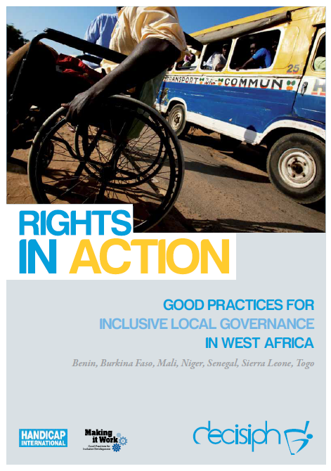
Full project report: Rights in Action - Good Practices for Local Inclusive Governance in West Africa (Handicap International 2010)
Criteria for the good practices: see pages 81 – 82 of the full report.
Recommendations from the good practices: see pages 98 – 111 of the full report.
Links to further resources: Full text on CRPD article 29 – Participation in political and public life

