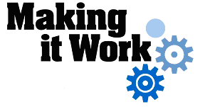

Good Practice case study

How can people with disabilities participate in city councils and ensure disability issues are included in decision-making processes?

Relevant articles of the CRPD: 24, 29
Country: Sierra Leone
Region: West Africa
Languages available: English, French

Representation of People with Disabilities on the Bombali District Council - Makeni

Description of the practice and the process involved

Bombali District is one of the four Districts that make up the Northern Province of Sierra Leone. The district headquarter town of Bombali district is Makeni City with a population of about 40,000. Makeni is located about 145 Km north-east of Freetown, the capital of Sierra Leone.
The following DPOs are active in Bombali District: Sierra Leone Association of the Blind (SLAB), Voice for the Blind (VFB), Polio Persons’ Development Association (PoPDA), Bombali Amputees’ Association (BAA) and the National Leprosy Patients Association (NLPA).

The enactment of the 2004 Local Council Act by the Sierra Leone house of parliament marked the beginning of the process of decentralization in the country. The Act had specific provisions to promote inclusion and full participation, for example, the inclusion of women in the Local Council. However, there was no distinct provision for the inclusion of people with disabilities. When the DPO leaders realized this, they mobilized themselves and then participated in various meetings, awareness-raising campaigns, advocacy and capacity-building workshops. These awareness-raising campaigns on disability were organized by local NGOs such as DAAG and VFB, with financial support from YAPAD.
In 2008, as a result of this advocacy and awareness-raising in relation to disability issues, the Bombali District local council invited three representatives of DPOs to be coopted as members and to attend and participate in council meetings. The three representatives were selected through democratic elections, conducted within their respective DPOs, to give them the mandate and legitimacy to represent the interests of all people with disabilities in the Bombali District.
In September 2008, during one of the monthly council meetings, the DPO representatives tabled the problem of the shortage of drinking water at the Bombali School for the Blind located at Panlap village. This issue was verbally presented at the council meeting. It was discussed and finally selected as a priority need to be met by the council. The council then developed an inclusive action plan, mandating a team comprised of councillors, DPO representatives and community members to conduct a visit to the school and identify a site for the construction of a well.
The hand pump well became operational in November 2008. A team of Korean technicians constructed the well under the supervision of the Bombali District councillors, village community and the staff at the school for the blind in Panlap.

The factors that made this practice possible

- The advocacy / awareness-raising efforts of the Bombali District DPOs (e.g. SLAB, PoPDA) about the need for the inclusion of people with disabilities in local district council decision-making.
- The action by the local council to initiate DPO involvement. This was the direct result of sustained awareness-raising activities.
- The capacity of the DPOs to democratically elect competent representatives to the council.
- The cordial relationship between DPO representatives and the councillors. The advocacy and awareness-raising activities contributed to this.

Some of the difficulties encountered

The present building that houses the Bombali District Council meetings is not accessible. For example, there is no ramp; the steps are very high and without railings. During meetings, the DPO representatives are assisted by the councillors in order to access the building. Improvements could certainly be made.

The effects / impact of the practice

- People with disabilities are now involved in local decision-making processes and can influence local council to consider key disability issues;
- The local council now has disability expertise: DPOs have specific knowledge about the rights and needs of local people with disabilities and they can use this to inform local council action;
- Greater awareness created about the existence of the Bombali School for the Blind which now admits blind children from outside the district;
- Visually impaired school children have access to drinking water, thanks to the intervention of the local council.

An example of inclusive development
This practice involved the inclusion of disabled people as co-opted members of the Bombali District Council (the local authority that makes decisions for development services at local district level).

Related articles of the CRPD

This practice relates to article 29 of the CRPD concerning the participation of people with disabilities in political and public life and article 24 concerning the right to education.

What are the main points that require attention? How could it be improved?

- This practice could be improved by allowing disabled representatives to have voting rights at the council meetings.
- Local council meeting rooms / buildings have to be accessible.
- Possibility to scale up this practice – Bombali district council and DPOs can share this success with other local councils/authorities.

For more information, contact:

Matthew Tholley, Member, Polio Victims Association,
Tel.: 00 232 033 223 796.

Background and context
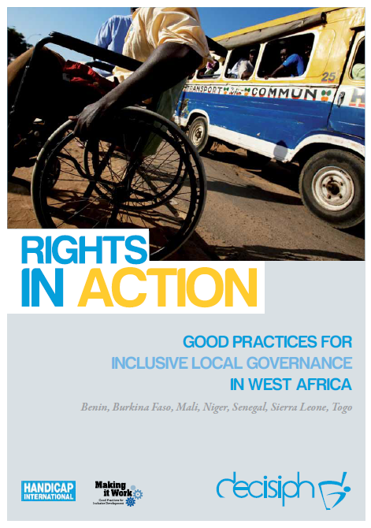
Full project report: Rights in Action - Good Practices for Local Inclusive Governance in West Africa (Handicap International 2010)

Criteria for the good practices: see pages 83 – 84 of the full report.

Recommendations from the good practices: see pages 98 – 111 of the full report.

Links to further resources:
Full text on CRPD article 24 – Education
Full text on CRPD article 29 – Participation in political and public life

