

Good Practice case study

How can people with disabilities ensure disability issues are included in local development processes?

Relevant articles of the CRPD: 27, 29
Country: Senegal
Region: West Africa
Languages available: English, French

Participation of People with Disabilities in the Consultation Framework of the Municipality of Oussouye

Description of the practice and the process involved

The municipality of Oussouye is the administrative centre of the Department of Oussouye. According to the 2002 census, it has 4,052 inhabitants. It is located in Lower Casamance in the region of Ziguinchor, southern Senegal, and is surrounded by thick forests of mango and kapok trees; most of the forest is sacred and used by Diola animists.
In 2000, a Consultation Framework involving the municipal council, CBOs, NGOs, decentralized services and other partners was established by the Prefect of the Department of Oussouye. The aim of the Framework was to promote the socio-economic development of the municipality with the participation of all development stakeholders.
The Union of People with Disabilities of the municipality of Oussouye was invited to join the Consultative Framework; it is in charge of the administrative secretariat of the income generating activities committee.

The Consultation Framework has supported people with disabilities in several areas, including the creation of income-generating activities such as basketry or small businesses (through financial support and guidance) as well as gardening and livestock farming (through the provision of a site on the outskirts of the city).
To address the needs of people with disabilities, the municipality has allocated land to the DPO for the construction of an equipped multiuse headquarters. It has also linked the organization with a Spanish NGO with which a tripartite agreement (city council, NGO, DPO) has been signed for the construction and equipment.
Accessibility issues are addressed at the level of the town council during the meetings of the Consultation Framework, and more generally at the municipality level.

The factors that made this practice possible

- The Mayor of Oussouye, who is recognized as a human rights activist, places great importance on the socioeconomic integration of people with disabilities. Before heading the municipal council, he was involved in the organization and empowerment of mine victims in the municipality of Oussouye and in the Ziguinchor region.

- In this locality, tradition inspires a lot of practices. One of these traditions prohibits the marginalization of people with disabilities in social life.

- Disability INGOs have been present in this area for over a decade, providing services in the fields of education, advocacy and training to develop the capacities of people with disabilities and improve their leadership.

- These factors have encouraged the inclusion of people with disabilities in all local development projects.

Some of the difficulties encountered

Means of transport are limited in the municipality of Oussouye. People with disabilities often live far from the town centre, where the Consultation Framework is located, and this poses difficulties regarding regular attendance.

The effects / impact of the practice

Through the Consultation Framework, people with disabilities in Oussouye can develop actions supported by the community and local authorities.

- “There are a dozen of us - all women – working in this basketry unit. We produce hand-made bags, baskets, and mats. We use willow leaves. We are waiting for the construction of our headquarters to expand and diversify our business. Our biggest problem is the marketing of our products because tourists are becoming increasingly rare in the region. The mayor and Handicap International are our key partners; they support us in several fields such as the design and implementation of microprojects, not to mention the training seminars”.

An example of disability inclusion
Through the creation of the Consultation Framework, the municipality ensures the participation of people with disabilities and their organizations. The problems faced by people with disabilities are treated in the same way as those of other citizens. They are taken into account in the planning of the activities of the municipal council.

Related articles of the CRPD

The experience of the Consultation Framework of the municipality of Oussouye is in line with Article 29 of the CRPD on the participation of people with disabilities in public life. It also relates to Article 27 on employment.

What are the main points that require attention? How could it be improved?
Some aspects to be improved would include the promoting of the project and of the products research into market opportunities.

For more information, contact:

Maxime MANGA, DPO member of Oukout in Oussoye Department
Tel: 00 221 77 652 32 70.

Background and context
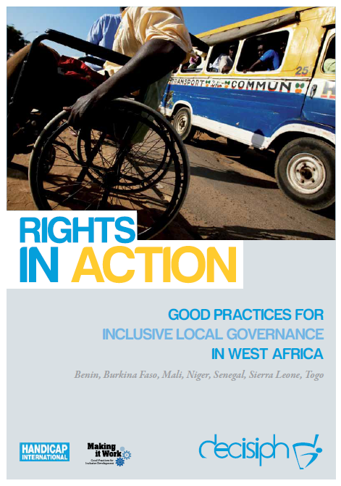

Full project report: Rights in Action - Good Practices for Local Inclusive Governance in West Africa (Handicap International 2010)

Criteria for the good practices: see pages 79 – 80 of the full report.

Recommendations from the good practices: see pages 98 – 111 of the full report.

Links to further resources:
Full text on CRPD article 27 – Work and Employment
Full text on CRPD article 29 – Participation in political and public life

