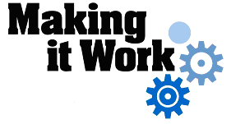
Good Practice case study

How can people with disabilities ensure disability issues are included in local development processes?

Relevant articles of the CRPD: 29
Country: Senegal
Region: West Africa
Languages available: English, French

Inclusion of Persons with Disabilities in the Local Development Consultation Framework of East Pikine

Description of the practice and the process involved

Description of the practice and the process involved

The urban municipality of East Pikine is located in the Department of Pikine in the Dakar region.
As part of a decentralized cooperation with the city of Antwerp, East Pikine has implemented since 1999 a local development programme based on civil society participation. Under this programme, the municipality of Pikine established in 2001 the Local Development Consultation Framework of East Pikine (CLC/DPE).
This body was created to promote conditions for concerted and participatory development. It is composed of 10 local networks and federations of the organizations of East Pikine, such as the Association of neighbourhood representatives, the Coordination of public schools, the Union of Women’s Groups, the Coordination of Medical Stakeholders, etc.
The framework’s mission is to intervene in the fields of health, education, sanitation and environmental management, culture and sport, and to support local entrepreneurship and income-generating activities.
During the setting up of the Local Consultation Framework, in compliance with the inclusion principles of the Decentralized Cooperation Programme, the City council has asked the DPOs of Pikine to join the Framework.

In 2004, the Collective of Associations of East Pikine (COGAPE) was asked by the Local Consultation Framework to identify the persons with disabilities in the municipality and to detail their needs. This work has led to the creation of a training centre for tailoring, hairdressing and literacy run by the Association of People with Disabilities of East Pikine. This training project was made possible through support from the Pikine - Antwerp cooperation programme that financed the rental of a building for the training and for the headquarters of the organization.
At the end of the project, the DPO moved into the headquarters of the Local Consultation Framework, where it continues its training activities.
Collaboration with all the members of the Framework has enabled the DPO to find other funding partners to strengthen the training workshops and develop the income-generating activities.

The factors that made this practice possible

- The North-South partnership (between East Pikine and Antwerp) has been crucial for the inclusion of people with disabilities in the programme. Indeed, the management of the programme requires not only the sharing of responsibilities between the local authorities and civil society, but it also explicitly promotes the involvement of all population groups, including women and people with disabilities.
- The willingness of municipal authorities and leaders of associations has also facilitated the identification of the DPOs working in the locality and a process of taking into account their concerns.

Some of the difficulties encountered

It was not easy to identify people with disabilities and to document their expectations. People with disabilities often have many needs for autonomy and not all of them can be satisfied by the action of the Consultation Framework. Partnerships with stakeholders at the local, national and international levels are crucial.

The effects / impact of the practice

- All the actions developed by the municipality and the Local Consultation Framework take into account people with disabilities and their organizations.
- In addition to supporting initiatives for people with disabilities in the fields of vocational training, literacy and income-generating activities, the Framework has also identified the educational needs of children with disabilities in the municipality. Five children with severe disabilities have been placed in a special school located outside the suburbs. The transportation and school supplies of these children have been supported by the Local Coordination Framework and its partners.
- The President of AHPE was the treasurer of the Consultation Framework and sits on its board of directors. This gives the DPO an important role in the decision-making process and contributes to the change in attitude of society vis-à-vis people with disabilities.
- Through the partnership between the Framework and the municipality, the president of the Women’s Section of AHPE was appointed adviser to the Mayor on issues relating to the promotion and protection of people with disabilities in the community.

An example of disability inclusion
Due to the participation of DPOs in the Consultation Framework, the problems of people with disabilities are taken into account in local development activities. The municipal team uses the technical expertise of people with disabilities to make sure that their specific needs are not overlooked.

Related articles of the CRPD

People with disabilities in Pikine are involved in the local governance mechanisms of their locality. Some participate directly in decision-making in the Consultation Framework and at the municipality level. This practice is therefore an example of the implementation of Article 29 of the Convention.

For more information, contact:

Mame Mor FALL, Tresurer of Consultation Framework of East Pikine
Tel: 00 221 33 854 60 83 or 00 221 77 623 39 58
E-mail: ahpe5057@yahoo.fr or mamorfatou@yahoo.com

Background and context
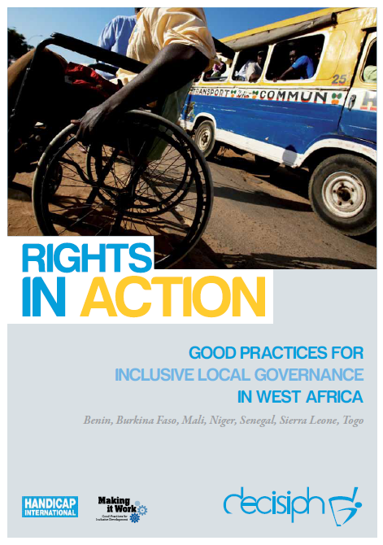
Full project report: Rights in Action - Good Practices for Local Inclusive Governance in West Africa (Handicap International 2010)

Criteria for the good practices: see pages 75 – 76 of the full report.

Recommendations from the good practices: see pages 98 – 111 of the full report.

Links to further resources:
Full text on CRPD article 29 – Participation in political and public life

