

Good Practice case study

How can Disabled People’s Organisations ensure disabilities issues are included in decision-making processes?

Relevant articles of the CRPD: 29
Country: Senegal
Region: West Africa
Languages available: English, French

Involvement of DPOs in the Network of CBOs of South Yeumbeul

Description of the practice and the process involved

South Yeumbeul is an urban municipality in the Department of Pikine, located in the suburbs of Dakar. According to the 2002 census, it has 80,439 inhabitants.
Given the significant number of community-based organizations (CBOs) active in the municipality (75), the Mayor of South Yeumbeul invited them to come together as a single entity to make their actions more effective and coordinated and to give the mayor a single point of contact.

The CBOs therefore created the Network of Community-Based Organizations of Yeumbeul South (ROCBYS). It is a network of organizations from all social and professional categories of Yeumbeul South, including 2 DPOs: Handicap SOS Réinsertion, and the Association of Blind Musicians of Senegal (AMAS).
The organizing committee of the first general meeting of the network in 2004 was led by a person with a disability. This placed DPOs at the heart of the movement from the outset. After the meeting, members of Handicap SOS Réinsertion and AMAS were placed at the head of organizing committees: the women’s committee, and the committee for communication and external relations, respectively.
The headquarters of the Network was installed in the premises of the city hall; the most accessible part was occupied by the DPO members of the network.

In 2005, on the fringes of the network’s annual general meeting, these committees organized awareness raising days on decentralization in the presence of the Minister for Local Government and Decentralization.
The Network works in the fields of micro-finance, education, and training. Network representatives are always invited to the meetings of the council and participate in the decision-making process concerning local development strategies. For example, in collaboration with the municipality, the Network has created the Savings and Credit Mutual Association of South Yeumbeul (MECYS), the management of which is entrusted to the treasurer of the Network, a woman with a disability.
In the field of education, the president of Handicap SOS Réinsertion and director of the management committee of a parents’ association, represents the Network on the Local Committee for Education and Training. Under the annual programme of support for access to school supplies, all children of the municipality, disabled or not, are taken into account.

The factors that made this practice possible

- The willingness of the municipality to encourage synergy among its social partners, promote dialogue, and provide spaces for civil society (headquarters of the Network);
- The motivation, dynamism, and mobilization capacity of the DPOs whose work on the ground was very visible and known to the inhabitants of the municipality;
- The understanding among CBOs and DPOs that unity is strength.

Some of the difficulties encountered

- CBOs in South Yeumbeul were numerous and not easy to mobilize.
- The process of creating the network faced logistical and transportation problems. Distances were often long and difficult in the suburbs.
- But thanks to the financial and material support of the municipal council and the solidarity of the stakeholders, the network was put into place in two phases:
  - the first phase was the setting up of a small committee of 12 organizations that developed a strategy to reach out to all the CBOs of the municipality
  - in the second phase, the Network was established with the support of local authorities.

The effects / impact of the practice

- Through the establishment of the Network, people with disabilities have access to very important elected and appointed positions. Some of them have had some responsibilities of paramount importance for the development of the area with the possibility of intervening in all spheres of the life of the municipality.
- The creation of a savings and credit mutual association with the help of the Network has allowed women with disabilities in the municipality to have access to micro-finance and thereby strengthen their financial autonomy.
- Through the annual educational support programme, several children have received support.
- All the members of the network have benefited from capacity building initiatives developed locally with support from various partners. People with disabilities have systematically been invited to participate in training sessions organized by community organizations. Equally, when DPOs organize activities, they always involve the other members of the network.

- “I am a member of Handicap SOS Réinsertion. I participated in the creation of ROCBYS. I was involved in the financial and material organization of the first general meeting, and it was a success. Today, I am a local politician and adviser to the Mayor on disability issues. I must admit that ROCBYS has influenced me a lot at the political level. I have represented the network in almost all meetings with the municipal council. That’s where I realized that I could become a local elected official. So I joined a political group that positioned me for election in my community. Thanks to my popularity with grassroots community organizations and DPOs, I am now part of the municipal team. I will work for everyone but I will always be mindful of people with disabilities who are my real foundation”.

An example of disability inclusion
The Network and the local authorities take into account people with disabilities in their work. They do not hesitate to use the expertise of DPOs and to give them positions of responsibility.

Related articles of the CRPD

The experience of the Network of Community-Based Organizations of South Yeumbeul has allowed a real participation of people with disabilities in line with Article 29 of the Convention.

For more information, contact:
Abdou Cogna DIOP, Communication and external relations officer of ROCBYS.
Tél: 00 221 77 451 18 06,
E-mail: soshandicappikine@yahoo.fr.

Background and context
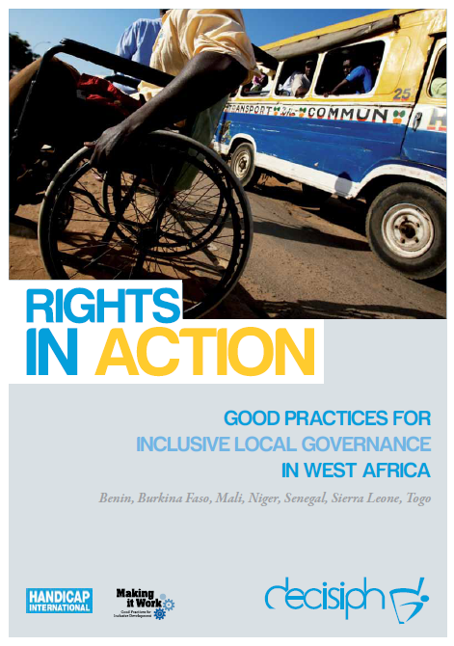
Full project report: Rights in Action - Good Practices for Local Inclusive Governance in West Africa (Handicap International 2010)

Criteria for the good practices: see pages 73 – 74 of the full report.

Recommendations from the good practices: see pages 98 – 111 of the full report.

Links to further resources:
Full text on CRPD article 29 – Participation in political and public life

