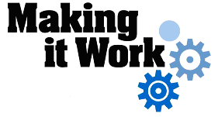
Good Practice case study

How can people with disabilities ensure disability issues are included in local development processes?

Relevant articles of the CRPD: 24, 27, 29
Country: Senegal
Region: West Africa
Languages available: English, French

Integration of Disability Issues in the Local Development Process through the Consultation Framework for the Inclusion of People with Disabilities in the Department of Dagana

Description of the practice and the process involved

Dagana is one of the three departments of the Region of Saint- Louis in northern Senegal. In 2005, its population was estimated at 207,991 people.
In 2002, the Departmental Consultation Framework on the inclusion of people with disabilities in the Department of Dagana was created to promote the socio-economic integration or reintegration of people with disabilities in the Department.
It has been implemented by “The Partnership11” in connection with the Federation of People with Disabilities of Dagana and the Departmental Social Action Service, which plays the role of coordinator.
The majority of state and non-state stakeholders of the Department (Prefecture, Health Municipality, IDEN, rural communities, training centres, community-based organizations, etc.) are members. The Framework, which meets twice a year, also has resource persons among its members and is open to anyone interested in its mission.
Following a participatory approach, the Framework identifies, in consultation with DPOs, the problems of people with disabilities and tries to find solutions. Each member contributes, depending on their expertise and areas of intervention.
The Framework supports the Federation of people with disabilities of Dagana in the fields of rehabilitation, advocacy, education, vocational training, employment and accessibility.

In the education sector, the Consultative Framework has enabled the construction of ramps, sanitation facilities in schools and has provided educational support to children with disabilities. This has included raising the awareness of parents as to the importance of registering the birth of children with disabilities.
The apprenticeship of young people with disabilities who are beyond school age is encouraged by the Consultative Framework. It identifies young people with disabilities, agrees with them a trade they would like to be trained in, and then puts them in contact with public or private formal or informal institutions. The members of the Consultative Framework then jointly put in place the training process. IDEN facilitates contacts with the training institution, The Partnership and the local communities provide the financial means, and social services and the Federation of People with Disabilities takes charge of the monitoring and mentoring.

The Partnership also supports the professional integration of the trainee through subsidies for the creation of income-generating activities.
Individual promoters or groups also receive funding for activities and technical support from the members of the Framework. Activities such as the marketing of rice, the rental of tarpaulins, chairs and sound equipment, and the setting up of small businesses have been subsidized.
With the support of all the stakeholders of the Consultative Framework, advocacy tours focusing on the rights of people with disabilities are organized in the local communities. Each stakeholder makes a financial or material contribution.
Local authorities also support the activities of DPOs through periodic grants.

The factors that made this practice possible

- The fact that The Partnership had set as a priority actions to support the integration of people with disabilities, and the fact that it had a sound knowledge of the various local stakeholders, was crucial to the success of this initiative. The strategy developed by The Partnership was completely consistent with the development programmes implemented by the government and especially by the Social Action service in the department.
- The Federation of People with Disabilities of Dagana was highly active and well organized, enabling it to play the role of catalyst within the Consultation Framework.
- The geographical proximity of the stakeholders and their integration within the local community encouraged dialogue and consultation.

Some of the difficulties encountered

Time constraints on the various stakeholders and the difficulty of meeting frequently has resulted in the Framework holding two meetings per year.
An action plan with an annual allocation of tasks is developed each year. During the second meeting of the year, members assess the actions of the framework for the period just elapsed and discuss prospects for the coming period.

The effects / impact of the practice

- Through their participation in the Consultative Framework, people with disabilities have been directly involved in research and the implementation of actions to address their main needs and difficulties. Following the actions taken by the Consultative Framework, more children with disabilities have been enrolled in the schools of the department. Young people with disabilities have access to vocational training, conduct income-generating activities, and participate in the development of the locality.
- Development stakeholders have started to recognize the need to make their work more inclusive of people with disabilities.
- “I’m 18 and I have a disability. Thanks to the Consultation Framework of Dagana, I am doing a training course in catering at the Regional Technical School for Girls (CRETEF). I have finished my first year and I was first in my class. I’m entering my second year. I have many friends in the centre. At the end of my training, I want to open a big, high-class restaurant where I will employ people with disabilities” said a beneficiary of the vocational training programme.

An example of disability inclusion
The approach of the Consultation Framework is inclusive in that all development stakeholders in the department have joined forces to give more space to their fellow citizens with disabilities, and have started to systematically take disability into account in all their actions.

Related articles of the CRPD
The Consultation Framework of Dagana for the inclusion of people with disabilities is fully in line with article 29 of the Convention. It also highlights articles 24 and 27 on education and employment.

For more information, contact:
Ibrahima THIAM, Head of Departmental Service of Social Action and Director of the Service of Social Promotion and Reintegration (CPRS) of Dagana.
Tel: 00 221 33 963 11 83 or 00 221 76 591 09 37
E-mail: thiamiba58@yahoo.fr.

Background and context
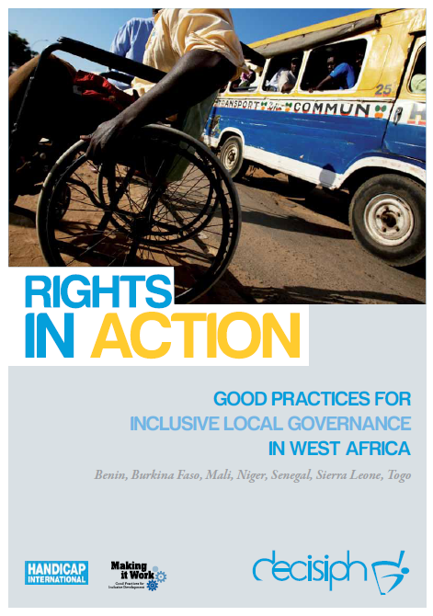
Full project report: Rights in Action - Good Practices for Local Inclusive Governance in West Africa (Handicap International 2010)
Criteria for the good practices: see pages 71 – 72 of the full report.
Recommendations from the good practices: see pages 98 – 111 of the full report.
Links to further resources:
Full text on CRPD article 24 – Education
Full text on CRPD article 27 – Work and Employment
Full text on CRPD article 29 – Participation in political and public life

