

Good Practice case study

How is it possible to improve access to rehabilitation services for people with disabilities?

Relevant articles of the CRPD: 19, 26, 27
Country: Palestine
Region: Middle East
Languages available: English

Access to Rehabilitation Services in Palestine

Name of Organisation:

The Regional Committee for Community Based Rehabilitation
(CBR) – Southern Region of West Bank (Bethlehem and Hebron
Districts)
CBR Office
Beit Jala
Palestine
TEL.FAX: 02-2767796
Email:cbrsouth@palnet.com

General services provided

This service is under a legal umbrella of a coalition of non-government organisations comprised of the Bethlehem Arab Society for Rehabilitation (BASR), Palestinian Red Crescent (PRCS) and Health Work Committees (HWC). The range of activities undertaken includes:

- home visits for persons with disabilities

- facilitation of the integration into vocational training centres and mainstream schools for children with disabilities

- adapting schools and houses for physical accessibility

- provision of technical aids and referral to various health and rehabilitation services

Good practice area submitted

Outreach rehabilitation services.

Good practices

Availability

- Selection of target group is flexible, depending on project funding, resources and local demand.
- Statistics and information about the target population were put to good use.
- Surveys conducted prior to starting work to set priorities.
- Ensured limited overlap with other service providers because of the corresponding services in Central and Northern Palestine.
- Offers subsidised transport to large referral centres if required and rural services are continually being developed.
- Psychiatric referrals exist (however there is limited expertise in this area) with improving knowledge of autism/learning disability.
- Secured commitment from larger supporting organisations to continue CBR if funding becomes restricted.

Affordability

- No cost for services.
- Minimal cost for summer camps or other special events.
- Subsidised transport available for some users if needing referral to larger centres.
- No equipment rental scheme for users but they must wait for equipment from larger centres.

Accessibility

- Some municipal offices are reportedly accessible, but most services are home-based, not centre-based.
- Some volunteers have a disability while most of the staff employed does not.
- Mix of religious denominations in the office, with no gender/religion discrimination demonstrated.

Accountability

- Demonstrated good file management and financial/accounting processes.
- Limited strategic input from service users/community members.

Quality

- Treatment plans are developed with family and professionals.
- Good networks with other disability stakeholders and complementary service providers.
- Good input in regional networks and training activities.

General – Overall comments

The CBR service is a good model for service delivery in the occupied Palestinian Territories due to:

- The limitations of people accessing services;

- Restricted transportation;

- The political implications on infrastructure and the rural population.

The backing of the three larger institutions ensures a good degree of sustainability of activities and that the service would be improved with increased user involvement and linking with DPOs.

Background and context

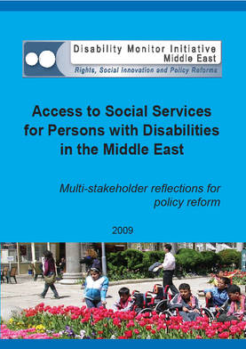
Full project report: Access to services for Persons with Disabilities in the Middle East (DMI ME, 2009)

Criteria for the good practices: See pages 99 -118 of the full report.

Recommendations from the good practices: See pages 122 -125 of the full report.

Links to further resources:
Full text on article 19 – Living independently and being included in the community
Full text on article 26 – Habilitation and rehabilitation
Full text on article 27 – Work and employment

