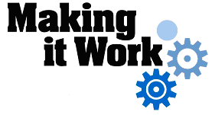

Good Practice case study

How can people with disabilities participate in decision-making processes and development programmes?

Relevant articles of the CRPD: 29
Country: Mali
Region: West Africa
Languages available: English, French

Involvement of People with Disabilities in the Framework of Consultation, Information and Monitoring of the Actions of the Prefecture of Tominian

Description of the practice and the process involved

The circle of Tominian is located in the Ségou region in the east of the country. It includes 12 rural municipalities, 313 villages and a population of 183,185 inhabitants (data: World Vision).
In 2007, World Vision, Handicap International and the Messiah College, in cooperation with the local Federation of DPOs (FELAPH), conducted a study on the «Access of people with disabilities to water, hygiene and sanitation in the circle of Tominian”.
The study highlighted a lack of physical accessibility and a high degree of dependency on their relatives for people with disabilities and their families in terms of access to water, hygiene and sanitation.
This research was carried out in preparation for the installation of a pilot site in the municipality of Tominian, where innovative solutions have been developed by the Messiah College.
Since 2008, latrines have been built and pumps made available to people with disabilities in the municipality of Mandiakye.

Given the importance of the study and the facilities built in 2008, the Federation of DPOs has taken steps to become a member of a local consultation framework for information-sharing and monitoring the actions of the Prefecture of Tominian and thereby to be able to attend the meetings.
The President of the DPO Federation requested this in a letter to the Prefect of Tominian, in his capacity as chairman of the consultation framework.
This framework brings together representatives of government, elected municipal officials, civil society, and development partners. Composed of several committees (health, rural development, economics, water, education, social affairs), its mission is to facilitate the planning and monitoring of development projects in a participatory manner in the circle. The forum meets twice a year to conduct annual planning and to take stock of achievements. Intermediate or special sessions are organized to address unexpected situations.

The request of the local Federation of DPOs was accepted and two people with disabilities were selected to represent the Federation in the framework.
« The acceptance of consultation framework has been very important for us, because through the meetings, we are aware of the actions that are carried out in our community and how decisions are taken. During one of these meetings, two of our projects were accepted », said the President of FELAPH.
Among the range of the Federation’s proposals supported by the project coordinators, one involves a training course in tailoring in six of the municipalities and the allocation of sewing machines to beneficiaries of the training in order to facilitate their professional inclusion, while another offers training in the processing of leather via the Support Programme for Rural Communities (SPRC) in the municipality of Gosso.

The factors that made this practice possible

- The initiative shown by the Federation of DPOs in becoming a member of the consultation framework was a decisive factor.
- The strong involvement of people with disabilities in carrying out the study on accessibility and in the setting up of sanitation facilities in the circle was a decisive factor in the local authorities approving their participation in the consultation framework. «People with disabilities have played an important role in the development and consolidation of certain localities in the prefecture; that’s why we can not ignore them in decision-making at the local level» said the prefect of Tominian.
- After joining the framework, representatives of people with disabilities have been able to assert their interests and propose concrete actions to the prefecture.

Some of the difficulties encountered

The low level of education of people with disabilities in certain municipalities represented an obstacle to their participation in discussions at the meetings organized by the framework. Indeed, the use of French as a working language was often a barrier for people with disabilities. To address this, the communication skills of people with disabilities should be improved through adapted capacity building activities and also the possibility of using local languages during the meetings should be considered.

The effects / impact of the practice

- Informing and raising the awareness of development stakeholders on disability issues;
- Informing people with disabilities of the activities that are carried out in the prefecture;
- The involvement of people with disabilities in decisions concerning the locality;
- The implementation of training projects and income-generating activities for people with disabilities (tailoring, cooking, leather processing) in partnership with the NGO World Vision and the Support Programme for Rural Communities;
- The commitment of local decision makers to take into account the concerns of people with disabilities in the design of the Economic, Social and Cultural Development Programmes of the municipality in the circle of Tominian.
- “With this training, I will learn a trade that will allow me to satisfy my needs and those of my family” said a beneficiary of the training project supported by the consultation framework.

An example of disability inclusion
Issues and proposals from people with disabilities are discussed and addressed in a forum that brings together all stakeholders of the locality. Decisions on local development are taken through an inclusive approach.

Related articles of the CRPD

This practice is in line with Article 29 on the participation of persons with disabilities in public life through their involvement in governance and decision making in the prefecture.

For more information, contact:
Adama Sidibe, Governor of Tominian.
Tel: 00 223 21 37 50 10 or 00 223 21 37 50 13

Background and context
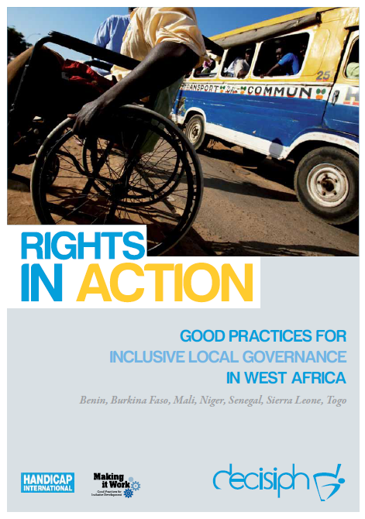
Full project report: Rights in Action - Good Practices for Local Inclusive Governance in West Africa (Handicap International 2010)

Criteria for the good practices: see pages 63 – 64 of the full report.

Recommendations from the good practices: see pages 98 – 111 of the full report.

Links to further resources:
Full text on CRPD article 29 – Participation in political and public life

