

Good Practice case study

How can Disabled People’s Organisations ensure disability issues are included in development programmes?

Relevant articles of the CRPD: 24, 25 and 29
Country: Mali
Region: West Africa
Languages available: English, French

Initiative for the Inclusion of the Concerns of People with Disabilities in the Economic, Social and Cultural Development Programme of the Municipality of Bougouni

Description of the practice and the process involved

Bougouni, which means “small hut” in the Bambara language, is a municipality located 160 km from Bamako, Mali’s capital, and 210 km from Sikasso, the administrative centre of the region.
The population of the municipality of Bougouni is estimated at 45,890 inhabitants according to the 1996 census. There are 2,624 people with disabilities according to a census conducted by the Local Federation of DPOs (FELAPH) in 2008.

In June 2008, FELAPH, with support from an international NGO, conducted a participatory local diagnosis of the situation of people with disabilities in the municipality with a view to developing concrete proposals to help address their main needs and concerns.
The results of the diagnosis were analysed and endorsed during a workshop involving key stakeholders in the municipality. The main problems highlighted by the study were access to health, education (more than 90% of people with disabilities did not attend school) and employment.

To overcome these problems, the following actions have been proposed by the actors involved in the diagnosis:
- Increase the level of education of people with disabilities
- Increase access to basic social services
- Facilitate professional integration through the development of income generating activities
- Promote the participation of people with disabilities in community life
- Educate and inform people about disability
- Educate all stakeholders at the municipality level so that they consider disability as an across-the-board issue in their work.

After the study, the FELAPH approached the municipal council of Bougouni to discuss the results and make proposals for action.
Following consultations between the FELAPH, the municipality of Bougouni, the Circle Council and local services, concrete actions have been undertaken to promote the inclusion of disability issues in the Programmes for Economic and Cultural Development of the municipality and also to improve access to health and vocational training.

Inclusion of Disability in the Economic, Social and Cultural Development Programmes
Partnership agreements were signed between FELAPH, DPOs and the municipality of the Circle of Bougouni (Bougouni, Koumantou, Zantiébougou, Faragaran Faradielé, and Kelea). These agreements aimed to encourage the involvement of DPOs in the development process, and in the implementation, monitoring and evaluation of the Economic, Social and Cultural Development Programme in the various municipalities. The involvement of DPOs ensures that people with disabilities are participating in decision-making processes and can promote the rights and needs of people with disabilities on the development agenda. The agreements were signed by the President of the Federation of DPOs, the mayors of the various municipalities involved, and the heads of local DPO.

Access to health services
A multiparty agreement was signed by the Chairman of the Circle Council, the president of the Local Federation of Community Health Associations (FELASCOM), the head of the Social Development and Solidarity Economy department in the prefecture, and the President of the Federation of DPOs. This convention guarantees free consultations and hospitalization in all health centres of the prefecture to any person with a disability who is a member of the federation. This could be improved – to ensure that nonmembers can also benefit from this.

Access to vocational training
An agreement was signed between the private vocational school ESET and the local federation of DPOs of Bougouni. Renewable every year, this agreement allows the bearing of 50% of the school fees by the institution, and the remaining 50% by the individual with a disability.

The factors that made this practice possible

The factors that made this possible were:
- The existence of a federation and very dynamic and organized local DPOs;
- Good relations between the federation and the partners (technical services, municipal councils, circle councils, and INGOs);
- The constructive dialogue with the local council;
- The financial support provided for the conducting of the study.

From the results of the diagnosis, the Federation of DPOs has implemented a strategy of awareness-raising and advocacy on disability rights, and has submitted proposals to the council to improve the situation of people with disabilities.

The effects / impact of the practice

- Disabled people’s organizations are now involved in developing the new Economic, Social and Cultural Development Programmes in the circle of Bougouni thanks to the signing of the partnership agreement between the local federation of DPOs and individual municipalities;
- The updating of the Economic, Social and Cultural Development Programme (2005-2010) of the municipality of Bougouni allowed the incorporation of measures for people with disabilities, including the completion of a project for the manufacture of wire netting and training in soap production and in dyeing;
- The advocacy actions carried out by FELAPH and DPOs which targeted the local authorities and development partners have helped raise awareness of the rights of people with disabilities;
- Following the recommendations of the study, several projects have been set up for people with disabilities and funded by development partners (funding for a motorcycle ambulance, for a soap factory...);
- The free medical consultation obtained via the agreement signed between FELAPH and health authorities allows extensive medical care for people with disabilities;
- Since the signing of the agreement between the vocational school ESET and the Federation of DPOs, six people with disabilities have accessed training courses.

Kanata Maïmouna Mariko, 1st Deputy Mayor of the municipality of Bougouni, said: “Decision-making is the essential basis of managing a municipality and should involve all segments of society, without any discrimination”.

An example of disability inclusion
This practice is an example of inclusion because it involves all stakeholders in the development of the locality. It has enabled people with disabilities to participate in the decision-making process in the municipality and see their needs addressed by local stakeholders.

Related articles of the CRPD
This practice is in line with articles 25 (access to health), 24 (vocational training) and 29 (participation in public life and politics).

For more information, contact:

Ousmane Diakité, President of Local Federation of DPOs.
Tel: 00223 76216727.

Background and context
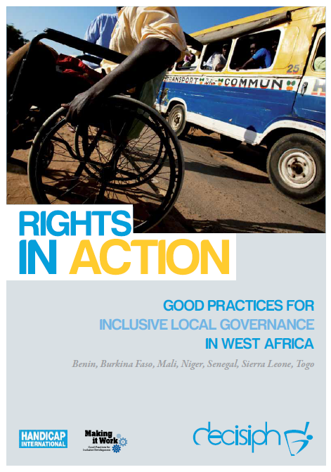
Full project report: Rights in Action - Good Practices for Local Inclusive Governance in West Africa (Handicap International 2010)

Criteria for the good practices: See pages 56 – 57 of the full report.

Recommendations from the good practices: See pages 98 – 111 of the full report.

Links to further resources:
Full text on CRPD article 24 – Education
Full text on CRPD article 25 – Health
Full text on CRPD article 29 – Participation in political and public life

