

Good Practice case study

How can Disabled People’s Organisations ensure disability issues are included in development programmes?

Relevant articles of the CRPD: 28 and 29
Country: Mali
Region: West Africa
Languages available: English, French

Involvement of People with Disabilities in the Local Development Process in the Circle of Banamba

Description of the practice and the process involved

The circle of Banamba is located in the Koulikoro region. It is composed of nine municipalities and has a population of 182,411 inhabitants, according to the 1996 census.
In August 2005, the Local Federation of DPOs (FELAPH) of Banamba, in collaboration with the Department of Social Development and Economic Solidarity, Banamba deputies and the NGO CAEB (Advice and Support for Basic Education) conducted a survey and diagnosis study to assess the number of people with disabilities and their situation in the circle.
The census identified 1139 people with disabilities in the circle (about 6% of the total population of the circle). The census costs have been assumed by deputies of the locality.
Following the census, an organization was created in each of the nine municipalities of the circle by FELAPH and the city council. A management committee has been established to ensure the smooth functioning of these organizations and to ensure their representation at various municipality meetings. All of these organizations have joined the local Federation of DPOs of Banamba.

Support in terms of institutional and organizational strengthening has been provided by the NGO CAEB, who have extensive experience in participatory development and capacity building. It was involved in several localities (Kayes, Ségou, Sikasso and Koulikoro) and in different fields (education, community financing, health and governance).
The participatory local assessment, conducted in 9 municipalities of the circle, identified the main difficulties faced by people living with disabilities and made proposals for solutions. The main issues that emerged from the diagnosis were poverty (defined as the lack of financial resources, but also the lack of education), the lack of confidence, and discrimination.
At the meeting for the debriefing and validation of the results of the study, people with disabilities identified gaining financial independence as their first priority.
A project for access to microcredit for people with disabilities was therefore designed and submitted to the financial institution SINSINSO by FELAPH with the support of the CAEB and local elected representatives.
A Memorandum of Understanding was signed between FELAPH and SINSINSO; it contained the following elements:
- FELAPH was the only channel of communication with SINSINSO. Any person with a disability applying for a loan had to receive the prior approval of FELAPH;
- The cost for the savings account was set at 2,000 FCFA for all members;
- Exemption from the payment of interest during the solidarity month.

The people with disabilities involved in the project have received training on feasibility studies and business management, financed by CAEB (an NGO). These courses have enabled people with disabilities to analyze their economic plans in terms of the amount, rate and repayment schedule of the credit requested.
The amount of credit granted in this first operation was 1,000,000 CFA francs, distributed among 20 members of FELAPH for undertaking small projects. The amount varied between and 25,000 and 50,000 CFA francs per recipient. The activities conducted were: small businesses, tailoring, catering, livestock farming (cattle and sheep), purchase of seeds for gardening etc.

In September 2009, thanks to the dynamism of FELAPH in the circle, local organizations of people with disabilities were invited to participate in the preparation of the Economic, Social, and Cultural Development Programmes in the various municipalities. Concrete actions were thereby incorporated into the community plans, after analyzing the difficulties faced by persons with disabilities.

The factors that made this practice possible

- The dynamism and determination of the local Federation of DPOs of Banamba and the many awareness-raising and advocacy actions carried out with local stakeholders;
- The openness and willingness of local authorities to cooperate (MPs, advisers, technical services);
- The census and participatory local diagnosis highlighted the number of people with disabilities in the circle. This made stakeholders aware of the priority needs of this population;
- The presence and the dynamism of the NGO CAEB in developing the self-governance capacities of the communities;
- The support for the structuring of DPOs with the establishment of management bodies by CAEB has contributed to more organized and effective actions by the local DPOs;
- The willingness of the financial institution SINSINSO to enter into a novel partnership with the local federation of people with disabilities. Through this partnership SINSINSO has seen a considerable increase in its number of clients;
- The accountability of the members of management committees regarding the allocation and management of the funds.

Some of the difficulties encountered

- Communication was difficult for some people with sensory disabilities. Translators using sign language were arranged for the meetings and specific training was provided to some members of the Federation of DPOs;
- The lack of training for people with disabilities in the management of NGOs;
- The difficulties for some people with disabilities in travelling and participating in meetings in the circle (some people often had to travel several kilometres without transport). These problems have not yet been resolved;
- The insufficient amount of the individual credit granted. SINSINSO is now considering increasing the amount for the second loan.

The effects / impact of the practice

- The local participatory diagnosis and the identification of people with disabilities have provided a foundation for local inclusive action to take place.
- The creation and structuring of DPOs in the municipalities has allowed people with disabilities to be better represented and to have their voices heard at the local level.
- The partnership between the local Federation of DPOs and the microfinance institution SINSINSO has promoted the development of income-generating activities by people with disabilities.
- They have improved their management skills through the training provided by CAEB.
- This initiative has created a lot of enthusiasm and motivation among people with disabilities.
- Improving access to economic activities also led to more taxes being collected by the municipality.
The process of developing and implementing the Economic, Social and Cultural Development Programmes of the municipality in the Circle of Banamba became more inclusive with the participation of DPOs. The difficulties and concerns of people with disabilities have been heard and taken into account by policy makers, particularly regarding access to education, socio-economic inclusion, and medical care.

- “During these meetings we forgot about our disabilities and discussed like the others” said the Secretary General of FELAPH.
- “This is the first time people have paid attention to our real problems! During the meetings, the Assembly listened to us and our proposals have been accepted by everyone...” said the President of the local Federation of DPOs.
- Another member of the Federation said: “Now we will feel involved in decision-making and the management of the development activities of our community”.

An example of disability inclusion
This practice has encouraged the inclusion of disability in the access to micro-finance services.
Due to the involvement of people with disabilities, communal development programmes have also become more inclusive and collaborative.

Related articles of the CRPD

This practice is in line with Article 29 of the Convention; it is an example of participation of people with disabilities in the governance of their locality. It has enabled people with disabilities to improve the organization and structure of their representative associations and facilitated their representation in the local bodies responsible for municipal planning.

For more information, contact:
Fodé Sylla, President of Local Federation of DPO.
Tel: 00 223 79109997.

Background and context
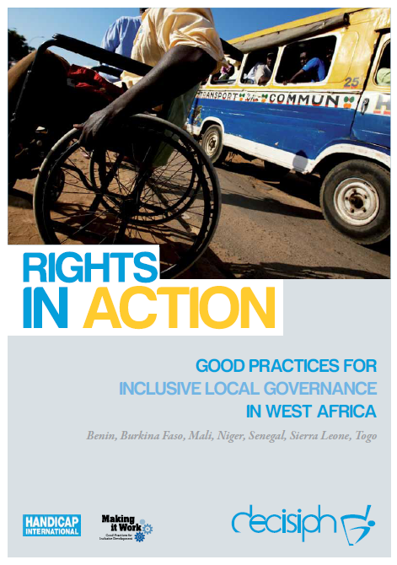
Full project report: Rights in Action - Good Practices for Local Inclusive Governance in West Africa (Handicap International 2010)

Criteria for the good practices: see pages 58 – 60 of the full report.

Recommendations from the good practices: see pages 98 – 111 of the full report.

Links to further resources:
Full text on article 28 – Adequate standard of living and social protection

