

Good Practice case study

How is it possible to improve access to rehabilitation services for people with disabilities?

Relevant articles of the CRPD: 19, 24, 25, 26, 27
Country: Lebanon
Region: Middle East
Languages available: English

Access to Rehabilitation Services in Lebanon

Name of Organisation:

Community-Based rehabilitation Association (CBRA)
Al-Badawi - Al-Jabal - Facing the northern entrance of the camp.
northcbr@yahoo.com

General services provided

The organisation is now located at Al Badawia camp; it started in 1991 at Naher Elbared Camp as a rehabilitation and training centre, providing social and academic training. In 1997, CBR projects started and the CBR committee established. In 2006, it was legally registered as Lebanese association with License no. 440\Ed working on:
- Academic and vocational integration program
- Advocacy, awareness and training
- CBR
- Special education program
- Physical, occupational and speech therapies
- Geriatrics and stroke rehabilitation
- Psychosocial support
- Supporting groups
- Referral system
- Relief work

Good practice area submitted

- Academic and vocational integration program
- Advocacy groups and training
- CBR
- Special education program
- Advocacy, awareness and training
- Physical, occupational and speech therapies
- Referral system

Good practices

Availability

- The association has clearly defined a target population and geographical areas.
- It strives to keep an updated database of all persons with disabilities in the area.
- Simple outreach services depend on funding sources, with good ability to efficiently allocate resources and promote itself in the local community.
- They have developed partnerships with complementary service providers and the semi-public sector.

Affordability

The association presents good affordability measures with minimal sliding- scale fees, rental scheme and simple outreach services.

Accessibility

- The association participates in awareness-raising initiatives to reduce the physical barriers for persons with disabilities in the community.
- As much as 10 percent of employees have disabilities, though there is no policy for PWD employment.
- The association tries to develop a philosophy of non-discrimination.

Accountability

- Has a working supervisory board, which includes persons with disabilities.
- Listed legally as a Lebanese Association and there are audits (i.e. financial audit) by Lebanese authorities in relation to this.

Quality

- The association participates in a network of stakeholders in the disability field.
- Has a good file management system with a fair user-centred approach.
- There is a good staff performance system and it tries to ensure the safety and protection of vulnerable persons from abuse.

General – Overall comments

- The association possesses the good ability to reform itself after its destruction and to cope and exist in camp circumstances.

- They have a good outreach service and the capacity to meet the demands of users, especially after the disaster (i.e., camp destruction).

- Psychosocial support services were designed to meet the demands of the community it served.

Background and context
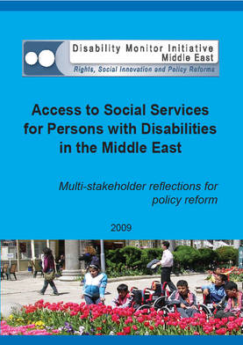
Full project report: Access to services for Persons with Disabilities in the Middle East (DMI ME, 2009)

Criteria for the good practices: See pages 99 -118 of the full report.

Recommendations from the good practices: See pages 122 -125 of the full report.

Links to further resources:
Full text on article 19 – Living independently and being included in the community
Full text on article 24 – Education
Full text on article 25 – Health
Full text on article 26 – Habilitation and rehabilitation
Full text on article 27 – Work and employment

