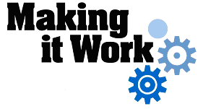

Good Practice case study

How is it possible to improve access to educational services for people with disabilities?

Relevant articles of the CRPD: 9, 19, 24, 26
Country: Jordan
Region: Middle East
Languages available: English

Access to Educational Services in Jordan

Name of Organisation:

Arab Episcopal School – Irbid
Al-Barha Street, Irbid, Jordan
Tel. 02 / 7275572
www.aeschool.org

General services provided
- Kindergarten
- School for children until the sixth grade
- Mainstreaming program for children with visual impairments in kindergarten and schools

Good practice area submitted

The Church provides social services to teach and integrate the blind and visually-impaired children and address issues related to isolation. It supports opportunities to teach and include children within the local community.

Good practices

Availability
The target population is very clearly defined. They are well-known to provide educational opportunities for blind children between the age of four and thirteen. Transportation is offered for free to most blind students except the ones living in very far areas outside Irbid. They are the only school in the whole area that includes blind children in regular classrooms.

Affordability
The school fees for blind students are supported by the church and partially from the Al Dia Charity Association. Blind students do not have to pay any fees for educational services.

Accessibility
The school is quite accessible for blind children: there are Braille signs, special floors at the steps’ edges, Braille books, some screen readers and other similar devices. There are safety rails, but it is not accessible to wheelchair users in all the facilities. All the educational materials are in Braille format for the children. The work environment is suitable for blind employees: currently, they have five teachers who are blind and are capable to use the facilities efficiently.

Accountability
They have an anonymous complaints system: there is a form where families can fill and put in a box at the school.

Quality
The school’s inclusion program is a good example of the inclusion of children with disabilities in regular schools. They build students’ plans based on consultations with families, medical teams and other national NGOs working in the same sector. A variety of innovative and required services are present in this high demand environment. There is a very good security of information and filing system. Capacity building for teachers is conducted regularly.

General – Overall comments

The practice of the school is a good model for the mainstreaming of children with disabilities in schools; many lessons can be gleaned from their experience. Their case is a strong advocacy tool to prove that implementation of inclusive policies is not difficult if there is a will to do it and commitment to see it through.

Background and context

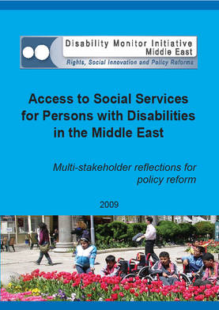
Full project report: Access to services for Persons with Disabilities in the Middle East (DMI ME, 2009)
Criteria for the good practices: See pages 99 -118 of the full report.
Recommendations from the good practices: See pages 122 -125 of the full report.
Links to further resources:Full text on article 9 - Accessibility
Full text on article 19 – Living independently and being included in the community
Full text on article 24 – Education
Full text on article 26 – Habilitation and rehabilitation

