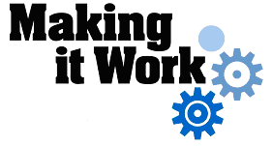

Good Practice case study

How is it possible to improve access to educational services for people with disabilities?

Relevant articles of the CRPD: 19, 24, 26
Country: Egypt
Region: Middle East
Languages available: English

Access to Educational Services in Egypt

Name of Organisation:

Egyptian Centre for Knowledge Building and Creative Child
142 Jalal Al-Dessouki, Waboor El-Mayyah - Bab Sharq - Alexandria
m_ebed@yahoo.com
Tel: 0123992044

General services provided

The centre was founded in 2000 and it took on many distinct and successful educational services and projects to raise the awareness of the society on education issues of children with disabilities and learning difficulties:
- Rehabilitation services for children with learning difficulties
- Support services for mainstreaming children with learning difficulties in public schools
- Counselling services for families
- Training courses to staff in other centres and schools
- Awareness-raising campaigns in the field of education

Good practice area submitted

- Rehabilitation services for children with learning difficulties.
- Support services for mainstreaming children with learning difficulties in public schools.
- Counselling services for families.
- Awareness-raising campaigns in field of education.

Good practices

Availability

The association has a clearly defined target group but not geographical areas. Its ability to maintain sustainable funding and resources from grants and income from services is quite good. Services are provided to a group within the population that is known to be under-served (i.e., children with learning difficulties). The association did it with good ability to promote themselves and forge partnerships with others.

Accountability

Working procedures are documented to act as accountability and evaluation references.

Quality

The association participates in a network of stakeholders in the disability field and has a good file management system with a fair users-centred approach. They have a good staff performance system and try to ensure the safety and protection of students from abuse.

General – Overall comments

The organization is a good example of working on inclusion of persons with disabilities through the provision of special services and support services for mainstreaming. From a professional perspective, they network with other service providers for cooperation and capacity building.

Background and context
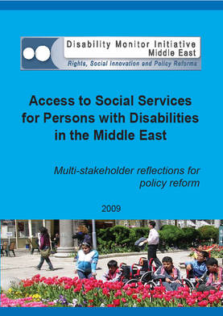
Full project report: Access to services for Persons with Disabilities in the Middle East (DMI ME, 2009)

Criteria for the good practices: See pages 99 -118 of the full report.

Recommendations from the good practices: See pages 122 -125 of the full report.

Links to further resources:
Full text on article 19 – Living independently and being included in the community
Full text on article 24 – Education
Full text on article 26 – Habilitation and rehabilitation

