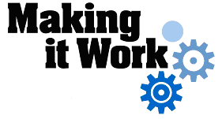
How to develop individualised measures of effective support for students at school?

Location: Mindelo, Municipality of São Vicente, São Vicente Island
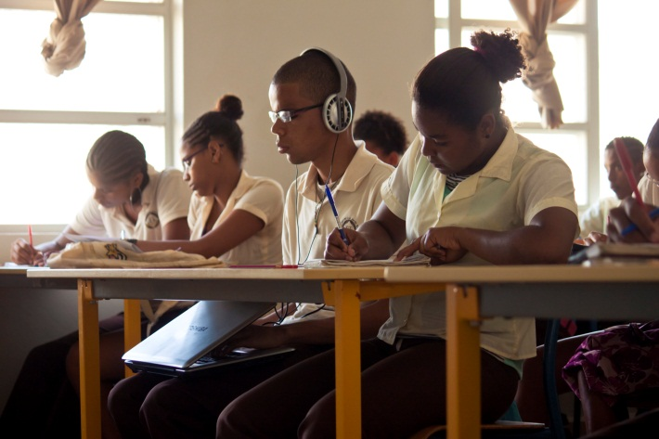
Stakeholders involved: Ministry of Education and Sports (MES), school and family.

A blind student using a computer, his primary learning tool in classes, at Jorge Barbosa Secondary School, São Vicente Island, Cape Verde.

DESCRIPTION OF PRACTICE AND PROCEDURE FOR IMPLEMENTATION
For six years in primary education, the teacher, Hirondina Lima, dedicated herself to the teaching and learning of two blind students attending a class with children without disabilities. However, one of the students emigrated so only Ailton, the other student, continued his secondary education. As a teacher without specialist training to work with blind students, she was able only to provide them with an atmosphere of friendly social interaction. The lesson content was accessible only for students without disabilities.
In order to improve her teaching skills, the teacher sought, from the MES, suitable strategies and methodologies to support blind children’s learning. After a short basic training course in Braille taught by specialists from the MES, Hirondina started a more intensive communication and learning programme with the student, which enabled the process of teaching and learning, with impacts on that student’s life and throughout the school community. Today attending secondary school, Ailton is considered a success story and an example of personal triumph over difficulties.

FACTORS THAT MADE THE IMPLEMENTATION OF THIS PRACTICE POSSIBLE
- The presence of a teacher in the classroom with time available to support blind students’ learning;
- The training received in Braille by the MES which provided Hirondina with knowledge about and skills in Braille;
- The teacher's dedication and willingness to break down barriers and create support materials to learning;
- The pedagogical relationship between the teacher Hirondina and the student Ailton which took place in an atmosphere of mutual respect and reciprocal help.

MAIN DIFFICULTIES AND HOW THEY WERE OVERCOME
- The parents and carers did not believe in Ailton’s ability to overcome the barriers of visual impairment and therefore discouraged the child from attending school. Through awareness-raising work, Hirondina showed the parents the achievements and development possibilities that were within Ailton’s reach;
- The absence of an effective system of reading and writing. With the training received by the MES in Braille it was possible to improve the process of reading and writing with the student. Today he attends classes using a laptop computer, which is his primary learning tool;
- The lack of suitable teaching materials led the teacher, to bridge this need, creating resources out of cardboard, cards, buttons etc. to support access to learning content.

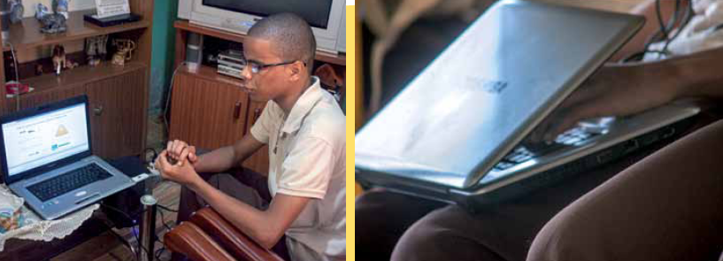

EFFECTS OF THIS EXAMPLE OF GOOD PRACTICES
- As a result of this learning relationship Ailton is one of the few visually impaired students on the island to attend Secondary School successfully;
- The education community is more aware of the ability of visually impaired pupils to learning;
- The teacher, Hirondina, shared her experience with her teaching peers, thus cascading the good practices.

KEY POINTS TO CONSIDER
- The presence of a teacher assistant in the classroom is a key element to ensure the right to quality education for children with disabilities;
- Teacher training in Braille is essential to ensure success of teaching and learning;
- It is essential to equip the school with appropriate teaching materials to support blind students’ teaching and learning.

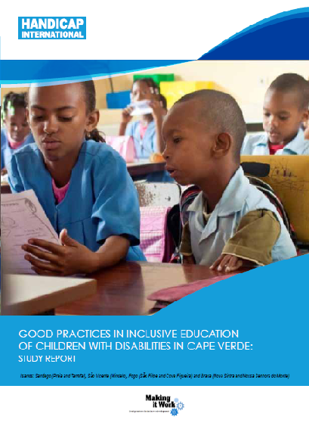
For more information:
Full project report: Report on good practices in inclusive education of children with disabilities in Cape Verde
Criteria for the good practices: see page 6.
Recommendations from the good practices: see page 33-34.
Contact: Hirondina Lima, Retired teacher,
Tel: 231 40 12

