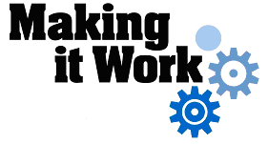
How to adapt to the curriculum needs of children with disabilities?

Location: Nova Sintra, Municipality of Nova Sintra, Brava Island
Stakeholders involved: Delegation of the Ministry of Education and Sports, Centre of Inclusive Education of the Ministry of Education and Sports, School and Family.

DESCRIPTION OF PRACTICE AND PROCESS FOR IMPLEMENTATION
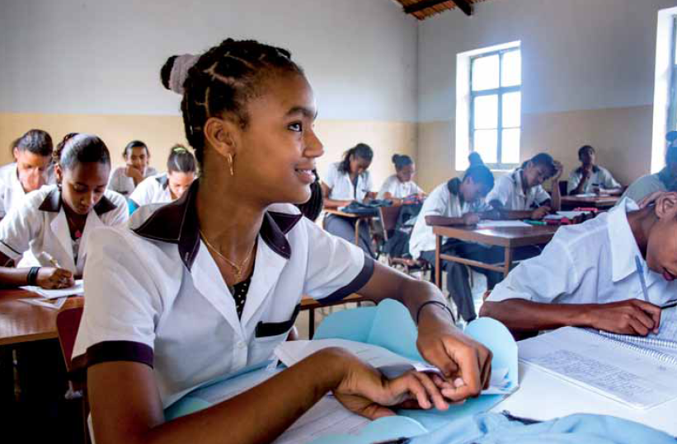
The Nova Sintra Secondary School has adopted the principle of Inclusive Education promoting the access of blind students to Secondary Education. The three students with visual impairment are in the same classes and grades as their sighted peers. This initiative is an example of how, with enlightened teachers and the availability of a system adapted to their needs, it is possible to make the most of the skills of those students irrespective of their special needs.
The involvement of families and their relationship with the school allowed full inclusion of blind students in the education system through their participation in individual meetings, group discussion and in other school activities addressed at parents and guardians. This partnership allowed the teachers and coordinators to build a bond with family members of the students with disabilities. The school ended up providing a family support role through fulfilling their educational responsibilities. The family members’ input provided guidance on how to support the children in the classroom. The professionals improved their relationship with families by treating the children with disabilities not as a ‘case’ but as individuals. Referring to each of them by their given names (often children from underprivileged backgrounds are assigned, at home, and in their neighbourhood, a different name than their given name), by having an interest in knowing their abilities, the challenges they face and their individual characteristics, rather than trying to simply classify or categorise them.

So in this way, the teachers and other professionals learned to move their approach of medical model for approaching disability to a more inclusive model in which each person is looked at as an individual with individual strengths and needs.
The strategies that have been implemented to support the learning of these students are a curriculum and teaching practices that allow students to build on their skills and reach their potential. E.g. For blind students, the teacher used oral tests instead of written work used for the students without disability.

FACTORS THAT MADE THE IMPLEMENTATION OF THIS PRACTICE POSSIBLE
- Open school management;
- Parents motivated and engaged in their children's education;
- Trained and enlightened teachers;
- Technical support from the School delegation and Centre of Inclusive Education in the Island.

MAIN DIFFICULTIES AND HOW THEY WERE OVERCOME
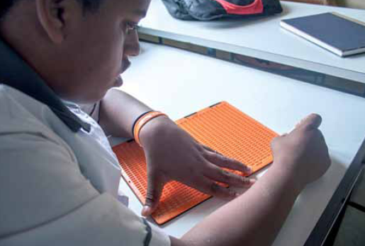
- The format of the examination used by the school was not adapted to the needs of the students with visual impairment. In partnership with the Centre for Inclusive Education on the Island, a new adapted format for curriculum content and assessment was set up, specific areas of the official school curriculum were selected which are appropriate to their needs and will be able to enhance their potential. For example: these visually impaired students were assessed more on their listening skills rather than their ability to write;
- Lack of teaching materials specifically for visually impaired students. The problem has, in the meantime, been resolved, with the involvement of families, the students acquired their own materials (braille writing tools, adapted books in an accessible reading format, computers with adapted reading software, etc.).

EFFECTS OF THIS EXAMPLE OF GOOD PRACTICES
- Visually impaired students attending classes in a regular school with better opportunities for social participation;
- An educational community that is less prejudiced and learning to respect the difference;
- Motivated families aware of their responsibility in the education of their children.

HOW CAN THIS PRACTICE BE IMPROVED?
- Increased involvement of teachers in the learning process of those students. Teachers can assess the initial knowledge of those students before starting the formal program through the targeted meetings with the former teachers and the parents. This information helps planning the program of education and in the learning strategies structuring which are consistent to the needs and abilities of those students;
- Having the appropriate materials that facilitate the learning of visually impaired student;
- A higher level of involvement of visually impaired students in extracurricular and cultural activities developed by the school.

For more information:
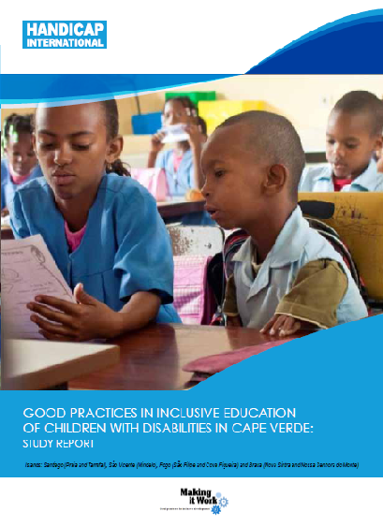
Full project report: Report on good practices in inclusive education of children with disabilities in Cape Verde
Criteria for the good practices: see page 6.
Recommendations from the good practices: see page 33-34.
Contact: Alfredo Silva, Inclusive Education Focal Point of the Ministry of Education and Sports

