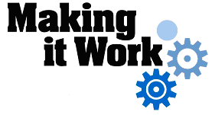
How can water points and latrines be made accessible to people with disabilities?

Topic area
Water, Sanitation and Hygiene (WASH)

Title
Access to drinking water for people with disabilities in the town of Tenkodogo, Burkina Faso

Target groups
Politicians and local authorities: to support them to include accessible infrastructure in the construction of WASH facilities in the future and to support them to delegate standpipes management to citizens.
Standpipe operators: to increase their knowledge on the management and maintenance of the facility.
Management Committee of standpipes: to raise-awareness on the possibilities to appoint a person with disabilities to manage the standpipe.
Service providers on accessibility work: to provide them with technical support on design guidelines.

Criteria for good practice on this topic
Services have to be:
Available
Safe
Acceptable
Accessible
Affordable
Services are guaranteed without discrimination.
Services ensure participatory processes are followed.
Institutions are accountable to users.

Description of the context
In the past, people with disabilities in Tenkodogo were strongly dependent on society and family members because of their exclusion from services, including water supply and sanitation facilities.

In the 1980s a few measures were taken by government to address institutional barriers faced by people with disabilities. These measures included the establishment of a disability card to give people with disabilities easy access to certain public services such as health, public transport, schooling, etc. The card allowed people with disabilities to get discounts or free services. Similarly, the revolutionary regime (1983-1987) contributed significantly to remove certain social / behavioural barriers (negative attitudes vis-à-vis people with disabilities) through information campaigns, awareness and the fight against discrimination and all forms of exclusion.

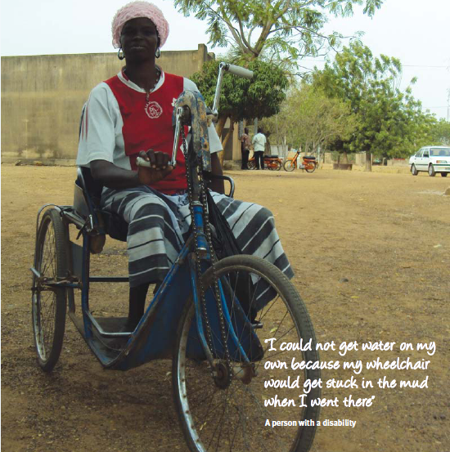
But, in addition to institutional and social barriers that can be met, people with disabilities face enormous environmental barriers including barriers to access water points. In terms of access to the built environment, there was no notable action taken by the government or any other organization to address the removal of barriers.
As a result, people with disabilities faced difficulties in accessing water points and had to rely on family and community members to provide them with water.

Description of the good practice
Since 2001, Dakupa , wanted to ensure people with disabilities had greater access to water points and could use them independently. Dakupa, with the support of WaterAid, began to implement a WASH project in several urban municipalities of the region. The objective of this project was to improve access to WASH services for persons with disabilities through the construction of accessible water points (boreholes, standpipes, wells) and latrines. To date, about ten wheelchair accessible standpipes have been constructed, including in the town of Tenkodogo.
Dakupa’s members saw there was a need for accessible water points and prioritized this issue to be addressed. One of the other catalysts in getting the project off the ground was the presence of WaterAid in the region with an organizational commitment to equity and inclusion. WaterAid’s commitment to inclusion made it possible for Dakupa to form a strong partnership with them to implement an inclusive WASH project.

The technical aspects of the Dakupa intervention
Under this project, Dakupa aimed to provide standpipes that would be accessible to people with disabilities, featuring ramps and handrails. Several obstacles typically prevented people with disabilities from accessing water sources such as public standpipes. Thanks to the opportunities for intervention identified by the Dakupa team through a community meeting, several technological solutions were found (see Table 1).

Table 1: Situation Analysis (obstacles and opportunities) before the intervention of Dakupa

Barriers/obstacles | Opportunities
- Environmental
- Steep stairs (or presence of steps) making access to the standpipe difficult for people with disabilities | Possibility of building ramps with handrails, but local technical skills had to be identified for implementation
- Surrounding area of the standpipe liable to swamping (mud), thus preventing access with a wheelchair | > Possibility of earthwork (stone bund) around the standpipe. Local skills were available for implementation.
- Taps too high | Easy to solve at the construction stage
- Institutional
- Lack of local technical skills for certain WASH facilities | > Existence of a local private provider that can support WASH actions and the community

Table 2: Presentation of the actions taken under the Dakupa intervention

Barriers | Solutions
- Environmental
- Steep stairs (or presence of steps) making access to the standpipe difficult for people with disabilities | Construction of ramps and handrails at standpipes
- Surrounding area of the standpipe liable to swamping (mud), thus preventing access with a wheelchair | Stone bunds constructed around the standpipes.
- Taps too high | > Standpipes with taps set at different heights
- Institutional
- Lack of local technical skills to meet WASH construction needs | > Identification of a private local provider with experience in the construction of WASH facilities

The innovative elements of the Dakupa intervention

What was most innovative about the Dakupa intervention was the introduction of access ramps and handrails, and in adapting standpipe technical specifications, including the height of the tap. This is the first time that this kind of innovation has been implemented not only in this town but also in Burkina Faso.
The innovations were made possible through collaboration between Dakupa and a private service provider identified locally. It is important to note that the provider, despite their experience in the execution of WASH works with ONEA (national water and sanitation company), had never undertaken similar accessibility work. The inclusive designs (especially that of the handrail) were well executed thanks to the creativity of the provider and the guidance of the Dakupa WASH unit who consulted with people with disabilities in order to get their opinions on the designs.

Most significant changes
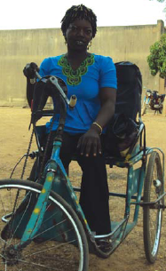
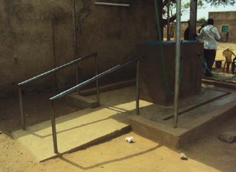
To date, ten standpipes of this type have been constructed. They have improved the independence of persons with disabilities regarding access to water. Local stakeholders including politicians and local authorities have also realized the importance and value of accessible infrastructure and intend to take this into account in the construction of WASH facilities in the future. In addition, this project demonstrated how standpipe management can be more inclusive of people with disabilities. The municipality authority has delegated management of the standpipes to all citizens including people with disabilities.
Standpipe in the municipality of Garango

Each neighbourhood is organized around the standpipe by a Management Committee composed of district resource persons known for their moral integrity. This Committee appoints one person in the area to manage the standpipe. The standpipe manager sells water, pays his bill and pays part of the profit to the Committee. Some people with disabilities are in charge of the management of some standpipes, and this has become an income generating activity for them. This allows people with disabilities who previously did not have access to a source of income to improve their living conditions, provide schooling for children, purchase food and pay for health care.
A lady with a disability who uses the new facilities

Impact statements
The following comments come from community members speaking about the impacts of the new accessible standpipe:

"It is really good now. Before, I could not access the standpipes with my wheelchair, but now it is possible and I can do it without any assistance."

"I find this innovation very positive for us people with disabilities; it makes us less dependent on others for our water needs. I really invite the originators to raise more awareness about the usefulness of this innovation. "

"Now I can do my laundry without asking anyone to bring me water. I can go to the standpipe when I want. I could not do it before. "

Facilitating factors that made this practice successful
Several factors facilitated the implementation of the Dakupa action on the ground. The most important of these included:
• Support from local authorities (municipalities) and ONEA;
• Presence of stakeholders committed to upholding the rights of people with disabilities, such as Handicap International which organizes awareness campaigns on the rights of disabled people in the area;
• Mobilization of people with disabilities and DPOs (people with disabilities as well as DPOs participated in meetings in order to collect their views on making water and sanitation facilities more accessible, people with disabilities also provided management of certain standpipes)
• Dakupa carried out activities throughout the municipality to support the success of the project including: facilitation of community meetings, monitoring the work of the service provider, financing achievements
• WaterAid technical and financial support for Dakupa (WaterAid formed a partnership with Dakupa, and provided both technical and financial support to Dakupa);
• Landform of the region (the existence of a sheet of water within the municipality);
• Existence of a local service provider that was able to build accessible facilities using minimal resources.

Barriers or challenges
Initially, the service provider for this project had begun construction with no reference to technical designs provided to them by Dakupa. To overcome this challenge, Dakupa had to ensure close technical monitoring of the building process to ensure the guidelines were respected.

Another challenge that was faced was poor budget planning. After the project began, the service provider realized that the budget was inadequate and had to be revised which caused further delays. As a result this has delayed the building of facilities.

Finally, the management committee implementing the project was unaware of certain administrative procedures and were unaware that there is a City Council tax for all construction in the municipality (US$398). As a result, the tax was not included in the budget. In future, urban WASH projects like this should closely involve the local authorities to enable them to share advice and relevant information.

Recommendations
Based on project activities in Tenkodogo, the project team recommends that future work of this type:
• Involve PWD in all project stages (design to implementation) because they can correct or give their opinion on a certain design;
• Raise awareness on how to use the facility, before, during and after the action;
• Use zinc-coated pipes for the handrail; and
• Have a local service provider undertake the accessibility work.

To ensure the sustainability of the project, the team recommends that future projects:
• Plan to continually educate and inform users for greater ownership and good management of the facilities;
• Take into account the depreciation of the facility and provide for its renewal;
• Train standpipe operators in the management and maintenance of the facility; and
• Promote exchanges between urban standpipe operators who could form a cooperative and support each other.

Contact information:
Cathy Dimbarre Kpehounton: regional-decisiph@hi-sen.org
Handicap International/Coordinatrice Régionale Projet DECISIPH
Dao Moussa Serge: dm.serge@yahoo.fr

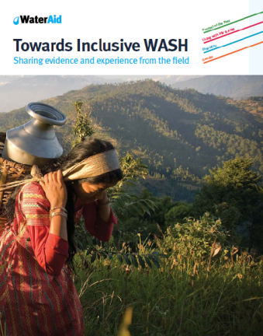
This case study is one of sixteen from the Towards Inclusive WASH series, supported by AusAID’s Innovations Fund. Please visit www.inclusivewash.org.au/case-studies to access the rest of the publication and supporting resources.
Links to further resources:
Article 9 on Accessibility
Article 19 on Living independently and being included in the community
Article 25 on Health

