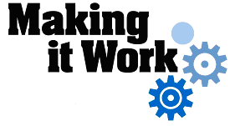

Good Practice case study

How can people with disabilities participate in community management, access municipal services and ensure disability issues are included in decision-making processes?

Relevant articles of the CRPD: 19, 27 and 29.
Country: Burkina Faso
Region: West Africa
Languages available: English, French

Promoting Inclusion of People with Disabilities in Community Water Management and Access to Municipal Services in the District of Tenkodogo

Description of the practice and the process involved

Tenkodogo is the capital of the East Central region of Burkina Faso. Officially a ‘municipality’ since 1995, Tenkodogo has 124,053 inhabitants, according to the 2006 census. Around 1,772 people with disabilities live in the district, grouped into 18 organizations (Handicap International Burkina-Niger Programme, 2007). A regional coordination of these organizations was established in 2009.
This coordination has initiated a process of advocacy and negotiations with the local authorities for:
- The inclusion of people with disabilities in the management of community pump wells;
- The access of people with disabilities to municipal services.

Management of pump wells
The town’s water supply and pump wells were put in place by the Tenkodogo branch of the national water and sanitation company (ONEA). In 2009, the National plan for the Development of the Water and Sanitation Sector, Phase II (PADESEA II) supplied the city with nine additional standpipes in addition to the 35 already existing in the district.
Following the advocacy undertaken by Disabled People’s Organizations (DPOs), the municipal council decided to give priority to people with disabilities in the management of these facilities. A decision has been taken by the council in this regard. The criteria for the selection of pump well managers were the ability to manage such facilities and residence in the neighbourhood or area where the standpipes are located. The management of 6 of the 9 pump wells has now been assigned to people with disabilities.
These managers include three women and two men with motor disabilities and a man with visual impairment. A DPO (APEAMB) is also on the waiting list for future allocations.
A project for the supply of three other pump wells to the town council from a partner organization, «DAKOUPA», will enable the coordination to put forward other people with disabilities for new allocations, taking into account tangible management results on the ground.

Access to municipal services
To fully include people with disabilities in society, they should be given easy access to municipal services and registry office services like any other citizen.
To this end, priority access and support services have been granted to people with disabilities in the city. The procedures for obtaining vital documents have been simplified to reduce waiting time. A future decision of the board should also exonerate holders of the indigence card from the costs of these vital documents.
To facilitate access for people with reduced mobility, a ramp was built at the entrance to City Hall.

The factors that made this practice possible

This initiative was made possible by the positive attitude of the City of Tenkodogo vis-à-vis people with disabilities. Undoubtedly, this vision has been facilitated by the existing presence of 5 people with disabilities working for the city council; one of whom serves as the President of the Regional Coordination of DPOs. This has enabled their colleagues to recognize the skills of people with disabilities and become aware of the difficulties they encounter on a daily basis. This factor emphasizes the importance of the right to political participation for people with disabilities.
The coordination of DPOs played a decisive role in encouraging the participation of people with disabilities, by sending correspondence to the various member organizations. DPOs also monitored the work of the water managers, as it was important that people with disabilities were seen to be capable of managing communal facilities.
The attitude of the municipality was also favourable to DPO requests for improved access to municipal services.
The awareness and capacity building work of DPOs in the country has allowed the public to have a better knowledge of the problems faced by people with disabilities, and contributed to making the action of DPOs more organized and effective.

Some of the difficulties encountered

Regarding the management of pump wells, a major difficulty was the lack of physical access. The pump wells are not designed to be operated by persons with disabilities: they are very high, there is no ramp, and this causes difficulties for persons with disabilities.
«I have personally visited people with disabilities who manage pump wells and I have realized that it’s very difficult for some of them, but the design of the pump wells is decided at a high level» said the head of the regional branch of ONEA. This is now a key issue for advocacy amongst DPOs engaged on water issues.

The effects / impact of the practice

- People with disabilities now play a key role in local decision-making about the management of water services;
- The positioning of people with disabilities in the management of communal facilities promotes a different perception of disability within the community;
- People with disabilities have better access to local authority management positions, enabling them to improve their living conditions and their role in society;
- The disabled managers of pump wells raise public awareness about hygiene practices;
- People with disabilities can more easily reach the mayor’s office thanks to the construction of the ramp. They no longer have to wait or take appointments to obtain vital documents. They are welcomed and supported where appropriate within the City Hall;
- Users and staff are aware of the problems that people with disabilities face as regards access to communal services and the need to take measures to address their needs.
For Zarata, such initiatives will accelerate the change in the way persons with disabilities are perceived: “Today, people come to me for advice on hygiene and I also educate my family members, people in my area and especially women who come over to the standpipe. I am happy to be here and I know that people need me”.
Sawadogo Ousmanne has been a shopkeeper for many years and was born with a visual impairment. He operates his business without any assistance, picks articles for his customers, and gives them change. He confirms that the management of the pump well is a little more profitable than operating the shop: “What I earn from the management of the pump well will allow me this year to send my daughter to a big school in the municipality. Without it, she would have been obliged to stay at home”.

An example of disability inclusion
The city council has taken into account the needs and concerns of disabled people’s organizations and has facilitated:
- Their access to employment by entrusting the management of community facilities to them on the basis of their skills;
- Access to municipal services.

Related articles of the CRPD

This practice has links with the articles of the CRPD on the autonomous living of persons with disabilities and their inclusion in society (Section 19), employment (Article 27) and participation in public life (Article 29).

What are the main points that require attention? How could it be improved?

The physical accessibility of communal facilities (pump wells, public buildings etc.) is crucial to ensure conditions for the genuine participation of people with disabilities in economic, social and political life.

For more information, contact:
Balima Christian, President of the Central East Regional Coordination of DPOs.
Tel: 00 226 70 23 86 77.

Background and context
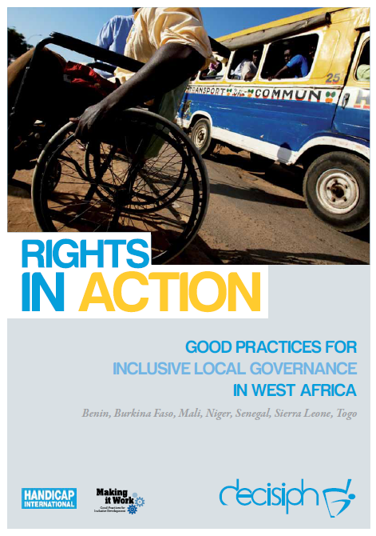
Full project report: Rights in Action - Good Practices for Local Inclusive Governance in West Africa (Handicap International 2010)

Criteria for the good practices: see pages 47 – 49 of the full report.

Recommendations from the good practices: see pages 98 – 111 of the full report.

Links to further resources:
Full text on CRPD article 19 – Living independently and being included in the community
Full text on CRPD article 27 – Work and Employment
Full text on CRPD article 29 – Participation in political and public life

