# How to bring beneficiaries together to actively participate in Mine Risk Education processes?

## Background and context of the good practice

Mine Risk Education (MRE) is one of the most challenging aspects of mine action. It remains a necessary measure within counter-mine activities, and yet it is often very difficult to implement and achieve positive results.

The population of Bosnia and Herzegovina (BiH) living in mine-affected communities often reluctantly receive messages/information from MRE organizations. Indeed in many situations, communities showed no desire to be present at the workshops organized for them. The reasons for such behaviour lay in the fact that the war was over 17 years ago and many feel that MRE is the out of date activity.

All the above mentioned issues point towards the need for an approach that involves the whole population living in mine-impacted communities and not only specified target groups. Such an approach has been developed gradually through small projects implemented by the organisation ***Posavina without mines*** (Posavina bez mina). These ideas were then scaled up into a municipal MRE methodology supported by mine-impacted municipalities, relevant governmental and public institutions and UNICEF.

This has led to an increased interest to participate in the MRE activities among targeted beneficiaries, which then enabled continuous MRE after the implementation of the project.

## Description of the practice and the process involved

This good practice case study actually corresponds to a range of different practices which together proved very effective in the goal of **bringing beneficiaries together to actively participate in Mine Risk Education processes.** Various activities were developed in a specific order in order to achieve this goal.

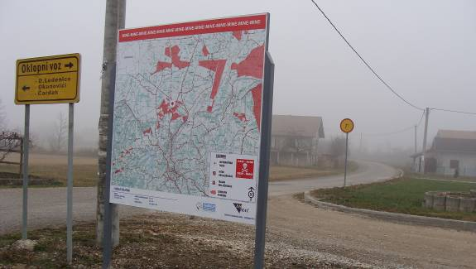The process of developing the practice lasted a few years. It was developed gradually, so that as the projects were implemented a new aspect of good practice would emerge and then be applied in subsequent projects. The main goal was to identify the **tools required to reach as much of the population as possible in a targeted mine-impacted community** and other neighbouring communities impacted by landmines as well.

***Photo 6: The billboard installed in mine-impacted community at cross-road, Medjidja Gornja***

***(by HI, all rights reserved)***

The first idea that was accepted by the Bosnia and Herzegovina Mine Action Centre (BHMAC) was the installation of billboards with updated mine situation information. The billboards were linked with the activities of marking risky or suspected hazardous areas. Billboards always followed the activities of marking. This tool was later upgraded to a municipal MRE methodology.

The educational material was also linked with the marking activities; leaflets offered a better understanding of the current mine situation, providing clear maps. This was an excellent tool – which was perceived by communities as *useful information* rather than *education*. Group presentations and workshops were designed to provide the population with updated information including maps. Maps are so important for several reasons: based on the project experience, the BiH population generally responds very well to maps. Maps always draw a lot of attention. When large maps are provided with leaflets, our beneficiaries very often actively participate in the workshops. They share information and experience. In this way, half of the participants at workshops became peer educators for their neighbourhoods.

A subsequent good practice was to invite the Municipal Coordinators for Demining to the workshop. Their presence was possible due to the fact that one of the first activities was community liaison focusing on briefing the local officials about the plan of activities and goals. Furthermore, the continuous presence of all relevant parties involved (including targeted mine-affected populations) ensured that the Municipal Coordinators for Demining could find local associates.

## Effects / impact of the practice

The implementation of this practice produced good results because it influenced a wide range of the population. In addition, the practice associated local officials and final-beneficiaries that represent the at-risk population. This linkage allowed the exchange of information at all levels within the targeted community.

This practice is something that has emerged over time as a series of different activities, not as one specific action. From the beginning Posavina without mines has marked better and better results which can be measured by the number of beneficiaries who wanted to be a part of the project.

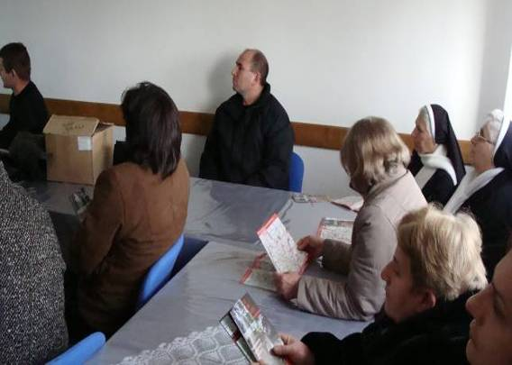**This practice is mostly concerned with changing the attitudes of beneficiaries towards MRE actions.** The active role in the implementation of the project (through peer to peer education, education of local associates for the continuing MRE, bringing local officials to presentations, and cooperation with the Civil Protection Agency team) is a key factor in creating this positive attitude. A positive attitude is the first and very important step towards changing behaviours and actions.

***Photo 7: MRE presentation organized in mine-impacted community Medjidja Gornja in Gradačac Municipality***

***(by HI, all rights reserved)***

There have been noticed improvements in the changing behaviour of final beneficiaries. This has been caused by the fact that, all members of a household in a targeted community were all exposed to some type of MRE service. Children receive information and educational material at school, adult members participate in workshops, some adults help in implementing marking activities, and door to door presentations are made in each neighbour accompanied with the dissemination of educational material. Before the end of the project, it is hard to find a person that was not “informed” about the current mine-risk in their community and the adjacent communities.

Yet, it was important not to cross a line and become annoying with presenting the mine problems.

## The factors that made this practice possible

The national documents related to MRE that currently exists are the national Mine Action Strategy 2009-2019 and, national Mine Risk Education Sub-Strategy 2009-2019.

The activities which enabled the achievement of good results in targeted communities are in accordance with the objectives set out in two national documents. Moreover, the good practice was supported by the BHMAC, and its municipal plans for MRE have been improved on the basis of the good practice results and tools presented here: by UNICEF and by local authorities, namely mine-impacted municipalities. There are municipalities that ask for MRE of the sort detailed in this case study. Furthermore, many international organizations supported broad access to the problem of MRE including Handicap International, International Trust Fund…

The activities of Mine Risk Education five years ago were limited to certain affected groups and individuals. Those activities did not include such a big number of final beneficiaries and were limited to the high-impacted communities only. Domestic and international donors have recognized the importance of a new methodology as the response to considerable decrease of funds aimed for mine action in BiH since a couple years ago. This new methodology ensures wide range coverage of beneficiary despite their risky behaviours, the mine-risk and level of mine-impact (low or high) in a particular targeted community. Implementing agencies (even those with limited funds) are able to achieve significant outcomes in the long-term – billboards installed are more long-lasting, visually more understandable, more precise and clear, more accessible to travellers and tourists in comparison with posters, leaflets, brochures that used to be distributed to individuals or its families.

***Posavina without mines*** have not conducted any special training. The personnel involved in developing and implementing the practice possess a lot of experience in a range of the activities implemented. Drawing maps, marking of risk areas, developing new ideas for education materials are skills that have been developed along with developing the practice. Certain technical equipment is necessary such as the equipment for marking activities and billboards.

Nevertheless, in line with National Standards for MRE, it is important to emphasize that employees engaged in MRE activities have to obtain official certificates issued by the BHMAC after completion of a minimum Basic MRE course and MRE Management course.

## Lessons learned

* **Risk behaviour tends to become a routine** - beneficiaries are aware of mines and unexploded ordnances (UXO), but still enter risk areas mainly due to economic reasons, which requires a special and continued approach. It is important to identify reasons for entering the risk areas, to document and present them to the local and municipal officials.
* All activity-oriented information must be accessible to all stakeholders. Hence, it is important to establish good community liaison activities.
* Mass media (radio, TV, Newspapers) are good instruments to inform beneficiaries outside the targeted local communities (hunters, fishermen and other visitors).
* Baseline data must be drawn from various resources. Data obtained from existing databases are sometimes insufficient, so it is necessary to find local associates. All findings about the targeted mine-impacted community must be documented.
* Local associates should be trained on MRE in each targeted community in order to support continuation of MRE activities after the project implementation.
* Following completion of urgent marking activities, the population should be informed and results should be shown on billboards, so that all beneficiaries have a better understanding of the mine situation in the area.
* Community Mine Action Liaison is one of the most efficient Mine Risk Education tools because it involves all stakeholders in the problem solving.
* The population of the mine-impacted communities and their representatives have a scarce knowledge related to the candidature of mine affected areas for the purpose of demining prioritization process and therefore, discussion and information sharing on this issue is highly recommended.
* MRE presentations should be organized in a manner that all present beneficiaries are provided with answers to their questions related to mine risk areas.

### Main successes

The main success is that there **were no mine casualties** in the affected communities where the MRE activities were implemented.

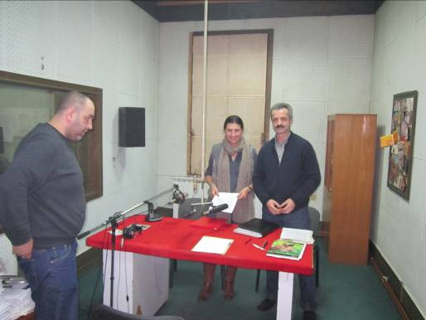The greatest change the practice made was the increase in the number of beneficiaries and the willingness of individuals to practice MRE on their own. For instance, radio journalists offered to give out warnings related to entering mine risk areas and media from municipalities adjacent to the targeted affected municipality invited MRE Instructors to talk about mine danger so that population coming from their areas of responsibility got a better understanding of the mine situation and remaining mine risks.

***Photo 8: Radio Gradačac: news casting about MRE activities at field (by Posavina bez mina, all rights reserved)***

## Key recommendations by initiating agency and multi-stakeholder discussion

This practice was presented to BHMAC in late 2008, the key governmental institution for accreditation, planning, education, quality management as well as coordination among all local and international stakeholders in BiH. It was later discussed with the UNICEF which was providing technical assistance on Mine Risk Education at that time. It was also discussed with local authorities and local mine-impacted communities.

Led by very good results and feedback by the final beneficiaries (mine-affected populations) this good practice on MRE tools (billboards and leaflets with maps of mine situation) has been included into Annex II dated January 13, 2010 of the national Standards for mine clearance and Explosive Ordnance Disposal (EOD) operations in BiH[1]. It has been also integrated into municipal MRE methodology and planning issued by the BHMAC. In line with this annex, any local organization accredited for MRE by the BHMAC in BiH, should comply with this Standard and apply MRE with a new group tool.

This practice has been replicated several times in different communities. It is to be replicated in other affected communities. Activities may change but the practice remains the same: **it is a group of tools which enable reaching all the affected population in mine-impacted communities.**

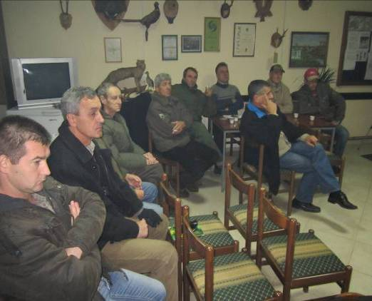The successful replication requires the participation of local structures in order to strengthen their responsibilities toward the mine action. It is important that revised MRE sub strategy is adopted. It would be great if structures at municipal, entity and state level recognize the importance of MRE. The Government of Brcko District BiH has planned financial means for MRE in the District. It would be great if successful companies and individuals in BiH recognize the importance of investing in demining. They are also our target groups.

***Photo 9: Members of Hunting Association attend MRE workshops***

***(by HI, all rights reserved)***

All in all, for the future replication of the practice it is necessary to have financial means and good planning of MRE activities including the improvement of related priority settings.

**For more information:**

*Svjetlana Pavlovic, NGO Posavina bez mina (Posavina without mines)*

*E.N Velimirovica 1a, Brcko*

[*info@posavinabezmina.org*](mailto:info@posavinabezmina.org)

*www.posavinabezmina.org*

Read the full report: Examples of good practices in mine action in Bosnia and Herzegovina

1. The second amended edition on edition dated June 1, 2003